Елена Музланова, Елена Кисунько

Английский язык: Экспресс-репетитор для подготовки к ЕГЭ: «Грамматика и лексика»

ВЕДЕНИЕ

Предлагаемый сборник тестовых заданий предназначен для формирования и контроля грамматических и лексических навыков и ориентирован, главным образом, на учащихся 10–11 классов и абитуриентов. Он поможет качественно подготовиться к итоговой государственной аттестации в форме ЕГЭ.
В пособие включен обширный лексический и грамматический материал, что позволяет использовать его на различных этапах обучения в школах с углубленным изучением языка, лицеях и гимназиях, а также при подготовке к экзаменам на получение международных сертификатов и к вступительным экзаменам в вузы.
Основная цель сборника – закрепить, обобщить и систематизировать знания, умения и навыки, приобретенные учащимися в рамках базового курса, а также овладеть определенным количеством нового материала в соответствии с требованиями государственного стандарта к надбазовому уровню владения иностранным языком.
Пособие составлено в соответствии с кодификатором элементов содержания по английскому языку, подготовленным Федеральным институтом педагогических измерений (ФИПИ). Каждый из разделов посвящен формированию одного из навыков, проверяемых на ЕГЭ. В разделах представлен краткий теоретический материал по теме, а также разнообразные задания для формирования и закрепления лексико-грамматических навыков. Сборник включает более 200 многоуровневых тестов, расположенных в порядке нарастания сложности, которые помогут прочно усвоить лексику и наиболее важные аспекты грамматики.
Поскольку в разделе «Грамматика и лексика» Единого Государственного Экзамена проверяется умение применять полученные знания при работе с иноязычными текстами, то в конце каждого раздела приводятся лексико-грамматические задания на базе аутентичных текстов, при работе с которыми учащиеся овладевают различными аспектами иноязычной культуры.
Раздел «Exam Practice» включает все типы лексико-грамматических заданий, входящих в ЕГЭ: определение требуемой грамматической формы заданного слова; определение однокоренного слова; выбор правильного варианта из четырех предложенных. Эти задания составлены на основе аутентичных материалов, максимально приближенных к формату единого государственного экзамена… Итоговый тест содержит 25 заданий, что позволяет легко оценить знания: 23–25 баллов – «отлично», 18–22 балла – «хорошо», 13–17 баллов – «удовлетворительно». Весь комплекс тестов имеет одну цель: активировать лексико-грамматический материал, изученный ранее на уроках, и подготовить учащихся к успешной сдаче единого государственного экзамена по английскому языку. Все тесты снабжены ключами, что позволяет использовать сборник для самоконтроля и самостоятельного изучения английского языка. Представленные в пособии тестовые задания были апробированы в московских школах и с успехом применяются на практике. Надеемся, что оно окажется полезным не только учащимся и учителям, но и всем желающим самостоятельно изучить английский язык.
При подготовке данного пособия автором были использованы следующие издания:
1. Luke Prodromou. Grammar and Vocabulary for First Certificate. – Pearson Education Limited, 2000.
2. Luke Prodromou. Rising Star. An Intermediate Course – Macmillan, 2005.
3. Michael Harris, David Mower, Anna Sikorzynska. Opportunities. – Pearson Education Limited, 2006.
4. N. Kenny, L. Luque – Mortimer. First Certificate Practice Tests. – Pearson Education, 2000.
5. Raymond Murphy. Englisc Grammar in Use. – Cambridge University Press, 1995.
6. Virginia Evans. Round-Up. – Pearson Education Limited, 1994.
7. Ионина А.А., Саакян А.С. Английская грамматика XXI века. Учебное пособие по английскому языку. – М.: Издательство «Менеджер», 2006. – 400 с.
8. Демоверсии ЕГЭ по английскому языку. – www.fipi.ru.

1. NOUNS

1.1. SINGULAR AND PLURAL NOUNS

Nouns are made plural by adding

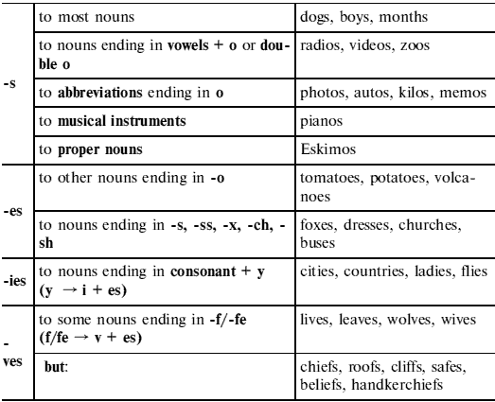
Irregular plurals
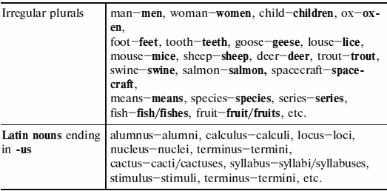
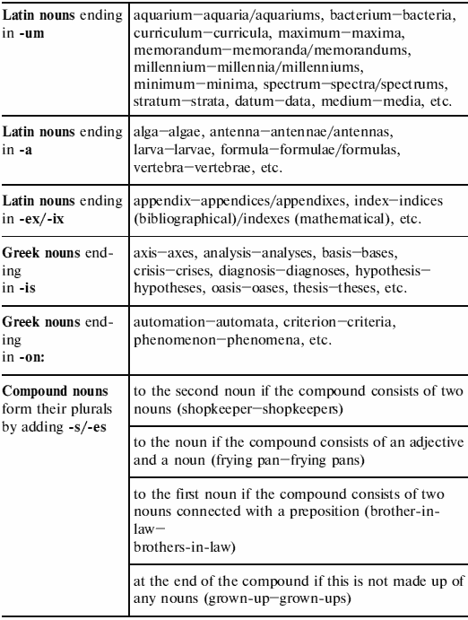

Test 1. Write the plural of the following nouns.

1. church – 8. woman – 15. radio —
2. difficulty – 9. deer – 16. ox —
3. mouse – 10. leaf – 17. fish —
4. month – 11. goose – 18. wolf —
5. child – 12. potato – 19. country —
6. roof – 13. foot – 20. tooth —
7. boy – 14. dress – 21. curriculum —

Test 2. Write the plural of the following nouns.

1. nanny – 8. radio – 15. violin —
2. father-in-law – 9. train robbery – 16. wife —
3. headache – 10. painkiller – 17. medium —
4. dictionary – 11. bush – 18. mouse —
5. pincushion – 12. pen-friend – 19. godfather —
6. hold-up – 13. video – 20. wish —
7. hoof – 14. pillowcase – 21. phenomenon —

Test 3. Write the plural of the following nouns.

1. deer – 8. sheep – 15. datum —
2. lady – 9. species – 16. Eskimo —
3. roof – 10. day – 17. leaf —
4. chief – 11. family – 18. life —
5. studio – 12. dish – 19. zero —
6. zoo – 13. paw – 20. buffalo —
7. bus – 14. fork – 21. criterion —

Test 4. Write the plural of the following nouns.

1. trout – 8. baby – 15. vowel —
2. composer – 9. handkerchief – 16. buzz —
3. insect – 10. church – 17. glass —
4. oasis – 11. memo – 18. man —
5. analysis – 12. ball game – 19. goose —
6. bacterium – 13. passer-by – 20. foot —
7. waiter – 14. letdown – 21. volcano —

Test 5. Write the plural of the following nouns.

1. bench – 8. scarf – 15. fruit —
2. celebrity – 9. belief – 16. swine —
3. louse – 10. sheep – 17. activity —
4. bath – 11. half – 18. thief —
5. woman – 12. tomato – 19. kilo —
6. cliff – 13. means – 20. party —
7. play – 14. photo – 21. appendix —

1.2. COUNTABLE AND UNCOUNTABLE NOUNS

Nouns can be countable (those that can be counted) or uncountable (those that can’t be counted). Uncountable nouns take a singular verb. The most common uncountable nouns are:
• Mass nouns: fluids (blood, tea, coffee, milk etc), solids (bread, butter, china, coal, food, fruit, glass, ice, iron, fish [meaning food], etc), gasses (air, oxygen, pollution, smoke, smog, etc), particles (corn, dust, flour, hair, pepper, rice, salt, sand, etc).
• Subjects of study: chemistry, economics, literature, mathematics, physics, etc.
• Languages: Chinese, English, French, etc.
• Games: billiards, chess, golf, soccer, tennis, etc.
• Diseases: flu, measles, mumps, etc.
• Natural phenomena: darkness, hail, heat, rain (but: the rains = season of continuous rain in tropical countries), humidity, thunder, snow, etc.
• Some abstract nouns: accommodation, advice, anger, applause, assistance, behaviour, business, chaos, countryside, courage, damage, dirt, education, evidence, housework, homework, information, intelligence, knowledge, luck, music, news, peace, progress, seaside, shopping, traffic, trouble, truth, wealth, work, etc.
• Collective nouns: baggage, cutlery, furniture, jewellery, luggage, machinery, money, rubbish, stationery, etc.
• Many uncountable nouns can be made countable by adding a partitive: a piece of paper/cake/advice/information/furniture; a slice/loaf of bread; a(n) item/piece of news, etc.
• Some nouns take only a plural verb. These are objects consisting of two parts: garments (pyjamas, trousers, etc), tools (scissors, etc), instruments (binoculars, compasses, spectacles, etc), or nouns such as: arms, ashes, barracks, clothes, congratulations, earnings, (good) looks, outskirts, people, police, premises, riches, stairs, surroundings, wages, etc.
• Group nouns refer to a group of people. These nouns can take either a singular or a plural verb depending on whether we see the group as a whole or as individuals. Such group nouns are: army, audience, class, club, committee, company, council, crew, crowd, headquarters, family, jury, government, press, public, staff, team, etc.

The team was the best. (the team as a group)

The team were all given medals. (each member separately as individuals)
• With expressions of duration, distance or money meaning ‘a whole amount’ we use a singular verb: Two years is long to wait. Three miles is a long way to go. Nine thousand pounds is a high price to pay.

Test 6. Fill in: is or are.

1. Your trousers _____ in the wardrobe.
2. Where______ his scissors?
3. There_____ a lecture on history today.
4. The shopping________ heavy.
5. Where_____ my gloves?
6. This information______ correct.
7. His hair_____ brown.
8. My socks_____ in the drawer.
9. Our furniture_____ very cheap.
10. His accommodation_____ luxurious.
11. Evidence_____ needed before the trial can continue.
12. The news_____ very exciting.
13. Mumps_____ a common illness among children.
14. My glasses_____ on the table.
15. Chinese_____ difficult to learn.
16. Where_____ the kitchen scales?
17. Billiards_____ a popular game.
18. His work_____ very interesting.
19. People_____ starving in some countries.
20. Education_____ the key to his success.

Test 7. Fill in: is or are.

1. Where_____ your trousers?
2. Could you tell me where_____ the scissors?
3. Tonight, there _____ athletics on TV.
4. Money_____ easy to spend and difficult to save.
5. Gloves_____ worn in cold weather.
6. This student’s knowledge_____ amazing.
7. Love_____ reason for much happiness.
8. This bread_____ stale.
9. Your jeans_____ on the chair.
10. His baggage_____ too heavy to carry.
11. Her advice _____ very interesting.
12. Mathematics_____ his favourite subject.
13. Measles_____ a common illness.
14. The glasses_____ on the table.
15. My sister’s hair_____ long.
16. Their bathroom scales_____ quite accurate.
17. Darts _____ a popular game in Britain.
18. This work_____ too hard.
19. People_____ unhappy with the new tax system.
20. The police_____ near.

Test 8. Choose the correct form of the verb.

1. Economics (is/are) his favourite subject.
2. The trousers he bought for her (doesn’t/don’t) fit her.
3. The police (want/wants) to interview men about the robbery.
4. Physics (was/were) my best subject at school.
5. Can I borrow your scissors? Mine (isn’t/aren’t) sharp enough.
6. The news (wasn’t/weren’t) as bad as we expected.
7. Where (does/do) your family live?
8. Four days (isn’t/aren’t) long enough for a good holiday.
9. He can’t find his binoculars. Do you know where (it is/they are)?
10. Do you think the people (is/are) happy with the government?
11. (Does/Do) the police know how the accident happened?
12. She doesn’t like hot weather. Twenty-eight degrees (is/are) too warm for her.
13. The staff at school (is/are) not happy with their new working conditions.
14. Thirty thousand pounds (was/were) stolen in the robbery.
15. Two years (is/are) a long time to be without job.
16. Five miles (is/are) a long way to walk every day.
17. I need more money. Six pounds (is/are) not enough.
18. These species (is/are) very rare.
19. My hair (is/are) dark brown.
20. His watch (need/needs) repairing.

Test 9. Choose the correct form of the verb.

1. All of her belongings (was/were) in a suitcase.
2. Athletics (is/are) very popular nowadays.
3. Aerobics (do/does) people a lot of good.
4. Chocolate (makes/make) you put on weight.
5. Most people (enjoy/enjoys) Easter.
6. The money she makes (is/are) enough for her.
7. The police (is/are) looking for the murderer.
8. His good looks (get/gets) him what he wants.
9. The government (is/are) passing new laws.
10. Her knowledge of English (is/are) very good.
11. Measles, which (is/are) a children’s disease, (is/are) dangerous for adults.
12. The audience (was/were) given free tickets.
13. The economics (is/are) very interesting.
14. His death (was/were) a great shock.
15. Fish (is/are) easy to look after as pets.
16. Radio news (give/gives) us less information than television news.
17. The stairs to the ground floor (was/were) over there.
18. The information (was/were) very helpful.
19. His glass (is/are) on the table.
20. There (is/are) toast on the dish.
2. PRONOUNS
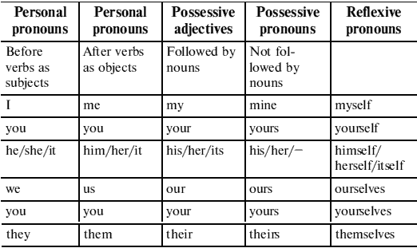
2.1. PERSONAL PRONOUNS

Test 1. Fill in the correct personal pronouns.

1. She is very handsome. I envy______.
2. They are not reliable. He doubts ______.
3. I taught her.______ learned it from ______.
4. We asked for his advice.______ advised______ not to come.
5. He dislikes her, and______ hates ______, it’s evident.
6. You should be there on time. I want______ to come on time.
7. She is from England,______ gave me lessons in English.
8. They are our friends. We invited______ to the party.
9. He wrote this letter. I recognized______ by his handwriting.
10. ‘Did you see the snake?’ ‘Yes, I saw______ and ______saw______.’
11. ‘Where’s Tom?’ ‘That’s ______over there.’
12. ‘Where’s my map?’ ‘I left ______on the desk.’
13. Look at that bird. ______always comes to my window.
14. ‘What time is ______?’ ‘______ is four.’
15. ‘Who is that?’ ______‘ ’s me.’
16. Hi, it is so nice to see ______again.
17. ______doesn’t matter.
18. I like when ______’s warm.
19. I find______ difficult to explain anything to him.
20. You are not guilty of ______, are you?

Test 2. Fill in the correct personal pronouns.

1. Who is that woman? Why are you looking at ______?
2. Do you know that man? I work with ______.
3. I’m talking to you. Please listen to ______.
4. These books are interesting. Do you want to look at ______?
5. He likes that camera. He’s going to buy ______.
6. Where are the tickets? I can’t find ______.
7. We’re going out. You can go with ______.
8. I don’t like dogs. I’m afraid of ______.
9. Where is he? I want to talk to ______.
10. These plums are bad. Don’t eat ______.
11. I want those pencils. Please give______ to ______.
12. They want the money. Please give______ to ______.
13. He wants the key. Please give______ to______.
14. He never drinks milk. He doesn’t like ______.
15. I often go to the parties. ______like ______.
16. ‘Where are my glasses?’ ‘______ are on the table.’
17. Where’s Dan? I want to talk to ______.
18. We’re going shopping. Do you want to go with ______?
19. I want to see him but______ doesn’t want to see ______.
20. I don’t know those people. Do you know ______?

2.2. POSSESSIVE PRONOUNS

Test 3. Fill in the correct possessive pronouns.

1. This book belongs to me. This is ______book.
2. The man put______ hand into pocket.
3. The cat ate______ food.
4. She took out______ purse and gave it to me.
5. My husband never wears______ glasses.
6. This is their car. That other car is______ too.
7. May I introduce to you one of______ colleagues?
8. There were a lot of people coming back from ______work.
9. Every season is beautiful in ______own way.
10. They would like a house of______ own.
11. I’ll try______ best, I promise.
12. Each country has______ own customs.
13. He cut______ finger this evening.
14. Lend me______ pen, I’ve lost ______.
15. They’re going to London with some students of ______.
16. This is not my pencil, ______is red.
17. I haven’t got a pen. Can you give me ______?
18. Take off______ coat, please.
19. I saw them. This is______ car.
20. Ann is married.______ husband works in a bank.

Test 4. Fill in the correct possessive pronouns.

1. They have two children but I don’t remember______ names.
2. I often see that man but I don’t know______ name.
3. Pete is a teacher but______ sister is a nurse.
4. Do you like______ job?
5. Do you think that most people are happy in ______jobs?
6. Put on______ hat when you go out.
7. We are going to invite all______ friends to the party.
8. ______favourite sport is tennis. She plays a lot in summer.
9. He didn’t have an umbrella, so she gave him ______.
10. He was very happy because we invited him to stay with us in______ house.
11. You’ll give me your address and I’ll give you ______.
12. I gave him my address and he gave me ______.
13. I saw Liz and Philip with______ son, Bill.
14. He invited Ann with ______parents.
15. We live with ______parents.
16. Oxford is famous for______ university.
17. I can’t find ______ticket.
18. The County of Kent is famous for______ gardens.
19. My sister plays tennis too but______ favourite sport is basketball.
20. Mr and Mrs Brown live in Paris but______ son lives in London.

Test 5. Fill in my, your, his, her, our.

Dear Sally,

Thank you for ______(1) letter. I’m fine and I hope that you and ______(2) parents are fine too. In your letter you ask me who helps me with ______(3) homework. I’ve got a brother, but he never helps me with ______(4) homework. My friend Joan has got a brother too and he always helps her with ______(5) homework, but then she helps him with cleaning ______(6) room. We do a lot of homework because ______(7) Maths teacher and ______(8) English teacher are very strict. ______(9) parents think it is okay to have a lot of homework. They always say, ‘ ______(10) teachers were strict too, and so we learned a lot.’ Well, so what can I do? Joan’s parents say that she needs some free time so that she can play or meet ______(11) friends. Thank you for ______(12) photo. I think you look so sweet.

Bye. I hope to hear from you soon.
Love,
Sarah

2.3. REFLEXIVE PRONOUNS

Test 6. Fill in the correct reflexive pronouns.

1. What will you do with______ this morning?
2. They were whispering among ______.
3. We should seldom speak of ______.
4. I drive the car ______.
5. Did you see the manager ______?
6. I often walk by ______.
7. His grandmother lives by ______.
8. The house______ is not worth much.
9. He has the habit of talking to ______.
10. He cut ______.
11. She told me the news ______.
12. The machine works by ______.
13. He______ told me that story.
14. They are making fools of ______.
15. She stretched______ out on the sofa.
16. She is interested only in ______.
17. She lives by ______.
18. Help______ to coffee.
19. Make______ at home!
20. He______ conducted the interview.

Test 7. Fill in the correct reflexive pronouns.

1. The girl decorated the room ______.
2. The winner looked very proud of ______.
3. She brought up her children by ______.
4. The cat is washing ______.
5. The children enjoyed______ when they visited Disneyland.
6. She was afraid of spiders, so she didn’t go into the room by ______.
7. She decided to do all the cooking ______.
8. He was asked to behave______ at school.
9. He shouted loudly to make______ understood.
10. Cats are very clean animals: they are always washing ______.
11. Doctors advised us that we have to exercise ______regularly in order to keep healthy.
12. In ______your problem is nothing to worry about.
13. She loves looking at______ in the mirror.
14. If you don’t behave ______, I shall put you all to bed early.
15. The music was so loud that I had to shout to make ______heard.
16. The teacher tried to make______ understood but she failed to get the class to understand.
17. We painted the room ______.
18. She was very pleased with ______when she got such a good job.
19. I think I’d go back to France. We really enjoyed______ there.
20. I don’t feel______ today. I don’t know what’s wrong with me.

2.4. DEMONSTRATIVE PRONOUNS
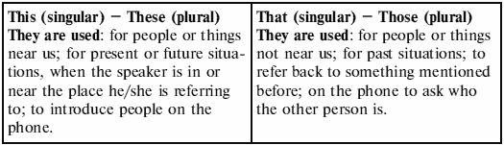

Test 8. Fill in the correct demonstrative pronouns.

1. Which flowers do you want? ______or ______?
2. Excuse me, is______ your bag?
3. They talked about ______and ______.
4. Which shoes do you like most? ______or ______?
5. ______’s why they accepted his proposal.
6. ______is Ann speaking.
7. After______ they decided not to come.
8. ______will do.
9. I’ll take______ books.
10. He’s been waiting______ three weeks.
11. She went to______ doctor and ______, no result.
12. ______day was the worst of his life.
13. I’m tired out.______ ’s why I’m going home early.
14. George likes Mary, but she doesn’t like him. ______’s what annoys him.
15. The engine starts and the light goes on. ______’s when you press the button.
16. ‘They’re getting engaged in April.’ ‘ ______’s marvellous.’
17. ______was the biggest mistake in his life.
18. ‘We’re moving to London.’ ‘ ______’s fantastic!’
19. ______ is what I think.
20. ______will help her to come in time.

Test 9. Fill in the correct demonstrative pronouns.

1. I never forget my holiday in London. ______was the holiday of a lifetime.
2. What are you doing ______ Sunday?
3. Didn’t you just love ______ striped trousers in the shop we just passed?
4. Mmm! ______ is the best cake I’ve ever tasted!
5. Do you see ______ boy over there? He’s my cousin.
6. Hello, ______ is Mr Cook. Can I speak to Mr Brown, please?
7. I can’t go out in ______ coat. It’s too tight.
8. ‘I’ve been accepted by my first choice of university.’ ‘Congratulations. ______ is fantastic!’
9. ______ were the days when we used to dance every night.
10. Don’t you think ______ new electronic diaries that we saw in the shop are really clever?
11. ‘______ belonged to my grandmother,’ said David as he slipped the ring onto Jane’s finger.
12. Don’t you think ______ jeans suit me?
13. ______ biscuits are delicious. Did you make them yourself?
14. ______ records you threw out were my original hits from the seventies!
15. Aren’t ______ girls over there your students?
16. ‘______ bike needs repairing.’ ‘______ is what I was trying to tell you.’
17. What do you think of ______ dress Ann was wearing last night?
18. I don’t go anywhere ______ week.
19. What’s ______ you’re reading?
20. ______ boy over there is my son.

2.5. SOME, ANY, NO, EVERY AND THEIR COMPOUNDS
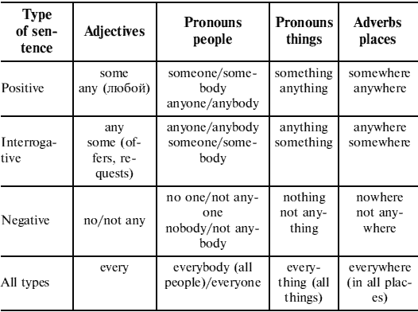

Test 10. Fill in some, any, no, every.

1. I’ve met ______ people, but I don’t have ______ real friends.
2. ‘Is there ______ petrol in the tank?’ ‘Yes, there must be ______ left.’
3. I’m sorry but there are ______ cookies left.
4. Have you ______ idea what time it is?
5. She had ______ games, but she didn’t have ______ computer games.
6. ‘Have you got ______ matches?’ ‘Yes, I think I’ve got ______ in my pocket.’
7. I can’t talk to you now. I’ve got ______ time.
8. Could you give me ______ examples?
9. I see him at work almost ______ day.
10. Everything was correct. There were ______ mistakes.
11. We get ______ letters from her month.
12. There weren’t ______ potatoes left.
13. There were ______ tomatoes left.
14. Would you like ______ milk?
15. I’d like to ask you for ______ advice.
16. Her car wasn’t ______ better than ours.
17. ______ of the information has already been used.
18. ______ country has a national flag.
19. It hasn’t made ______ difference.
20. ______ child can learn to read and write.

Test 11. Fill in some, any, no, every or their compounds.

1. Is there ______ meat in the fridge?
2. There isn’t ______ fish, either.
3. Can I have ______ coffee, please?
4. Take ______ book you would like to read.
5. She said ______ but I didn’t understand it.
6. He went to the shop but he didn’t buy ______.
7. There is ______ in the box. It’s empty.
8. I can do this job alone. I don’t need ______ to help me.
9. They’ve got ______ cheese but they haven’t got ______ bread.
10. I’m looking for my keys. Has ______ seen them?
11. ______ has taken my camera. I can’t find it.
12. He hasn’t got ______ eggs to make an omelette.
13. I heard a noise. There is ______ in the cupboard.
14. Look! ______ is sitting at the train station, waiting for a train!
15. ______ knows anything about her concert.
16. There was ______ selling tickets near the hall.
17. ______ Is in the room?
18. ______ student has to obey school regulations.
19. ‘Have you got ______ to tell me?’ ‘No, really’.
20. I walk with my friend’s dog ______ Sunday.

Test 12. Fill in some, any, no, every or their compounds.

1. There’s ______ milk in that jug. It’s empty.
2. She wanted ______ stamps but there weren’t ______ in the machine.
3. I’m afraid there isn’t ______ coffee left.
4. Is there ______ here who speaks Italian?
5. I’d like to buy ______ clothes but I haven’t got ______ money.
6. Would you like ______ juice?
7. She put her handbag down ______ and now she can’t find it.
8. Haven’t you got ______ friends in London?
9. We had to walk home because there was ______ bus.
10. Does ______ want a cup of tea?
11. I’ve looked ______ for my passport, but I can’t find it ______.
12. Come and have supper with us if you aren’t doing ______ tonight.
13. Are there ______ letters for me?
14. I’d like to make ______ friends, but I haven’t met _________ young people yet.
15. Jane is getting married to ______ she met on holiday.
16. Tommy is so nice. ______ likes him.
17. I can’t talk to you now. I’ve got ______ time.
18. I don’t know ______ about economics.
19. The accident looked serious but fortunately ______ was injured.
20. I am hungry. I want ______ to eat.

Test 13. Fill in some, any, no, every or their compounds.

1. I did Exercise 1 without ______ help.
2. ‘Would you like ______ more mineral water?’ ‘I don’t want ______ more.’
3. It was a public holiday, so there were ______ shops open.
4. My sister never has ______ trouble learning foreign languages.
5. This evening I’m going out with ______ friends of mine.
6. When we were on holiday, we went to the beach ______ day.
7. Why don’t you ask your father to lend you ______ money? I haven’t got ______.
8. Does ______ want a game of tennis?
9. What’s that smell? Is ______ burning?
10. I asked if ______ wanted an ice-cream, but ______ did, so I just bought one for myself.
11. Did ______ phone me while I was out?
12. Your face looks terribly familiar. I’m sure I have seen you ______ before.
13. She left the room without saying ______.
14. This doesn’t look a very nice restaurant. Can we go ______ else?
15. I have ______ more to say to you. Goodbye.
16. I have never been ______ more beautiful than Scotland.
17. ‘What do you want for supper?’ ‘ ______. I don’t mind.’
18. It was Sunday, and the town was deserted. ______ was in the streets, and ______ was open.
19. ‘Who was at the party?’ ‘ ______. Pete, Anna, James, Kathy, all the Smiths, Sally Beams and Sally Rogers.’
20. ‘Where do you want to go on holiday?’ ‘______ hot. I don’t care if it’s Greece, Spain, Italy or the Sahara, but it’s got to be hot.’
3. NUMERALS
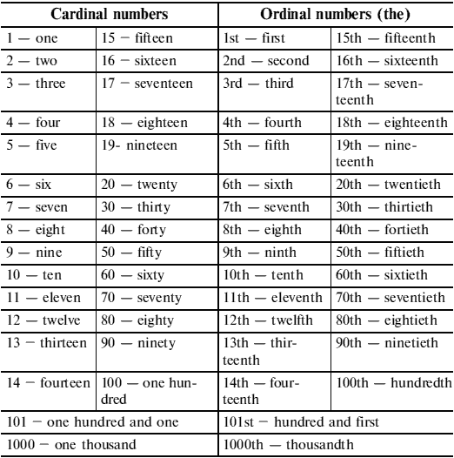
Test 1. What is the next number? Write it out in words.

1. 2, 4, 6, ______. 11. 10, 20, 30, ______. 21. 21, 24, 27, ______.
2. 7, 8, 9, ______. 12. 20, 40, 60, ______.
3. 2, 5, 8, ______. 13. 30, 60, 90, ______. 22. 31, 33, 35, ______.
4. 11, 13, 15, ______. 14. 60, 70, 80, ______. 23. 47, 48, 49, ______.
5. 3, 6, 9, ______. 15. 100, 200, 300, ______.
6. 4, 8, 12, ______. 16. 90, 80, 70, ______. 24. 53, 54, 55, ______.
7. 5, 10, 15, ______. 17. 3, 2, 1, ______.
8. 16, 15, 14, ______. 18. 0, 1, 2, ______. 25. 64, 63, 62, ______.
9. 13, 15, 17, ______. 19. 70, 80, 90, ______.
10. 20, 18, 16, ______. 20. 10, 30, 50, ______. 26. 77, 76, 75, ______.
27. 88, 89, 90, ______. 28. 100, 99, 98, ______.
29. 25, 50, 75, ______. 30. 15, 30, 45, ______.

Test 2. Write the following cardinal and ordinal numbers.

3, 4, 9, 11, 19, 30, 41, 42, 74, 85, 99, 100, 510, 900, 999, 1000, 2537, 5200, 10000, 1000000

Test 3. Use the ordinal numbers.

1. This is page one. This is the ______ page.
2. This is flat five. This is the ______ flat.
3. Where is chapter ten? Where is the ______ chapter?
4. He doesn’t remember page 20. He doesn’t remember the ______ page.
5. Book two is about travelling. The ______ book is about travelling.
6. He doesn’t understand lesson nine. He doesn’t understand the ______ lesson.
7. What picture is on page 21? What picture is on the ______ page?
8. She lives on floor eleven. She lives on the ______ floor.
9. Let’s talk about chapter eight. Let’s talk about the ______ chapter.
10. What is the date on page one hundred and one? What is the date on the ______ page?
4. ADJECTIVES AND ADVERBS
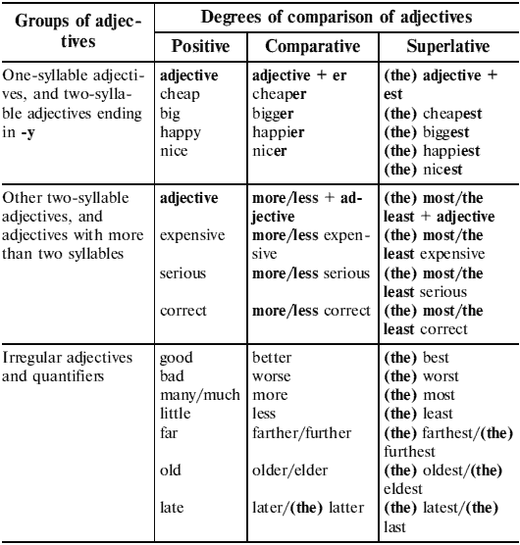
Test 1. Write the comparative and superlative forms of these adjectives.

1. cold – 6. comfortable – 11. new —
2. big – 7. easy – 12. expensive —
3. wonderful – 8. fat – 13. hungry —
4. happy – 9. bad – 14. hot —
5. good – 10. nice – 15. little —

Test 2. Write the comparative and superlative forms of these adjectives.

1. cheap – 6. red – 11. difficult —
2. far – 7. noisy – 12. few —
3. hot – 8. terrible – 13. old —
4. cheerful – 9. late – 14. sleepy —
5. pretty – 10. bad – 15. thin —

Test 3. Complete the sentences with а necessary form of the words in brackets.

1. Your TV is much (good) than ours.
2. This is the (bad) film he’s ever seen.
3. His accent is (correct) than yours.
4. A woman seems to get (young) every year.
5. He’s the (fat) person in his family.
6. This is the (tasty) meal I’ve ever eaten.
7. She has a friend who’s much (pretty) than her.
8. She’s the (beautiful) in the class.
9. A friend of mine married a girl who is much (young) than him.
10. Everest is the (high) mountain in the world.
11. The (bad) thing in the world is dishonesty.
12. I think she is the (good) person who ever lived.
13. She is (tall) than her sisters.
14. What is the (fast) car in the world?
15. Her flat is (small) than ours.

Test 4. Complete the sentences with а necessary form of the words in brackets.

1. Your English is improving. It’s getting (good) and (good).
2. Who is the (famous) person in the world?
3. The meal cost (little) than I expected.
4. Are you the (old) in your family?
5. There are (few) public holidays in Great Britain than in other European countries.
6. He was as (white) as а sheet.
7. This cartoon is (funny) than that one.
8. Who is the (good) student in the class?
9. It was an awful day. It was the (bad) day of my life. 10. Jane is two years (old) than Jack.
11. She is not so (nervous) as her brother.
12. It is the (busy) time of the year.
13. I’d like to have а (big) car than my old one.
14. That’s the (far) I’ve ever run.
15. The exam was quite difficult – (difficult) than we expected.
16. The (great) national holiday in our country is Victory Day.
17. Hard beds are (healthy) than soft ones.
18. She is the (slim) girl in our group.
19. Which month is the (short) in а year?
20. What is the (late) news?

Test 5. Complete the sentences with а necessary form of the words in brackets.

1. These cakes are probably the (good) in the world.
2. I am (happy) than I have ever been.
3. The game will certainly be much (exciting) than it was last year.
4. For (far) information, please write to the above address.
5. The (old) member of her family is her Granny.
6. He did very badly in the exam – (bad) than expected.
7. He was the (fat) man 1 had ever met.
8. This is the (attractive) room in the whole house.
9. Our new house is (big) than the one we used to live in.
10. Jill can run as (fast) as Jack.
11. My brother has (much) money than I have.
12. This is the (bad) weather so far this year.
13. Travelling by train is (comfortable) than travelling by bus.
14. The bedroom isn’t so (light) as the living-room.
15. Tom is the (reserved) boy in this class.
16. It’s getting (hard) and (hard) to find а job nowadays.
17. Summer is the (dry) period of the year.
18. ‘What time shall we leave?’ ‘The (soon), the (good).’
19. It’s (cheap) to go by car than by train.
20. Tom looks (old) than he really is.

Test 6. Complete the sentences with а necessary form of the words in brackets.

1. This exercise is too easy – can’t we try а (difficult) one?
2. England’s too cold in spring – let’s go to Spain where it’s much (warm).
3. She comes top in all the exams – she must be the (clever) girl in the class.
4. The temperature in July reaches 44 degrees – it’s the (hot) month of the year.
5. Let’s buy this video – it doesn’t cost that much – it’s (cheap) than the other one.
6. This book is not so (interesting) as that one.
7. California certainly has а (healthy) climate than New York.
8. When I passed my driving test, it was the (happy) day of my life.
9. Lying down in bed is (comfortable) than sitting on а hard chair.
10. That’s the (exciting) story I’ve ever heard.
11. I’d like to have а (good) pen than this one.
12. She is the (young) daughter in the family.
13. Australia is much (far) from Europe than I thought.
14. The (quick) we finish, the (soon) we’ll go home.
15. This is the (bad) restaurant in town; I’ll never come here again.
16. Actions speak (loud) than words.
17. The (good) things in life are free.
18. She was the (boring) person at the party and I sat next to her all evening. It was awful.
19. I have а (bad) headache today than I did yesterday.
20. You’re as (bad) as your sister.

Test 7. Complete the sentences with а necessary form of the words in brackets.

1. I could hardly keep awake – it was the (boring) film I’ve ever seen.
2. The (high) you climb, the (far) you fall.
3. Bill is (rich) than John.
4. Prices have gone up. Things aren’t as (cheap) as they used to be.
5. Tokyo is (big) than New York.
6. Tokyo is Japan’s (large) city.
7. You certainly look much (happy) than you did yesterday.
8. The day grew (hot).
9. This is his (good) novel. The other novels are much (bad) than this one.
10. Jane is the (young) of the three sisters.
11. I get on well with my (old) sister.
12. This is the (funny) bit of the film.
13. He is obviously (interested) in sport than I am.
14. It was the (expensive) hotel we had ever stayed in.
15. (Good) late than never.
16. Where is the (near) post office?
17. He was the (bad) pupil in the class.
18. Cats don’t usually live as (long) as dogs.
19. Children nowadays seem to be much (noisy) than they used to be.
20. Henry was the (big) of them.

Test 8. Choose the correct word.

1. I’m interesting/interested in collecting stamps.
2. Everyone is depressed/depressing by the awful weather.
3. I think that airports are exciting/excited places.
4. I’m tired/tiring. I think I’ll go to bed.
5. The journey was exhausted/exhausting!
6. It’s not surprising/surprised that she’s busy. She’s got six children.
7. The teacher was annoying/annoyed because I had forgotten to do my homework.
8. He loved the museum – he thought it was fascinating/ fascinated.
9. We went to the cinema but I was very boring/bored because I had seen the film before. 10. I like this monkey. It is very amused/amusing.

Test 9. Put an adjective from the box into each gap.
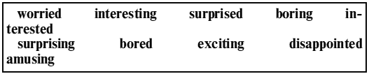
1. What programme are you watching? Is it _______?
2. ‘I’m going on a safari in Africa!’ ‘Really? How _______!’
3. What time did you get home last night? I didn’t know where you were. I was very _______ about you.
4. The children are _______ and they don’t know what to do.
5. It was quite _______ that he passed the exam.
6. I was _______ with the film. I expected it to be much better.
7. I don’t want to read this book. It is _______.
8. The cartoon was very _______. I laughed a lot.
9. I don’t want to go to the match. I’m not _______ in football.
10. We were very _______ when we heard the news.
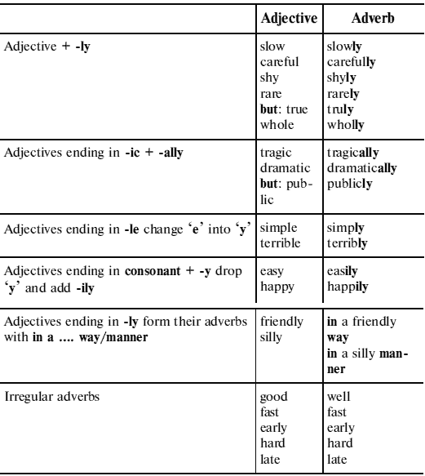
Test 10. Write the corresponding adverb.

1. quick – 6. careful – 11. hard —
2. bad – 7. nice – 12. slow —
3. late – 8. correct – 13. happy —
4. angry – 9. fast – 14. early —
5. good – 10. easy – 15. beautiful —

Test 11. Adjective or adverb? Choose the correct word.

1. I’m going to tell you something very important, so please listen careful/carefully.
2. Why are you angry/angrily? I haven’t done anything wrong.
3. Our teacher always explains the rules clear/clearly.
4. He was driving dangerous/dangerously.
5. Come on, Dave! Why are you so slow/slowly?
6. Jane is studying hard/hardly for her exam.
7. ‘Where is Tom?’ ‘He was here but he left sudden/suddenly.’
8. Her ideas are very useful/usefully.
9. He can understand people easy/easily.
10. Olga speaks English perfect/perfectly.
11. These jeans are very expensive/expensively.
12. Yesterday I came home very late/lately.
13. He always does his homework good/well.
14. We visit our relatives regular/regularly.
15. She always dresses nice/nicely.

Test 12. Adjective or adverb? Choose the correct word.

1. The boys played (quiet/quietly).
2. It was snowing (heavy/heavily) the day before yesterday.
3. He gave it a (careful/carefully) look.
4. He speaks (perfect/perfectly) English.
5. Have you seen your friend (recent/recently)?
6. She’s a (slow/slowly) runner.
7. She draws (good/well).
8. They bought a (nice/nicely) car.
9. She likes sitting (near/nearly) the fire.
10. She left too (late/lately) to catch the bus.
11. Have you seen Ann (late/lately)?
12. He tries very (hard/hardly) to make his family happy.
13. She (hard/hardly) plays the piano.
14. Computers are (wide/widely) used in schools nowadays.
15. I think she’s a (pretty/prettily) good singer.

Test 13. Adjective or adverb? Choose the correct word.

1. Use this chair if you want to sit comfortable/comfortably.
2. It’s not easy/easily to play football.
3. These flowers smell so strange/strangely.
4. He talked so polite/politely and danced so beautiful/ beautifully.
5. The apples taste sweet/sweetly. Help yourself!
6. I always feel happy/happily when the sun is shining.
7. Let’s discuss this idea serious/seriously.
8. ‘How are you?’ ‘I am very good/well, thank you.’
9. His English is perfect/perfectly. He always speaks correct/correctly.
10. You look upset/upsetly. What’s the matter?
11. The driver was driving too fast/fastly.
12. ‘I feel like going to a disco tonight.’ ‘That sounds great/greatly! Let’s go.’
13. It rained very heavy/heavily in London last night.
14. Quiet/Quietly he opened the door.
15. Those oranges look nice/nicely. Can I have one?

Test 14. Complete each sentence using a word from the list.
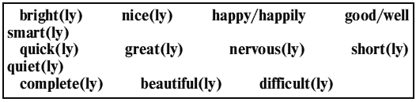
1. Mary sang _______ at the concert last night. She is a very _______ singer.
2. Our holiday was too _______. The time passed very _______.
3. What _______ flowers! They smell _______ very too!
4. He asked me to ring back but I _______ forgot about it.
5. The children played _______ in the garden. We could hear them laughing.
6. You’re speaking very _______. I can’t hear you.
7. Linda likes wearing clothes. She always looks _______!
8. It is a warm day and the sun is shining _______.
9. The exam was very _______ and I felt very _______.
10. This little boy can’t ride a bicycle very _______. He is just learning.

Test 15. Put the adjectives in brackets into the correct form.

New York is the (1)(large) city in the US. Perhaps, with all its suburbs, it is the (2)(big) city in the world. It is one of the (3)(important) industrial cities in the country. Some of the (4)(old) historic buildings are there. Some of the buildings in New York City are the (5)(high) buildings in the whole world. Now New York includes five boroughs: Manhattan, the Bronx, Queens, Brooklyn and Richmond. Manhattan is the (6)(small) in size but it is the heart and source of American policy. Perhaps, the (7)(expensive) office buildings in the world are there. The Bronx is a (8)(residential) than industrial part of the city. Queens is both residential and industrial area. New York’s two (9)(big) airports are both there. Brooklyn has (10)(many) people than any other part of the city – about 3, 000, 000. It is mostly a district of middle class people. New York has the (11)(great) number of factories, the (12)(large) banks and post offices. It sends out many letters and receives the (13)(heavy) mail bags. It is truly the (14)(famous) business city. New York is also called the cultural capital of the USA. There are a lot of museums in New York. One of the (15)(good) known is the Metropolitan Museum of Art.

Test 16. Put the adjectives in brackets into the correct form.

Fashion Through the Ages In the middle of the 18th century, some of the (1)(fashionable) rich young men in Britain copied the (2)(late) Italian fashions. They wore extravagant clothes, lots of make-up to look pale, and high wigs that were powdered and tied with ribbons.
In Europe at the end of the 18th century, women’s dresses began to get (3)(wide) and their hair began to get (4)(long). The (5)(wide) dresses measured nearly two metres, making it difficult to move around and sit down. To make themselves (6)(pretty), some women had enormous hairstyles. These were often decorated with flowers, feathers and even fruit!
After the First World War, the clothes of the swinging 1929s shocked many people. Fashions for women became (7)(relaxed) and (8) (free) than before. Their hair became much (9)(short) and dresses were not as (10)(long) and (11)(wide) as before. Their clothes became (12)(bright) and (13)(little) formal, to match the new music and dances like the Charleston.
Punk fashions were as (14)(aggressive) as punk music, which arrived in the 1970s. Punks chose the (15)(little) conventional hairstyles possible. They cut their hair in strange ways and often dyed it bright colours. They usually wore large boots, torn jeans and painted leather jackets.
5. TENSES
5.1. ACTIVE VOICE
The verb ‘to be’: Present, Past, Future
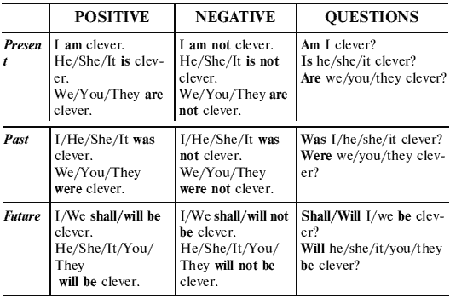

Test 1. Fill in am/is/are (present), was/were (past) or will be/won’t be (future) in the gaps.

1. She travels a lot. Yesterday she _______ in Paris. Today she _______ in London. Tomorrow _______ she in New York.
2. _______ you at home yesterday?
3. _______ you at home tomorrow?
4. I _______ in Great Britain last week.
5. ‘Are you ready yet?’ ‘Not yet. I _______ ready in five minutes.’
6. The weather _______ nice today.
7. My sister is going away for a few days, so she _______ at home tomorrow.
8. I _______ a pupil. I go to school.

9. _______ you in the country last summer?
10. It’s Tom’s birthday next Sunday. He _______ 11.
11. I _______ cold. Can you close the window, please?
12. You may visit Jane tomorrow. She _______ busy.
13. Where _______ Ann yesterday?
14. My brother and I _______ good tennis players. We like to play tennis very much.
15. ‘ _______ the soup _______ ready soon?’ ‘Yes, it _______ ready in a few minutes.’

Test 2. Fill in is, are, was, were.

1. There _______ three people in the photo.
2. There _______ a woman, a man and their child in our garden now.
3. There _______ an exhibition in our town last month.
4. I didn’t like the hotel because there _______ a lot of furniture in the room.
5. He was thirsty but there _______ no drinks in the fridge.
6. The furniture was very old, there _______ two chairs and a table in the room.
7. She is at her office now. There _______ a lot of people waiting to see her.
8. Today there _______ a lot of snow on the ground.
9. There _______ some chicken and fish in the fridge now.
10. _______ there any furniture in the room?
11. There _______ somebody in the kitchen now.
12. There _______ no one on the roof of the house at the moment.
13. There _______ no flowers in our garden last summer.
14. There _______ a sports centre near our house.
15. There _______ 26 letters in the English alphabet.

Have and Have Got
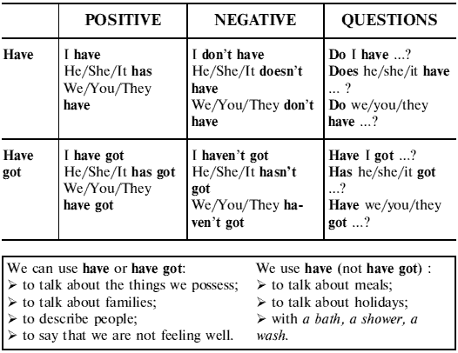

Test 3. Complete the sentences with is/isn’t, are/aren’t or has/have (got).

1. My brother _______ ten years old.
2. There _______ any flowers in the garden.
3. My sister _______ three children.
4. Tom never sees new films because there _______ a cinema in his town.
5. He _______ a good job in a bank.
6. _______ there a stadium near here?
7. How much _______ the ice-creams?
8. Can I _______ a cup of coffee, please?
9. My house _______ a garden and a balcony.
10. There _______ lots of good shops in this city.

Test 4. Fill in is/are/was/were/have/has.

1. Tom _______ lost his note-book.
2. This bridge _______ built ten years ago.
3. _______ you finished your work yet?
4. This town is always clean. The streets _______ cleaned every day.
5. Where _______ you born?
6. I just _______ made some coffee. Would you like some?
7. Cheese _______ made from milk.
8. This is a very old photograph. It _______ taken a long time ago.
9. Mike _______ bought a new car.
10. _______ Ann working today?

Present Simple/Present Continuous
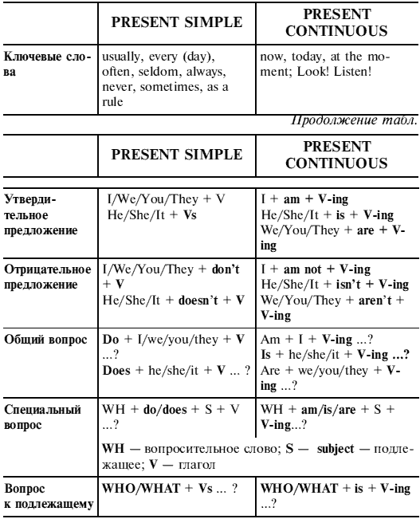

Test 5. Present Simple or Present Continuous?

1. Paul is good at tennis. He (plays/is playing) tennis very well.
2. It’s very noisy – Suzy (listens/is listening) to rock music.
3. Many birds (fly/are flying) south every summer.
4. Most students (don’t smoke/aren’t smoking) these days.
5. (Does Mr Black use/Is Mr Black using) the computer at the moment?
6. Jack usually (goes/is going) to work on Saturdays.
7. Dick isn’t at home now. He (helps/is helping) а student with his project.
8. (Does it rain?/Is it raining?) No, look, it’s sunny.
9. Cats (see/are seeing) very well in the dark.
10. You look nice, Ann. (Do you wear/Are you wearing) а new dress?
11. Japan (has/is having) many high mountains.
12. Every morning John (gets up/is getting up) at 7.00.
13. I’m sorry. I can’t help you at the moment. I (wash up/ am washing up).
14. (Do you go/Are you going) to the theatre tonight?
15. I (have/am having) а pain in my shoulder.
16. Jerry often (paints/is painting) pictures of different animals.
17. Derek is good at tennis but he (doesn’t play/isn’t playing) very often.
18. She’s not ready – she (cooks/is cooking) dinner.
19. (Do you always wear/Are you always wearing) glasses?
20. Turn the TV off – nо one (watches/is watching) it!

Test 6. Present Simple or Present Continuous?

1. Listen! I (want/am wanting) to ask you а few questions.
2. ‘Where is John?’ ‘He (has/is having) а smoke in the garden.’
3. How do you make this cake? It (tastes/is tasting) wonderful.
4. Those jeans (look/are looking) great on you!
5. Jane can’t come to the phone because she (washes/is washing) her hair.
6. I (don’t like/am not liking) football very much.
7. We usually (go/are going) to the seaside in summer.
8. I (think/am thinking) of going to university.
9. (Do you study/Are you studying) for your exams at the moment?
10. (Do you see/Are you seeing) my problem?
11. Can you be quiet, please? I (listen/am listening) to the radio.
12. He (thinks/is thinking) that school is boring.
13. They (meet/are meeting) for lunch once а month.
14. Ann paid for the boat so it (belongs/is belonging) to her now.
15. John! Answer the door, please! I (make/am making) dinner.
16. I (don’t enjoy/am not enjoying) cooking very much.
17. It (rains/is raining) а lot in this region in winter.
18. I (prefer/am preferring) volleyball to basketball.
19. (Do you know/Are you knowing) what’s happening?
20. We (have/are having) а house near the beach.

Test 7. Present Simple or Present Continuous?

1. The telephone (ring). Can you answer it?
2. Be quiet! I (watch) this film.
3. What he usually (have) for breakfast?
4. My parents (look) for а new country house now, because they (not want) to stay in Moscow in summer.
5. We usually (take) а bus to get to school.
6. ‘Why you (smile)?’ ‘I (have) nо homework today.’
7. Where you (go) on Sundays?
8. I always (wear) nice clothes at school. Today I (wear) а white blouse and а blue skirt.
9. ‘Jane! Where are you? What you (do)?’ ‘I (clean) my shoes.’
10. Nick (live) in Kiev. He often (phone) us when he (not be) busy.
11. ‘Why you (go) to bed? It’s only 10.00.’ ‘I always (go) to bed early.’
12. I can’t use the telephone now. It (not work).
13. It’s late. I (want) to go to sleep.
14. ‘How many languages she (speak)?’ ‘She (speak) six foreign languages.’
15. I (not think) Ann (like) me very much.
16. ‘Who is Richard?’ ‘He (stand) next to Jane.’
17. My father (work) in а bank, but today he is at home. He (write) letters.
18. ‘Where is Tom?’ ‘He (have) breakfast.’
19. John (not get) up very early on Sundays.
20. Oh, dear! This milk (taste) awful.

Test 8. Present Simple or Present Continuous?

1. Hurry up! Everybody (wait) for you.
2. ‘You (watch) TV?’ ‘No, you can turn it off.’
3. What you usually (do) at weekends?
4. The Volga (flow) into the Caspian Sea.
5. I’m tired. I (go) to bed now. Goodnight!
6. This train is never late. It always (leave) on time.
7. Don’t put the dictionary away. I (use) it.
8. Who is this man? What he (want)?
9. You look serious! What you (think) about?
10. He told me his address but I (not remember) it now.
11. Jane (not drink) coffee very often.
12. Please don’t make so much noise. Tom (do) his homework.
13. I (look) for Ann. You (know) where she is?
14. He never (tell) the truth. I (not believe) him.
15. ‘Tom usually (help) about the house?’ ‘No, he.’
16. You may phone Peter and ask him. I think he (not sleep) yet.
17. When your children usually (get) up?
18. Why that man (look) at us? You (recognize) him?
19. ‘Can you drive?’ ‘I (learn). My father (teach) me.’
20. Listen to those people! What language they (speak)?

Present Simple/Present Continuous/Future Simple
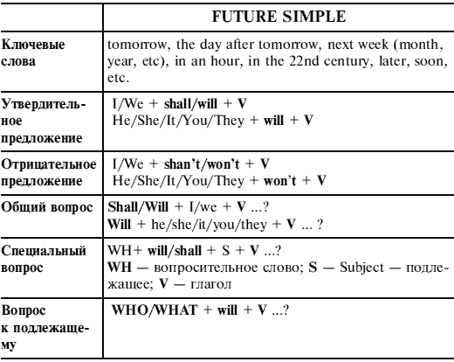
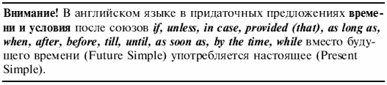
Test 9. Present Simple or Future Simple?

1. If the food (be) good, we’ll come here again.
2. What will you do if Ann (not pay)?
3. When I arrive, I (phone) you.
4. You (help) me if I have а problem?
5. Before you (go), leave my key on the table.
6. If you (not pay), you’ll get into trouble.
7. As soon as Linda (arrive), call me.
8. What you (say) if Peter asks?
9. If you don’t go away, I (call) the police!
10. I (not wait) if he is late again.
11. If he (miss) the last train, he’ll spend the night in а hotel.
12. What will you do if the weather (be) bad on holiday?
13. If I stay here, I (not be) happy.
14. If I (be) unhappy, I won’t work hard.
15. She’ll have some German lessons before she (go) to Berlin.
16. If Peter (ring), tell him I will never see him again.
17. He (be) happy if he wins his next match.
18. She won’t be able to go until she (feel) much better.
19. If the bus (not come) soon, I’ll be late for school.
20. I want to speak to him before he (go) out.

Test 10. Present Simple or Future Simple?

1. If he (speak) to Ann tomorrow, he (say) hello from you.
2. I’m sure he (talk) to you before he (leave) Moscow next week.
3. We (not go) to the seaside this weekend if the car (not be) repaired.
4. We (have) some food when we (finish) the housework.
5. As soon as we (arrive), we (give) you а call.
6. She (feel) much happier when she (get) her exam results.
7. There (be) а short break before the film (start).
8. We (not go) out until the weather (improve).
9. When he (see) her, he (give) her the message.
10. What you (do) if you (not get) the job?
11. They (not know) until the letter (arrive).
12. Mike is а little boy. He (want) to be а pilot when he (grow) up.
13. Let’s have а drink before we (start).
14. Don’t worry if I (be) late tonight.
15. I don’t know when he (come) tomorrow.
16. He (phone) you tomorrow as soon as he (arrive).
17. I’m sure Ann will pass the exam. It’ll be very strange if she (not pass) it.
18. I wonder if Jane (come) to my birthday party next Saturday.
19. When he (come) home from school, he usually (have) dinner.
20. After Mary (finish) school, she (enter) the University.
Test 11. Present Simple, Present Continuous or Future Simple?

1. He (phone) you tomorrow when he (get) home from work.
2. ‘I (be) very busy now.’ ‘Why? What you (do)?’
3. Tom (not be) lazy. He (work) hard every day.
4. How often you (go) to the theatre?
5. We (go) to England for our holiday next year.
6. Wait for me! I (come) as soon as I (finish).
7. ‘You (work) hard today!’ ‘Yes, I have а lot to do.’
8. ‘What he usually (do) at weekends?’ ‘He usually (play) tennis.’
9. I (read) а very interesting book at the moment.
10. He is enjoying his holiday. He (have) а nice room in the hotel.
11. You (be) hungry? You (want) something to eat?
12. When I (come) home tomorrow, all my family (be) at home.
13. ‘Where is Ann?’ ‘She (have) а bath.’
14. You (see) that man over there? It’s our new teacher.
15. Look! Kate (dance) again. She (dance) every day.
16. How long it usually (take) you to get to school?
17. John (not go) for а walk today until his mother (come) back from work.
18. You (understand) me now?
19. ‘Would you like а cigarette?’ ‘No, thanks. I (not smoke).’
20. Let’s go out! It (not rain) any more.

Test 12. Present Simple, Present Continuous or Future Simple?

1. ‘When he (get) up every day?’ ‘He (get) up at 8 o’clock.’
2. They (not drink) coffee now. I (think) they (watch) TV.
3. When he (return) to London next week, he (call) us.
4. Our friends always (go) to the country for the weekend.
5. Look! The kitten (play) with its tail.
6. What your brother usually (drink) in the evening?
7. We (have) an English lesson now.
8. ‘Listen! Who (speak) in the next room?’ ‘I (listen) very attentively, but I (hear) nothing.’
9. If it (not rain) tomorrow, we (not stay) at home.
10. Don’t go out: it (rain) heavily. You (get) wet through if you (not take) an umbrella.
11. ‘Have you done your homework?’ ‘Yes, I have. And now I (want) to watch TV.’
12. I (have) no time now, I (have) dinner.
13. ‘Where your sister (be) now?’ ‘She (do) her homework in the next room.’
14. Why she (come) home so late tomorrow?
15. What you (do) now? I (see) that you (not sleep).
16. Before he (start) for London tomorrow, he (visit) our office.
17. Nick (know) English rather well now.
18. When your lessons usually (begin) on Monday?
19. Tomorrow he (go) to the library after he (finish) his homework.
20. ‘Where you (be) tomorrow?’ ‘I (be) at home.’

Past Simple/Present Perfect
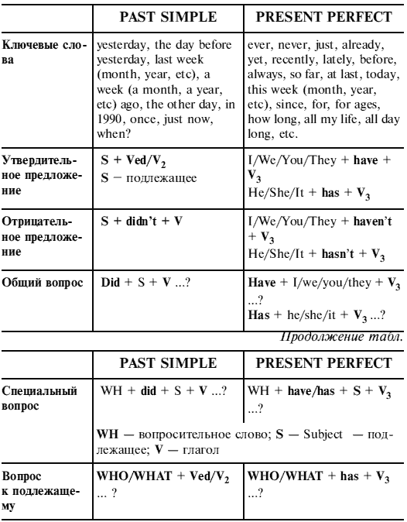

Test 13. Past Simple or Present Perfect?

1. Tom (didn’t meet/hasn’t met) his sister since he was а child.
2. Olga (lived/has lived) in England last year.
3. I (lost/have lost) my key. I can’t find it anywhere.
4. Look! Somebody (broke/has broken) my pen.
5. How many plays (did Shakespeare write/has Shakespeare written)?
6. Do you know about Jane? She (gave up/has given up) smoking.
7. I’m looking for Mike. (Did you see/Have you seen) him?
8. Your car looks great. (Did you wash/Have you washed) it?
9. Mr. Clark (worked/has worked) in а bank for 15 years. Then he gave it up.
10. I don’t know this young woman. We (never met/have never met) before.
11. When (did you write/have you written) this poem?
12. Chaikovsky (was/has been) а great Russian composer.
13. Mary isn’t at home. She (went/has gone) shopping.
14. (Did you see/Have you seen) this film? It’s fantastic!
15. Oh! I (cut/have cut) my finger. It’s bleeding.
16. Where (were you/have you been) born?
17. My parents (got/have got) married in а small village.
18. Agatha Christie (wrote/has written) 68 novels, 17 plays and more than а hundred stories.
19. I’m very hungry! I (didn’t eat/haven’t eaten) anything today.
20. When sending the telegram she (forgot/has forgotten) to write her name.

Test 14. Past Simple or Present Perfect?

1. It (not snow) this week.
2. You (see) the news on television last night?
3. Mike (leave) school in 1999.
4. I don’t know where my brother is. You (see) him?
5. ‘Where is your key?’ ‘I don’t know. I (lose) it.’
6. We (visit) the local museum the other day.
7. Ann is on holiday. She (go) to France.
8. When the last train (leave)?
9. ‘Would you like something to eat?’ ‘No, thanks. I just (have) lunch.’
10. The weather (be) good when you (be) on holiday?
11. We (not see) each other for а long time.
12. It’s the most interesting book I ever (read).
13. He (drink) too much coffee today.
14. What you (do) at the weekend?
15. John is hungry. He (not eat) anything since breakfast.
16. She (not go) to the library three days ago.
17. How long you (know) Bill?
18. Olga always (want) to visit Great Britain.
19. You (hear) from Jack recently?
20. Mark Twain (live) in the state of Missouri.

Test 15. Past Simple or Present Perfect?

1. ‘He ever (be) to London?’ ‘Yes. he _______. Several times.’
2. ‘What’s the news?’ ‘We (win) the tennis competition.’
3. ‘When you (speak) to him?’ ‘We (meet) yesterday.’
4. He (not call) me this month.
5. How long you (be) ill?
6. We (see) an interesting film the other day.
7. I (know) them for 2 years.
8. You (be) happy when you (be) a child?
9. I always (travel) by plane.
10. Where is Tom? You (see) him?
11. It’s the most interesting film I ever (see).
12. The construction (start) in April.
13. She (not call) me since she (arrive) in Moscow.
14. They (not go) to the cinema last week.
15. We (have) too many tests today.
16. What you (do) last Sunday?
17. William Shakespeare (write) a lot of plays.
18. I (lose) my exercise-book. I can’t find it anywhere.
19. You (go) to the cinema yesterday?
20. You (meet) Ann lately?

Test 16. Complete the text. Put the verbs in brackets into the Present Perfect or Past Simple tense.

I (1)(go) to New York for the first time three years ago.

I (2)(meet) an American girl of my age called Laura. She (3)(be) very friendly.
‘You (4)(be) to New York before?’ she asked me.
‘No, I ______(5),’ I said, and so Laura offered to help me.
‘You (6)(see) the Statue of Liberty yet?’
‘Yes, I (7)(see) it yesterday.’
‘OK. What about the Empire State Building?’
‘Yes, I just (8)(climb) to the top of it. It (9)(be) wonderful!’
‘What else you (10)(visit) in New York?’
‘Nothing really. I’d like to go shopping but I (11)(not find) any good shops yet.
‘Well, let’s go to Macy’s. It’s the best shop in New York. So, we (12)(take) the underground to Macy’s and I (13)(spend) a fortune! I (14)(leave) New York two weeks later after a terrific holiday. I (15)(enjoy) it very much.

Past Simple/Past Continuous/Past Perfect
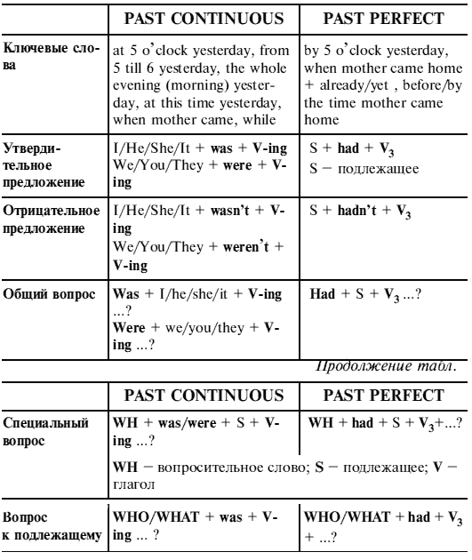

Test 17. Past Simple or Past Continuous?

1. While I (listened/was listening) to the radio, the telephone (rang/was ringing).
2. He (broke/was breaking) his leg when he (skied/was skiing) in the Alps.
3. They (listened/were listening) to the orchestra when the pianist (became/was becoming) ill.
4. Ann (played/was playing) the piano while Tom (painted/was painting) а picture.
5. We (saw/were seeing) an accident while we (waited/ were waiting) for the bus.
6. She (worked/was working) quietly at her desk when suddenly the door (opened/was opening) and her daughter (ran/was running) in.
7. While she (prepared/was preparing) lunch, she (cut/was cutting) her finger.
8. We (met/were meeting) while we (lived/were living) in Italy.
9. Which countries (did they visit/were they visiting) while they (travelled/were travelling) round the world?
10. (Did you work/Were you working) in the garden when I (came/was coming) home?
11. А strange man (walked/was walking) into the room. He (wore/was wearing) red trousers and а pink shirt.
12. (Didn’t you meet/Weren’t you meeting) your wife while you (worked/were working) in France?
13. I (saw/was seeing) you in the park yesterday. You (sat/ were sitting) on а bench.
14. They (lived/were living) in Canada when they (met/ were meeting) each other.
15. While I (listened/was listening) to music, my brother (did/was doing) his homework.
16. What (did you write/were you writing) when your computer (crashed/was crashing)?
17. As he (passed/was passing) the bank, а man in а mask (knocked/was knocking) him onto the ground.
18. Why (didn’t they visit/weren’t they visiting) me while they (stayed/were staying) in London?
19. Jack (drove/was driving) home from work when he (saw/was seeing) the accident.
20. Tom (arrived/was arriving) while the children (had/ were having) their bath.
Test 18. Put the verbs in brackets into the Past Continuous or the Past Simple Tense.

1. ‘What you (do) when the phone (ring)?’ ‘I (watch) television.’
2. ‘Was Jane busy when you came to see her?’ ‘Yes, she (study).’
3. ‘What time Tom (come) yesterday?’ ‘He (come) while I (have) breakfast.’
4. ‘Was Mary at school last week?’ ‘No, she (not go) to school. She was ill.’
5. ‘How fast you (drive) when the police (stop) you?’ ‘I don’t know exactly but I (not drive) very fast.’
6. ‘Your team (win) the football match yesterday?’ ‘No, the weather was very bad, so we (not play).’
7. ‘How you (break) the window?’ ‘We (play) football and the ball (hit) the window.’
8. ‘You (see) Jenny last night?’ ‘Yes, she (wear) a very nice jacket.’
9. ‘What you (do) at 10 o’clock on Sunday?’ ‘I still (sleep).’
10. ‘I (lose) my key last night.’ ‘How you (get) into your room then?’

Test 19. Past Simple or Past Continuous?

Yesterday I (1)(get) up at 7 а.m. That morning, I (2)(walk) to work. I (3)(not want) to go by bus because the sun (4)(shine) brightly and the birds (5)(sing) merrily. While I (6)(walk) past the supermarket, I (7)(see) something strange. А man (8)(pass) me and he (9)(sing) а football song very loudly, on his own! He (10)(continue) for а few minutes. Then he (11)(meet) а friend and (12)(stop) singing. I (13)(turn) round the corner and (14)(see) а friend of mine. He (15)(stand) at а bus stop and (16)(wait) for а bus. He (17)(tell) me that we (18)(be) late. At that moment а bus (19)(come) and we (20)(get) on.

Test 20. Past Simple or Past Perfect?

1. I (enjoyed/had enjoyed) the film even though I (saw/ had seen) it before.
2. I got up late that morning so when I (arrived/had arrived) at the station, the train (already left/had already left).
3. I couldn’t speak to them because when I (phoned/had phoned), they (went/had gone) out already.
4. We realized that we (met/had met) before as soon as we (saw/had seen) each other.
5. They (lived/had lived) in their house for twenty years when they (decided/had decided) to sell it.
6. My sister (bought/had bought) me а novel but I (already read/had already read) it.
7. As soon as I heard his voice, I (knew/had known) we (met/had met) before.
8. When I (opened/had opened) the door, the lesson (already began/had already begun).
9. She (painted/had painted) the wall before the children (came/had come) home.
10. The pupils (didn’t finish/hadn’t finished) the test when the bell (rang/had rung).
11. I (met/had met) Ann а week ago. She (just returned/ had just returned) from а business trip.
12. As soon as I (heard/had heard) а cry, I (ran/had run) out of the room.
13. I (tried/had tried) to phone John in the morning, but he (already left/had already left).
14. The children (didn’t clean/hadn’t cleaned) the room before their parents (came/had come) home.
15. I (finished/had finished) writing the project at 6 o’clock yesterday.
16. I (wrote/had written) the composition by 6 o’clock yesterday.
17. The teacher (understood/had understood) that the pupils (didn’t do/hadn’t done) their homework.
18. When my brother (returned/had returned) home, we (went/had gone) for а walk together.
19. He (told/had told) me that he (never played/had never played) football before.
20. She (was/had been) а nurse before she (became/had become) а doctor.

Test 21. Past Simple, Past Continuous or Past Perfect? Put the verbs in brackets into the correct form.

Yesterday Ann (1)(see) a strange man leaving the house. She (2)(notice) that he (3)(wear) a raincoat, and she (4)(wonder) why because it (5)(be) hot and sunny. The man (6)(not see) her. He (7)(begin) to walk away but he (8)(stop) suddenly and (9)(get) into a blue car that (10)(be) parked near the corner. Ann (11)(notice) a large bag by the wall. She was frightened as she (12)(watch) a programme about bombs the night before. So she (13)(decide) to phone the police. By the time they (14)(arrive), the man (15)(go).

Future Simple/Future Continuous/Future Perfect
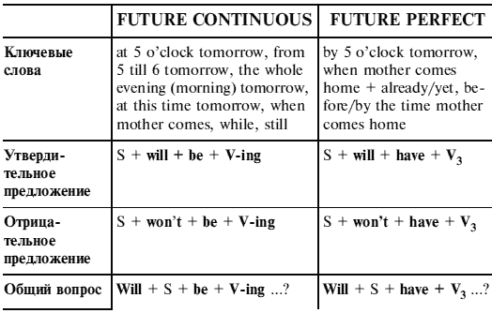
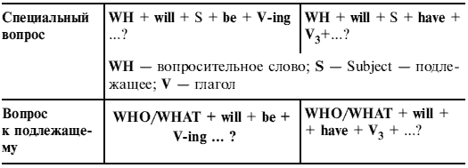
Test 22. Choose the correct form of the verb.

1. Please don’t call me this afternoon. I _______ some important work.
а) will do b) will be doing с) will have done
2. He will come round tomorrow if he _______ time.
а) will have b) have с) has
3. By the time we get to London we _______ over two hundred miles.
а) will drive b) drive с) will have driven
4. He _______ back to Moscow on the 15th of December.
а) will come b) come с) will have come
5. If they start school at four, most children _______ to read and write by the age of six.
а) will have learnt b) will be learning с) will learn
6. By the end of this century scientists _______ factories in space.
а) will be building b) will have built с) build
7. I think I’ll stay here until it _______ raining.
а) stops b) doesn’t stop с) will stop
8. When you arrive at their place, they won’t be ready. They _______ the meal.
а) will still cook b) will be still cooking с) will have still cooked
9. If he _______, I will let you know.
а) will come b) will have come с) comes
10. By 2020, he _______ here for twenty years.
а) will have worked b) will be working с) works
11. ‘Have you decided how to spend the prize money?’ ‘Well, I think we _______ а new car.’
а) buy b) will buy с) will have bought
12. This time tomorrow they _______ а film.
а) will watch b) will be watching с) will have watched
13. He _______ at 7 o’clock tomorrow.
a) will get up b) will be getting up c) will have got up
14. At 10 o’clock tomorrow, she _______ in her office.
a) will work b) will be working c) will have worked
15. We’re late. The film _______ by the time we get to the cinema.
a) already starts b) will already start c) will have already started
16. If we take a taxi, we _______ to the theatre in time.
a) come b) will come c) will be coming
17. This time next week I _______ in the sea.
a) will be swimming b) will have swum c) swim
18. Let’s wait for Jane to come back and then we _______ dinner.
a) have b) will have c) will have had
19. Phone me after 8 o’clock. We _______ dinner by then.
a) will have b) have c) will have had
20. We won’t start until everyone _______.
a) will arrive b) arrives c) will have arrived

Test 23. Put the verbs in brackets into the correct form (present or future).

When you (1)(take) a holiday with the Big Bus Company, you (2)(have) the time of your life. As soon as you (3)(arrive), you (4)(feel) as if you (5)(be) in a different world. While you (6)(stay) with us, we (7)(do) our best to ensure that your holiday (8)(run) smoothly and you (9)(not get) bored. The Big Bus Company (10)(have) something to offer for all ages and tastes. If you (11)(want) to play golf, ride or fish, our staff (12)(be) happy to make the necessary arrangements, or if you simply (13)(want) to relax and enjoy the breathtaking scenery we (14)(be) delighted to organise some guided walks. Before your holiday is over, you (15)(already/plan) your next visit.

Simple/Continuous/Perfect

Test 24. Mixed tenses: write the verbs in brackets in the correct form.

1. He (spend) last summer in the country.
2. What your brother (do) now?
3. He (not write) а composition by next Monday.
4. My sister (wash) the dishes every morning.
5. You (go) to the south next summer?
6. When I (ring) Mike up yesterday, he still (learn) а poem.
7. If you (not help) me, I (not do) this work by 5 o’clock tomorrow.
8. Yesterday he (go) for а walk only when he (do) his homework.
9. I (not go) to the cinema tomorrow, I (watch) TV the whole evening.
10. When I came to the station, the train already (leave).
11. We (not grow) tomatoes next summer.
12. You ever (be) to Piccadilly Circus?
13. What you (buy) at the shop yesterday?
14. If it (not rain) tomorrow, we (not stay) at home.
15. When he (come) tomorrow, I still (do) my homework.
16. Look! My friends (play) football.
17. He (not read) Turgenev since he was а pupil.
18. You (write) this letter by the time she (come) tomorrow?
19. ‘Lena usually (do) her homework at school?’ ‘No, she _______.’
20. What you (do) at 6 o’clock yesterday?

Test 25. Mixed tenses: write the verbs in brackets in the correct form.

1. I (not play) chess tomorrow.
2. He ever (be) to London?
3. Where you (go) now?
4. We (travel) around Europe last year.
5. If he (not see) her tomorrow, he (leave) her а note.
6. She usually (read) in the evening.
7. What you (do) at 6 o’clock tomorrow?
8. Yesterday I (find) the book which I (lose) in summer.
9. What your brother (do) every day?
10. When he (arrive) tomorrow, I still (sleep).
11. Listen! Somebody (play) the piano in the next room.
12. Where you (go) last summer?
13. He (not meet) Peter since they were pupils.
14. How many pages you (read) by 5 o’clock tomorrow?
15. When I left home, the snow already (stop).
16. What Nick (do) when you (ring) him up yesterday?
17. If he (not help) me, I (not write) а composition by next Monday.
18. I (not go) to the cinema yesterday, I (watch) TV the whole evening.
19. He (not do) his homework yet.
20. What you (buy) at the shop tomorrow?

Test 26. Mixed tenses. Put the verbs in brackets into the correct form.

А funny thing happened to me the other day. I (1)(be) in а hurry to get to work and I found that my car wasn’t working. I (2)(have) to rush out of the house to catch the bus. While I (3)(walk) along the street, I (4)(notice) а woman of about my age on the opposite side of the road. I looked at her again and I (5)(realize) that we (6)(meet) before. She arrived at the bus stop а couple of seconds after me. ‘She must be catching the bus, too,’ I thought. We (7)(just miss) the previous bus and we had fifteen minutes to wait before the next one. I looked at the woman behind me again and I was sure that I (8)(know) her.
‘Excuse me, have we met before? I’m sure that I (9)(recognize) you,’ I said. She looked а bit surprised, but she (10)(tell) me that her name was Angela Barker.
‘You (11)(study) history at Liverpool University from 1985 to 1988!’ I shouted.
‘That’s right!" she replied, ‘And you’re Claire….?’
‘Lewis. Well, my name was Lewis but I (12)(be) married now. What you (13)(do) nowadays?’ I asked.
‘Well, I (14)(work) in the Central Museum in town and I (15)(live) in this area, in George Street, for about three years,’ she replied.
‘You’re joking! I (16) (not believe) you. I live round the corner from there. We (17)(be) neighbours for three years and we (18)(never see) each other!’ I said.
‘I know, it’s incredible!’ she (19)(agree), ‘And I’m glad that you spoke to me because I wondered why you (20)(look) at me all the time!’

Perfect Simple/Perfect Continuous
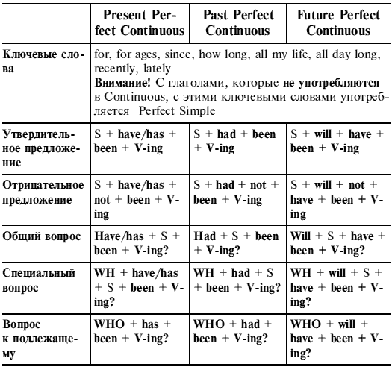
Test 27. Present Perfect Simple or Continuous? Choose the correct verb form.

1. John is reading a book now. He has (read/been reading) it for two hours. He has (read/been reading) 53 pages so far.
2. Ann’s clothes are covered in paint. She has (painted/ been painting) the ceiling. She has not finished it yet.
3. Jane is still doing her homework. She has (done/been doing) it all day long.
4. Have you ever (played/been playing) tennis?
5. Look! Somebody has (broken/been breaking) that window!
6. ‘Sorry I’m late.’ ‘That’s all right. I have not (waited/ been waiting) long.’
7. ‘Is it still raining?’ ‘No, it has (stopped/been stopping) raining.’
8. I have (lost/been losing) my address book. Have you (seen/been seeing) it anywhere?
9. My hands are very dirty. I have (repaired/been repairing) the car for two hours.
10. Mary has (written/been writing) ten letters today.
11. Have you (seen/been seeing) my bag anywhere? I have (looked/been looking) for it for ages.
12. How long have you (written/been writing) this composition?
13. They have (played/been playing) chess since 2 o’clock.
14. I have (known/been knowing) about it for a long time.
15. John has always (lived/been living) in London.
16. I haven’t (seen/been seeing) Tom since Monday.
17. Where have you been? Have you (played/been playing) football?
18. You have (driven/been driving) all day. Let me drive now.
19. Where is Tom? I haven’t (seen/been seeing) him today.
20. The British have (drunk/been drinking) tea since 1650.

Test 28. Present Perfect Simple or Continuous? Choose the correct verb form.

1. I have (broken/been breaking) your pen. I am very sorry.
2. ‘What’s the matter?’ ‘I have (read/been reading) in my room for hours, and I have got a headache.’
3. I am very tired! I have (worked/been working) all day, but I have not (finished/been finishing) yet.
4. I have (smoked/been smoking) since I was sixteen.
5. I have (smoked/been smoking) too many cigarettes today.
6. ‘Why are you out of breath?’ ‘I have (run/been running).’
7. I have (lost/been loosing) my note-book. Have you (seen/been seeing) it anywhere?
8. Someone has (eaten/been eating) my sweets. They are nearly all gone.
9. I have (waited/been waiting) for you for ages! Where have you been?
10. How many exercises have you (done/been doing) today?
11. This is the best book I have ever (read/been reading).
12. How long have you (known/been knowing) Jane?
13. How long have you (learnt/been learning) to drive?
14. I don’t know what Tom and Jack are doing. They have (argued/been arguing) all day.
15. You are so dirty! What have you (done/been doing)?
16. I have (painted/been painting) the living room for a week. It’ll be finished soon.
17. I have (painted/been painting) the living room. I finished it last night.
18. ‘Why is your hair wet?’ ‘ I have (swum/been swimming).’
19. I have (shopped/been shopping) all morning, but I have not (bought/been buying) anything.
20. The streets are all wet. It has (rained/been raining) all day long.

Test 29. Put the verbs in brackets into either the Past Simple, Present Perfect Simple or Present Perfect Continuous.

Ever since the day I (1)(decide) to move to London, I (2)(worry) whether the decision I (3)(take) was the right one. As I (4)(already sell) my house and (5)(arrange) а new job, it is too late to change my mind. However, since then I (6)(hear) а lot of negative things about living in the capital, and lately some of them (7)(begin) to bother me.
I (8)(grow up) in а fairly small town and I (9)(spend) all of my life there. I (10)(always want) to live in а big city and so when my company (11)(offer) me а job in their London office, I (12)(grab) at the chance. But according to а programme I (13)(just hear) on the radio, more and more реор1е (14)(stop) working in London recently, and а lot of large companies (15)(choose) to move away from the centre. Of course I (16)(tell) my parents that I’m moving and they (17)(accept) my decision, but when I (18)(tell) my friends they (19)(seem) rather shocked. Since then I (20)(hope) secretly that the company would tell me that the move was off!

Test 30. Past Perfect Simple or Continuous? Choose the correct verb form.

1. I knew the facts of the case because I had (read/been reading) the report.
2. My eyes ached because I had (read/been reading) for three hours.
3. The children were dirty. They had (played/been playing) in the garden, and they were covered in mud.
4. I was very nervous at the beginning of the match. I had never (played/been playing) before.
5. Donald was very angry. He had (worked/been working) in the kitchen all morning, and no one had offered to help him.
6. The roads were wet because it had (rained/been raining) all night.
7. He was broke. He had (spent/been spending) all his money.
8. His hands were covered in oil because he had (tried/ been trying) to fix the car all morning. Unfortunately, he had not (managed/been managing) to make it start.
9. I got to the meeting very late and everyone was waiting for me to start; the chairman told me they had (waited/ been waiting) for a whole hour.
10. When I arrived at the party, Mary had already (left/ been leaving).
11. We were good friends. We had (known/been knowing) each other for a long time.
12. They had (climbed/been climbing) for five hours before they reached the top of the mountain.
13. I had (felt/been feeling) sleepy all day so I went to bed early.
14. Ken gave up smoking two years ago. He had (smoked/ been smoking) for 30 years.
15. Ann had just (got/been getting) home when I phoned.
16. We were extremely tired at the end of the journey. We had (travelled/been travelling) for more than 24 hours.
17. I was sad when I sold my car. I had (had/been having) it for a very long time.
18. Mary was sitting on the ground. She was out of breath. She had (run/been running).
19. In the evening I was very tired because I had (cleaned/ been cleaning) my house since morning.
20. The house was dirty. They had not (cleaned/been cleaning) it for weeks.

Test 31. Future Perfect Simple or Continuous? Choose the correct verb form.

1. We are late. The film will already have (started/been starting) by the time we get to the cinema.
2. We will have (flied/been flying) non-stop for seven hours before we get to New York.
3. By the end of this year he will have (acted/been acting) for thirty years.
4. Next year John and Ann will have (been/been being) married for 25 years.
5. Mr. Jacobs will have (worked/been working) on this project for 3 years next month.
6. Yes, I make jam every week. I’ll have (made/been making) about 200 kilos by the end of the summer.
7. Ann always leaves for work at 8.30 in the morning. So she won’t be at home at 9 o’clock. She will have (gone/ been going) to work.
8. I hope they will have (repaired/been repairing) this road by the time we come back next summer.
9. His telephone is out of order. He is still repairing it. Tomorrow he will have (repaired/been repairing) his telephone for a week.
10. He spends all his time planting trees. He says that by the end of next year he will have (planted/been planting) 2,000.
11. We’d better wait till 14 December. David will have (had/been having) his exam by then, so he’ll be able to join us. 12. I am expecting an important letter and I think it will have (arrived/been arriving) by Thursday.
13. Jane will have (learnt/been learning) English for 5 years this summer.
14. By the end of the month he will have (climbed/been climbing) mountains for twenty years.
15. By the end of the month he will have (climbed/been climbing) 50 mountains.
16. Today is Tuesday. Rosie says she will have (finished/ been finishing) her composition by Saturday.
17. When Frank comes home, his mother will have already (cooked/been cooking) dinner.
18. By 6 o’clock Ted will have (played/been playing) football for 5 hours!
19. Wake me up by 9 o’clock! I’ll have (slept/been sleeping) long enough by then.
20. At the end of this term I will have (taught/been teaching) for six years.

Simple/Continuous/Perfect/Perfect Continuous

Test 32. Sequence of Tenses: choose the correct verb form.

1. The teacher asked who (is/was) present that day.
2. He realized that they (lost/had lost) their way.
3. She says she (will come/would come) in time.
4. He says he (has/had) a good camera now.
5. John said he (will leave/would leave) soon.
6. Ann said that she (is going/was going) to learn to drive.
7. He explained that he (stayed/had stayed) at home the day before.
8. My friend says he (has just returned/had just returned) from London.
9. He said that he (lived/had lived) in Moscow the year before.
10. I think the weather (will be/would be) fine next week.
11. He said he (was born/had been born) in 1955.
12. Bill asked if she (came/would come) the next day.
13. She said that she (can’t/couldn’t) come to the party.
14. I knew that he (is/was) a very clever man.
15. He said that they (were/had been) friends at school some years before.
16. I asked my sister what she (has bought/had bought) for my birthday.
17. He said he (is staying/was staying) at the ‘Rossiya’ hotel then.
18. I am sure you (must/had to) go to the meeting tomorrow.
19. The teacher promised that the pupils (read/would read) the text the next day.
20. I don’t know whether he (will come/would come) or not.

Test 33. Put the verbs in brackets into the correct tense.

1. ‘What you (do)?’ ‘I (read). I (read) for already two hours. I already (read) 100 pages.’
2. When I (leave) home yesterday, the snow already (stop), but a strong wind (blow).
3. How long you (wait) for me? I am really very sorry.
4. He said he (work) for a long time without achieving good results.
5. If he (ring) me up tomorrow, I (tell) him all about it.
6. ‘You ever (be) to the new stadium?’ ‘Yes, I (be) there last Saturday.’
7. At last the reply from my grandmother came, and my mother (tell) me she (come) soon.
8. He (help) his mother every day?
9. At this time tomorrow we (discuss) your report.
10. What you (do) when I came in?
11. He (teach) at school for five years when the war broke out.
12. Hi! What you (do) here since morning?
13. By the end of this year he (read) about two hundred pages.
14. When you (see) him last?
15. Don’t ring me up at 11 o’clock, I (sleep).
16. ‘You (find) your note-book?’ ‘No! I still (look) for it. I already (look) for it for two hours, but (not yet find) it.’
17. They (sail) down the river for many hours before they come to the village.
18. At last the librarian gave me the book which I (wait) for during two months.
19. He (write) the composition for three hours and he said he (finish) it soon.
20. On entering the drawing-room he (find) that his two friends (get) up and (wait) for him.

Test 34. Put the verbs in brackets into the correct tense.

1. Yesterday by 8 o’clock he (finish) all his work, and when I (come) at 9, he (read).
2. ‘When he usually (get up)?’ ‘He (get) up at seven o’clock.’
3. Come along, Henry, what you (do) now? I (wait) for you since morning.
4. The students (not write) a test tomorrow at 3 o’clock, as they already (write) it by then.
5. ‘What you (do) now?’ ‘I (prepare) for my report.’ ‘How long you (prepare) for it?’ ‘For two hours already.’
6. Yesterday he (wait) for half an hour when at last he (see) her at the end of the platform.
7. The teacher said that the pupils (read) the text the next day.
8. When I (come) home yesterday, my sister already (return) and (sit) at the fireplace looking through some magazines.
9. When he (come) to her place tomorrow, she still (pack) her suitcases.
10. This man is a writer. He (write) books. He (write) books since he was a young man. He already (write) eight books.
11. He (wait) for you for two hours already and said he (ring) you up later.
12. By the end of next month we (translate) ten articles.
13. ‘You ever (spend) your holidays in the Crimea?’ ‘Yes, I _____. I (be) there last year.’
14. ‘What he (do) next year?’ ‘After he (finish) school, he (enter) the University.’
15. ‘When you (see) Mary?’ – ‘I (see) her last week.’
16. At last I (do) all my homework: now I’ll go out.
17. They (work) hard for many hours before they are able to finish it.
18. What you (read) when I rang you up?
19. ‘You (learn) this poem?’ ‘No! I still (learn) it. I already (learn) it for two hours, but I (not yet learn) it.’
20. We could not go out because it (rain) hard since early morning.

Test 35. Put the verbs in brackets into the correct tense.

1. When I entered the room, her eyes (be) red because she (cry) for a long time.
2. She is very glad: she (finish) her composition at last.
3. When he (come) home tomorrow, mother still (cook) dinner.
4. Lena is a very good girl. She always (help) her mother about the house. Today she (help) her mother since morning. She already (wash) the floor. Now they (cook) dinner.
5. What you (do) at 5 o’clock yesterday?
6. ‘What Nick usually (do) in the evening?’ ‘He (read), (watch) TV and (play) chess.’
7. When I enter the Medical College, I already (study) English for more than ten years.
8. When I rang up Jim, he (read) my book for 2 hours, and said he (return) it to me soon.
9. ‘You (do) your homework?’ ‘No! I still (do) it. I already (do) it for 2 hours, but I (not yet do) it.’
10. ‘What you (do) tomorrow?’ ‘We (go) to the theatre if she (bring) tickets.’
11. You (play) football for already 3 hours. Go home and do your homework!
12. When I (ring) up Mike yesterday, he still (learn) the poem which he (begin) learning at school.
13. Boris said that he (spend) his next holidays in the Crimea.
14. ‘You (see) Mary today?’ ‘Yes, I ______. I (see) her 2 hours ago.’
15. When you come to my place tomorrow, I (watch) TV. I already (do) my homework by the time you (come).
16. ‘Where you (spend) last Sunday?’ ‘I (spend) it in the country.’
17. ‘What you (read)?’ ‘I (read) a magazine.’ ‘How long you (read) it?’ ‘For half an hour.’
18. By 8 o’clock yesterday I (do) my homework and at 8 I (play) the piano.
19. How many pages you (read) by five o’clock tomorrow?
20. When I (come) home yesterday, he (tell) me he (wait) for me for already an hour.

Test 36. Read the text and put the verbs in brackets into the correct past forms.

Last year Sam and Joanna decided to buy a house. They (1)(save up) for ages, and by the end of April they (2)(put by) enough for the deposit on a house. They (3)(live) in a tiny flat at the time and Joanna (4)(insist) that she wanted a house with a big garden. They (5)(search) for only a few days when they found exactly what they (6)(look for) – a two-bedroomed house in nearly an acre of garden. Unfortunately the owner (7)(ask) much more than they (8)(be) willing to pay, and when they (9)(look) more closely at the interior, they (10)(see) that whoever (11)(live) there before, (12)(make) an absolute mess of the walls and floors. Still Joanna (13)(like) the garden and the location so much that she (14)(manage) to convince Sam that, despite the price, it (15)(be) the perfect house for them.

Test 37. Read the text and put the verbs in brackets into the correct form.

Farmers, as we all (1)(know), (2)(have) а hard time of it in Britain lately, and (3)(turn) to new ways of earning income from their land. This (4)(involve) not only planting new kinds of crops, but some strange ways of making money, the most unusual of which has got to be sheep racing. Yes, you (5)(hear) me correctly! А farmer in the West of England now (6)(hold) sheep races on а regular basis, and during the past year over 100 000 people (7)(turn up) to watch the proceedings. ‘I (8)(pass) the farm on my way to the sea for а holiday,’ one punter told me, ‘and I (9)(think) I’d have а look. I (10)(not believe) it was serious, to tell you the truth.’

According to а regular visitor, betting on sheep is more interesting than betting on horses. ‘At proper horse races everyone (11)(already study) the form of the horses in advance, and there are clear favourites. But nobody (12)(hear) anything about these sheep! Most people (13)(find) it difficult to tell one from another in any case.’

‘I (14)(stay) to watch the races, and I must admit that I (15)(find) it quite exciting. In а typical race, half а dozen sheep (16)(race) downhill over а course of about half а mile. Food (17)(wait) for them at the other end of the track, I ought to add! The sheep (18)(run) surprisingly fast, although presumably they (19)(not eat) for а while just to give them some motivation. At any rate, the crowd around me (20)(obviously enjoy) their day out at the races, judging by their happy faces and the sense of excitement.’

Test 38. Read the text and put the verbs in brackets into the correct form.

Ask hundreds of people what they (1)(do) on а certain day in August next year, or the year after, and there (2)(be) only one reply. Provided of course that the people you (3)(ask) (4)(belong) to the Elvis Presley Fan Club. Although the King of Rock and Roll (5)(die) nearly two decades ago, his fans (6)(meet) every year since then outside his home in Memphis, Tennessee, to show respect for the singer they (7) (love) so much. Fans like Jean Thomas, from Catford in South London. Jean (8)(visit) Gracelands, the house where Elvis (9)(suffer) his fatal heart attack, twice in the past five years. ‘The first time I (10)(borrow) the money from my Mum, as I (11)(not work) then. But two years ago I (12)(get) married and since then I (13)(work) in my husband Chris’s garage. Chris and I (14)(go) together last year, and we (15)(think) of spending two or three months in the USA next year. I (16)(always want) to visit some of the places where Elvis (17)(perform). Like Las Vegas for example.’ Jean says that Elvis (18)(be) her obsession ever since she (19)(be) ten years old, and she (20)(own) every single one of his records, good and bad.

5.2. PASSIVE VOICE
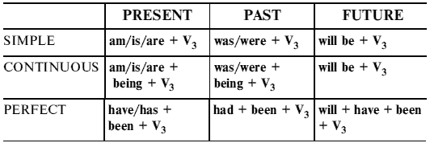
Test 39. Put the verbs in brackets into the correct passive form.

1. You (take) around the city tomorrow.

2. Melons (grow) in the south of France.

3. The ship-building industry (reduce) since 1970.

4. He (shock) by the story at our last meeting.

5. This text must (translate) tomorrow.

6. In 1980 the Olympic Games (hold) in Moscow.

7. The room (not clean) yet.

8. Mercedes cars (make) in Germany.

9. The furniture should (dust) every week.

10. The streets (decorate) at the moment.

11. The translation (do) in time. Everyone was glad.

12. We (impress) by her acting at her last concert.

13. More raw materials (import) in the future.

14. Your health can (improve) with more exercise.

15. The books have to (return) to the library.

16. The letters (send) this week.

17. Today a lot of electronic goods (manufacture) in SouthEast Asia.

18. The examination (hold) next Friday.

19. Coal (mine) in Wales for centuries.

20. Where’s the radio? It (repair)?

Test 40. Put the verbs in brackets into the correct passive form.

1. When the telephone (invent)?

2. I can’t give you these articles.They (translate) now.

3. The letter (not write) tomorrow.

4. English (speak) all over the world.

5. She showed me the picture that (paint) by her husband.

6. My dress is clean now. It (wash).

7. All the questions on the paper must (answer).

8. These houses (build) in 1500.

9. Tomorrow by 3 o’clock everything (prepare).

10. Rugby (play) since 1845.

11. My house (paint) the whole day yesterday.

12. Flowers usually (sell) in the streets.

13. This film (discuss) at the next lesson.

14. Your composition (write) yet?

15. I couldn’t use my hotel room because it (not clean) yet.

16. It was very dark. Nothing could (see).

17. What usually (make) from milk?

18. I’m sure that the invitation (receive) by next Sunday.

19. Wait a little! Your question (discuss) now.

20. The UK (wash) by the Atlantic Ocean and the North Sea.

Test 41. Put the verbs in brackets into the correct passive form.

1. When the first restaurant (open) on the Moon?

2. Pineapples (not grow) in England.

3. The room (clean) yet? Can I use it?

4. When you return from your journey, this novel already (publish).

5. Where are the skis? They (repair) now?

6. The results (announce) tomorrow morning.

7. All the work (do) by 6 o’clock yesterday.

8. The plants should (water) every week.

9. What kinds of medicines usually (make) from plants?

10. Coca-Cola (produce) since 1895.

11. When the first car (construct)?

12. When I came to the office, the text already (translate).

13. A new school (build) in our district now.

14. Your shirt is dirty. It must (clean).

15. The statue broke while it (move) to another room.

16. These books (buy) two days ago.

17. Don’t worry! Your keys (find). Here they are!

18. Russia (rule) from Moscow.

19. When I came, the film still (discuss).

20. I think the report (not write) by next Monday.

Test 42. Read the text and put the verbs in brackets into the correct passive form.

Policeman Shot Dead in Training A police officer has died after suffering a gunshot wound to the chest in a training exercise in Manchester. The male officer died in hospital after the incident, which took place in Thorp Road, about a mile from the city centre, at about 11.35. The officer (1)(take) to North Manchester General Hospital, where he (2)(pronounce) dead later. Police sealed off entrances to the site but forensic officers could (3)(see) in the yard outside the warehouse, which (4)(cordon) off with yellow tape. An ambulance was also on site. It was not immediately clear whether the officer (5)(shoot) accidentally by one of his own colleagues. A Greater Manchester Police spokesman said the training exercise (6)(hold) in a “reasonably routine” way. The Independent Police Complaints Commission (7)(notify) about the fatal shooting and three investigators (8)(send) to the scene to carry out an initial assessment. The area where the incident happened is the site of a disused former electronics factory, which (9)(know) locally as the Sharp Building. The factory (10)(surround) by other industrial units and wasteland.

5.3. ACTIVE OR PASSIVE?

Test 43. Active or passive? Choose the correct verb form.

1. The book (wrote/was written) by Hardy.

2. Four people (have killed/have been killed) in а train crash.

3. А famous architect (was built/built) the bridge.

4. The house (bought/was bought) by а pop-star.

5. Local police (have been arrested/have arrested) the bank robber.

6. I (arrived/was arrived) last Friday.

7. The room (will сlеаn/will be cleaned) later.

8. ‘Did you go to the party?’ ‘No, I (didn’t invite/wasn’t invited).’

9. It’s а big company. It (is employed/employs) two hundred people.

10. Tom (has lost/has been lost) his key.

11. Many accidents (caused/are caused) by dangerous driving.

12. А cinema is а place where films (show/are shown).

13. People (aren’t used/don’t use) this road very often.

14. This house (built/was built) in 1930.

15. This situation is serious. Something must (do/be done) before it’s too late.

16. My car (has disappeared/has been disappeared).

17. Have you heard the news? The President (has shot/has been shot).

18. А new supermarket (will be built/will built) here next year.

19. (in а shop) ‘Can I help you, madam?’ ‘No, thank you. I (am serving/am being served).’

20. When I came to the party, John (had already been gone/ had already gone) home.

Test 44. Active or passive? Put the verbs in brackets into the correct form.

1. The computer (use) at the moment.

2. Your house looks different. You (paint) it?

3. Water (cover) most of the Earth’s surface.

4. Most of the Earth’s surface (cover) by water.

5. When we got to the stadium, we found out that the game (cancel). So we couldn’t see the match.

6. The park gates (lock) at 6.30 p.m. every evening.

7. The letter (post) a week ago but it (arrive) yesterday.

8. Ann couldn’t use her office yesterday. It (redecorate) the whole day.

9. At 10 o’clock tomorrow, Ann will be in her office. She (work) then.

10. Ron’s parents (die) when he was very young. He and his sister (bring up) by their grandparents.

11. While I was on holiday, my camera (steal) from my hotel room.

12. Look! A new hospital (build) near the airport.

13. Where these photographs (take)? In London? You (take) them?

14. Two people (arrest) last night.

15. The computer broke down yesterday, but now it’s OK. It (work) again. It (repair).

16. The man next door (disappear) six months ago. Nobody (see) him since then.

17. The room looked nice. It (clean).

18. There’s somebody walking behind us. I think we (follow).

19. A mystery is something that can’t (explain). 20. I’m sure that by the time we come to the theatre, all the tickets already (sell).

Test 45. Active or passive? Put the verbs in brackets into the correct form.

1. How she usually (get) to school?

2. When we came, the dinner still (cook).

3. I was very tired because I (run) for an hour.

4. Jane ever (hear) this story?

5. When summer (come), we’ll go to the seaside.

6. Please wait! Your question (discuss) now.

7. She (paint) the door by the time we come back?

8. The book (publish) next month.

9. How long you (have) this book?

10. The cooking usually (do) by my mother.

11. ‘When he (get) this letter?’ ‘A week ago.’

12. If she (not come), we won’t be able to finish the work.

13. They (work) the whole evening tomorrow.

14. This novel (write) last year?

15. Tom (write) this report for two days.

16. What novel she (write) now?

17. What you (do) when I called you?

18. The clock (repair) by next Monday.

19. When the manager came, we (not write) all the letters yet.

20. Your bag (find) yet?

Test 46. Read the text and put the verbs in brackets into the correct form (active or passive).

The Public Welfare System in America The majority of Americans – about 85 percent – are neither wealthy nor poor. They (1)(belong) to the broad economic category considered to be ‘middle class’. But they (2)(trouble) by the fact that poverty (3)(exist) in their land. The US (4)(know) for its wealth, its abundance of food and its opportunity for everybody to build a good life. The goal is to operate a free enterprise economy in which everyone who (5)(want) to work can find it. Despite that goal, there is always a percentage of people who want to work but who cannot find employment for which they (6)(suit). In recent years, the official figure for unemployment (7)(average) between five and seven percent.

The public welfare system in the USA is so large that in the early and mid-1980s nearly one half of all money spent by the federal government (8)(be) for ‘social payments’ – money used to help people. The percentage (9)(double) since the 1960s, when only about 25 percent of the money spent by the federal government (10)(support) these welfare needs.

In addition to federal programs, there are programs in each of the 50 states which (11)(design) to help people in need.

Some people believe that increased direct expenditure by the federal government is the best means to eliminate poverty. Others say the welfare system (12)(not reward) individual initiative – it (13)(encourage) people to stay unemployed and spend, rather than save money. All of the studies and the arguments about poverty and public welfare programs show that Americans (14)(concern) about a problem that (15)(not solve) yet.

Test 47. Read the text and put the verbs in brackets into the correct form.

Jason Peters is a wildlife cameraman. He (1)(film) wild animals for documentary programmes on TV. For fifteen years he (2)(explore) the world’s jungles. Several times he (3)(bite) by snakes. Alligators (4)(attack) him more times than he can remember. But Jason (5)(enjoy) his lifestyle. ‘If (6)(not have) this job,’ he says, ‘my life (7)(be) boring.’ Last year he (8)(work) in Venezuela. While he (9)(film) the Matis Indians there, he learned some interesting facts which he (10)(not know) before. ‘The Matis (11)(eat) monkeys’, says Jason, ‘but they (12)(not eat) other animals which are part of their religion.’ At the moment he (13)(prepare) to go back to the Amazon, that’s why he (14)(study) the Amazon people. He (15)(already read) a lot of books about them.
6. CONDITIONAL SENTENCES. SUBJUNCTIVE MOOD
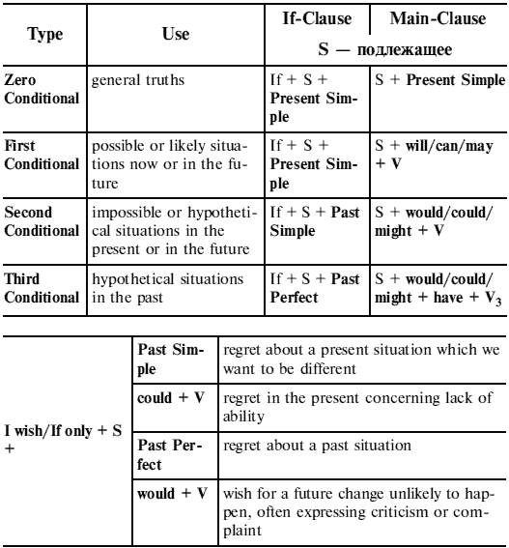
Test 1. First or Second Conditional? Put the verbs in brackets into the correct tense.

1. If he (run), he’ll get there in time.

2. They would be rather offended if I (not go) to see them.

3. If you took more exercise, you (feel) better.

4. If it (stop) snowing, we can go skiing.

5. If I was offered a job, I think I (take) it.

6. I’m sure Ann will lend you the money. I’d be very surprised if she (refuse).

7. If you (not go) away, I’ll send for the police. 8. If I sold my car, I (not get) much money for it.

9. The police (arrest) him if they catch him.

10. We (not have) any money if we didn’t work.

11. Tell Mary to ring me up if you (see) her.

12. What would happen if I (not come)?

13. If he (like) the house, will he buy it?

14. Carol gave me this ring. She (be) very upset if I lost it.

15. Our friends are expecting us. They will be disappointed if we (not come).

16. What will happen if my parachute (not open)?

17. I’m sure Jane (understand) if you explained the situation to her.

18. What you (do) if you lost your passport?

19. If we (tell) them the truth, they wouldn’t believe us.

20. If I lend you $1000, when you (repay) me?

Test 2. First or Second Conditional? Put the verbs in brackets into the correct tense.

1. If it (rain) this weekend, we (not be able) to go to the country.

2. Give me Ann’s letter. If I (see) her, I (give) it to her.

3. I have to work hard, so I’m very busy. But if I (have) any free time, I (go) in for swimming.

4. If I (be) taller, I (can) play basketball. But I’m too short.

5. Please stop talking! If you (not start) your meal now; it (go) cold.

6. If you (have) any problems, let me know and I (help) you.

7. You’re a wonderful cook! If I (can) cook as well as you, I (open) a restaurant.

8. We must hurry! If he (be) late, we (leave) without him.

9. He (have) a day off tomorrow if he (work) hard today?

10. That coat looks awful! I (not buy) it if I (be) you.

11. I think there are too many cars. If there (not be) so many cars, there (not be) so much pollution.

12. It’s a pity I’m not rich. If I (be) rich, I (have) a yacht.

13. I’m going out now. If anybody (phone) while I (be) out, can you take a message?

14. This soup isn’t very good. It (taste) better if it (not be) so salty.

15. ‘What shall we do tomorrow?’ ‘Well, if it (be) a nice day, we (not stay) at home.’

16. Liz is tired all the time. If she (not go) to bed so late, she (not be) tired.

17. You were rude to Mike. If I (be) you, I (apologize).

18. We’re lost. If we (have) the map with us, we (know) where we are.

19. If I still (feel) sick, I (not go) on holiday next weekend.

20. I don’t get any help at work. My job (be) easier if I (have) a secretary.

Test 3. Second or Third Conditional? Put the verbs in brackets into the correct tense.

1. If you (not be) busy, we could go for a walk.

2. If I (have) enough money, I would have taken a taxi.

3. If I were you, I (buy) a new suit.

4. If I (be) interested in the film, I would have gone to the cinema.

5. If we (not take) the wrong turning, we wouldn’t have arrived late.

6. If he had more time, he (take) up tennis.

7. You could have come first if you (run) faster.

8. If she (not have) a car, we would have to go by bus.

9. What (do) if you lost your job?

10. If I (not feel) tired, I would have gone to bed later.

11. If Bruce had asked me, I (say) ‘yes’.

12. If I (not take) an umbrella, I would have got wet.

13. If he knew that it was dangerous, he (not come).

14. If someone (give) you a helicopter, what would you do with it?

15. They (not miss) the plane if they hadn’t woken up late.

16. If you (ask), I could have told you the answer.

17. I could help you with the text if I (know) Greek.

18. If only he had asked, I (help) him.

19. If I (invite) to my friend’s party, I would never dress casually.

20. If she (pass) her driving test, she would have bought a car.

Test 4. Second or Third Conditional? Put the verbs in brackets into the correct tense.

1. We can’t afford to go to Austria. If we (have) more money, we (go) skiing there.

2. I didn’t know you were in hospital. If I (know), I (go) to visit you.

3. Ken got to the station in time to catch his train. If he (miss) it, he (be) late for his interview.

4. Tom doesn’t know Spanish. If he (know) it, he (help) us to translate this article.

5. It’s good that you reminded me about Ann’s birthday. I (forget) it if you (not remind) me.

6. If I (have) your address when I was in New York, I (send) you a postcard.

7. If I (know) the results of exam now, I (phone) her immediately.

8. ‘How was your holiday?’ ‘It was OK, but I (enjoy) it more if the weather (be) better.’

9. I took a taxi but the traffic was heavy. It (be) quicker if I (walk).

10. I’m not tired. If I (be) tired, I (go) home now.

11. I wasn’t hungry. If I (be) hungry, I (eat) something.

12. I’m glad we had a map. I’m sure we (get) lost if we (not have) one.

13. We decided not to move. We (lose) a lot of money if we (sell) our house.

14. If you (be) a bird, you (can) fly.

15. If she (ask) Tom yesterday, he certainly (tell) her about it.

16. He wasn’t ill last week. If he (be) ill, he (not play) football.

17. I don’t want to get up so early. If it (be) Sunday today, I (not have) to get up.

18. I’m glad we had a mobile phone. If we (not contact) the police, they (not catch) the criminals.

19. You should stop smoking! You (not feel) so bad if you (not smoke) too much.

20. You didn’t ring me up yesterday. If you (call) me, I (tell) you everything.

Test 5. Conditional sentences: mixed types. Put the verbs in brackets into the correct tense.

1. If he (pass) his examination, we’ll have a celebration.

2. What (happen) if I press this button?

3. If it (not rain) now, we would go to the country.

4. If we had booked tickets beforehand, we (not have) to wait now.

5. If I (be) you, I would ring him up myself.

6. If you don’t give me more information, I (not be) able to help you.

7. If it (not be) so cold yesterday, we would have gone to the forest.

8. If he were careful, he (not break) things.

9. If you (not help) me, I wouldn’t have been able to finish the work yesterday.

10. We won’t go to the theatre if he (not bring) tickets.

11. If he (not be) at home, leave him a note.

12. If you had learnt the words, you (not do) so many mistakes.

13. If Ann were slimmer, she (be) much more attractive.

14. If I (have) a chance last year, I would have visited Great Britain.

15. I will let you know if he (come).

16. If you (not hurry), you’ll miss the train.

17. I would buy this book if it (not be) so expensive.

18. ‘Does she love him?’ ‘Of course she does. If she (not love) him, she (not marry) him.’

19. ‘What you (do) if you saw a ghost?’ ‘I (run) a mile.’

20. If I (not be) busy, I’ll visit you.

Test 6. Conditional sentences: mixed types. Put the verbs in brackets into the correct tense.

1. If I (not borrow) the money, I wouldn’t have been able to buy the bike.

2. If he (not catch) the bus, he would have been late for work.

3. If she had known you needed the eggs for the cake, she (not use) them all.

4. She (win) the match if she hadn’t hurt her ankle.

5. If you (not put up) this shelf, you won’t have anywhere to put your books.

6. If she (change) her job, she would be a lot happier.

7. If I were you, I (tell) her how you feel.

8. If you continue to shout so loudly, you (wake up) the baby.

9. Even if she (ask) him, he wouldn’t have agreed to come.

10. Unless you (feel) any better, you can take the rest of the day off.

11. If they (not threaten) her, she wouldn’t have left.

12. I (not trust) her if I were you.

13. If you’re patient for a few minutes, I (be able) to finish this.

14. If he goes on making so much noise, I (punish) him.

15. If we (intend) to spend the day in Paris, we would have bought a day pass.

16. Keep your voice down in case she (overhear) us.

17. If he (be) more experienced, he would be more likely to get the job.

18. If the food (not be) so bad, they wouldn’t have complained.

19. Sales will increase provided that the advertising campaign (be) successful.

20. If she (spend) less on clothes, you would be able to save some money.

Test 7. Put the verbs in brackets into the correct form.

1. Bruce wishes he (have) more money so he could buy a new sweater.

2. The weather was cold while we were away. I wish it (be) warmer.

3. I wish I (be) taller so that I could be in the basketball team.

4. I wish you (stop) watching television while I am talking to you.

5. It was a terrible film. I wish we (not go) to see it.

6. I wish the holidays (come) so we could go off to the seaside.

7. I wish Ann (be) here. She’d be able to help us.

8. Yesterday I got very wet in the rain. I wish I (have) an umbrella.

9. I wish we (go) to the match next Saturday but we’re visiting my uncle instead.

10. I wish you (keep) your mouth shut yesterday. Now Mary knows everything.

11. It’s freezing today. I wish it (not be) so cold. I hate cold weather.

12. I wish I (not lose) all my money. Now I’m broke.

13. The weather is awful. I wish it (improve).

14. I feel sick. I wish I (not eat) so much cake.

15. I’m fed up with this rain. I wish it (stop) raining.

16. What I said was stupid. I wish (not say) anything.

17. It’s very crowded here. I wish there (not be) so many people.

18. I was late yesterday. I wish I (take) a taxi.

19. I wish it (be) summer now.

20. The phone has been ringing for five minutes. I wish somebody (answer) it.

Test 8. Put the verbs in brackets into the correct form.

1. If you had let me know yesterday, I already (bring) you my book.

2. If he (get) this book, I’ll be happy.

3. I wish I (know) Spanish.

4. If he (be) a poet, he would write beautiful poetry.

5. If my brother (be) in trouble, I’ll help him.

6. If they (know) it before, they would not have gone there.

7. If he (be) more courageous, he would not be afraid.

8. I wish you (go) skiing with me yesterday.

9. If it is not too cold tomorrow, I (not put) on my coat.

10. If he had warned me, I (do) the work in time.

11. If you (not miss) the train, you would have arrived in time.

12. I wish I (not have) to do my homework every day.

13. If it (snow), the children will play snowballs.

14. I am a doctor, but if I (be) a musician now, I (be) much happier.

15. I wish we (meet) again next summer.

16. If he did not read so much, he (not know) English so well.

17. If the weather (be) fine yesterday, we (play) outside.

18. If my sister (not go) to the south, we’ll spend the summer together.

19. If I (have) this rare book, I would gladly give it to you.

20. I wish I (be) at yesterday’s party.

Test 9. Put the verbs in brackets into the correct form.

1. I wish I (see) this film, but I couldn’t go to the cinema.

2. If he (live) in St. Petersburg, he would go to the Hermitage every week.

3. We (go) out of town tomorrow if the weather (not to change) for the worse.

4. If they had known it before, they (take) measures.

5. If my friend didn’t work so hard, we (meet) every day.

6. I wish you (read) more in the future.

7. If I (be) you, I would apologize.

8. If it (rain), we’ll have to stay at home.

9. I wish it (not be) winter now.

10. If you don’t give the child much fruit, he (not be) healthy.

11. You would have understood this rule if you (not miss) the lesson.

12. If I (meet) you yesterday, I (tell) you about it.

13. I wish I (not give) Nick my watch: he has broken it.

14. If he (be) a scientist, he would invent a time machine.

15. If he (work) hard, he would have achieved great progress.

16. If my sister (be) in Moscow, she’ll meet you at the railway station.

17. If she (not be) so lazy, she would study much better.

18. I wish I (live) in London now.

19. If he (ring) me up, I’ll tell him a secret.

20. If you had not wasted so much time, you (not miss) the train.

Test 10. Complete this text using the correct form of the verbs in brackets.

All the Difference I often wonder how my life (1)(be) different if on that particular day I (2)(go) in the other direction. Or what (3)(happen) if – in those seconds – I (4)(walk) a little bit faster? She (5)(not be) able to do what she did, say things she said. If it (6)(not be) for these shy words of greeting, I (7)(not be) here now – I probably (8)(live) in the same city I grew up in. It is amazing how our lives depend on the most minute details: a split-second decision which makes all the difference. I (9)(ever find) romance at all if I (10)(not meet) Julia that day and if she (11)(decide) to walk on that path beside the trees? I possibly (12)(not do) what I did in my life if we (13)(not meet) on that bright, sunny morning. And if we (14)(not be) together now, I (15)(not be) the happiest man in the world.

Test 11. Complete this text using the correct form of the verbs in brackets.

Long Summer Break Under Threat The Minister for Education thinks that if the summer break were shorter, children (1)(do) much better at school. ‘Imagine how you would feel,’ he (2)(tell) a press conference last week, ‘if you (3)(have) two months off work. You (4)(spend) a lot of time trying to get used to (5)(be) back at work. This is exactly what we ask children (6)(do) during the long summer holidays. If you ask teachers they (7)(tell) you that when kids get back from their summer break, they just (8)(not carry) on from where they stopped in June. They (9)(have) to do the same things again. If the summer holidays (10)(be) shorter, this would not happen. If our proposal (11)(go) ahead, we will introduce a system based on five terms a year. This means children (12)(have) lots of breaks with plenty of opportunities (13)(relax) during the year. If we didn’t have these long summer holidays, we (14)(do) much more work in our schools, so we think it (15)(be) time for a change.’
7. COMPLEX OBJECT
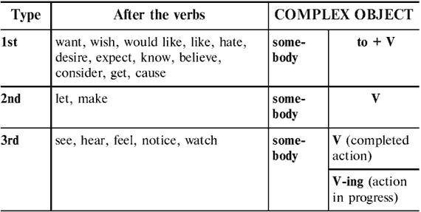
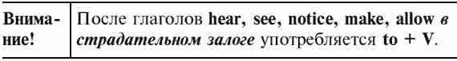
Test 1. Use to where necessary.

1. I saw him _______ drop his bag.

2. We expected Tom _______ be late.

3. The officer made Ann _______ open her suitcase.

4. Ann was made _______ open her case.

5. Suddenly they heard the front door _______ open and then _______ close softly.

6. Let me _______ carry your bag for you.

7. Do you want me _______ come with you?

8. I like my Granny _______ tell us fairy-tales.

9. Have you ever seen her _______ dance?

10. Hot weather makes me _______ feel tired.

11. She doesn’t allow us _______ smoke in the house.

12. I want you _______ tell me the truth.

13. I noticed Henry _______ come up and _______ speak to the stranger.

14. Her parents won’t let her _______ go out alone.

15. Would you like me _______ go now?

16. I know him _______ be a great politician.

17. My father allowed me _______ use his car.

18. Let him _______ do what he wants.

19. I expected my parents _______ help me.

20. Mr Graves felt somebody’s hand _______ touch him.

Test 2. V or V-ing? Choose the correct form of the verb.

1. Did you notice anyone (go/going) out?

2. When I woke up, I could hear the birds (sing/singing).

3. I suddenly felt someone (touch/touching) on my shoulder.

4. I didn’t hear you (come/coming) in.

5. John found Ann in his room (read/reading) his letters.

6. Did anybody see the accident (happen/happening)?

7. Listen! Can you hear a baby (cry/crying)?

8. I looked out of the window and saw Tim on his bike (cycle/cycling) along the road.

9. We noticed a group of people (dig/digging) something in the field.

10. ‘Why did you turn round suddenly?’ ‘I thought I heard somebody (call/calling) my name.’

11. Can you smell something (burn/burning)?

12. If you found a lot of money (lie/lying) in the street, would you take it to the police station?

13. We watched the two men (run/running) across the garden, (open/opening) a window and (climb/climbing) through it into the house.

14. Everybody heard the bomb (explode/exploding). It was a tremendous noise.

15. Oh! I can feel something (crawl/crawling) up my leg! It must be an insect.

16. I heard somebody (slam/slamming) the door in the middle of the night. It woke me up.

17. We saw the robber (walk/walking) quickly along the street.

18. I saw her (walk/walking) across the room and (take/ taking) a gun out of the desk drawer.

19. When we got home, we found a cat (sleep/sleeping) on the kitchen table.

20. I could hear it (rain/raining).

Test 3. Choose the correct form of the verb.

1. I want him _______ back soon.

a) to come b) come c) coming

2. My mother always makes me _______ up.

a) to wash b) wash c) washing

3. I felt Nick _______ his hand on my shoulder.

a) to put b) put c) putting

4. The pupils were made _______ at school after classes.

a) to stay b) stay c) staying

5. The teacher expected the children _______ this difficult question.

a) to answer b) answer c) answering

6. If I saw a child _______, I would ask what was the matter.

a) to cry b) cry c) crying

7. My parents didn’t let me _______ to the party.

a) to go b) go c) going

8. Everyone likes her _______.

a) to dance b) dance c) dancing

9. Would you like me _______ for you?

a) to wait b) wait c) waiting

10. We were allowed to _______ bed later.

a) to go b) go c) going

11. I smelled something _______ in the kitchen.

a) to burn b) burn c) burning

12. My parents don’t want me _______ home late.

a) to come b) come c) coming

13. Her present made me _______ happy.

a) to feel b) feel c) feeling

14. John saw his friend _______ the door of the room and _______ in.

a) to open, to come b) open, come c) opening, coming

15. This task is difficult! Let me _______ you!

a) to help b) help c) helping

16. We don’t expect them _______ for us after classes.

a) to wait b) wait c) waiting

17. The boy was made _______ the truth.

a) to tell b) tell c) telling

18. Mother watched her little children _______ in the yard.

a) to play b) play c) playing

19. He heard a distant voice _______.

a) to shout b) shout c) shouting

20. I hate you _______ late.

a) to be b) be c) being

Test 4. Read the text and put the verbs in brackets into the correct form.

Last night a terrible accident happened near my house. I was reading a book when I heard car breaks (1)(screech) and people (2)(shout) in the street. When I looked out of the window, I saw a crowd of about twenty people (3)(stand) around a young boy lying in the street. Next, I saw the driver of the car (4)(approach) the crowd and (5)(kneel) down by the boy. I wanted my wife (6)(phone) the emergency service but then I noticed some people in the street (7)(use) their mobiles to call an ambulance. Suddenly I saw a young woman (8)(run) towards the scene and (9)(push) her way through the crowd. I knew her (10)(be) the boy’s mother. A few minutes later I heard an ambulance siren (11)(scream) in the distance. Then I saw the ambulance (12)(stop) in front of my house. I watched the ambulance men (13)(get out) and (14)(run) to the injured boy. Minutes later I saw them (15)(run back) to the ambulance with the boy on a stretcher followed by his mother.

Test 5. Translate the sentences using complex object.

1. Я хочу, чтобы вы прочли эту книгу.

2. Я видел, что Коля пришел.

3. Я видел, как Джордж шел по улице.

4. Вам бы хотелось, чтобы я рассказал вам эту историю?

5. Собака заставила кошку взобраться на дерево.

6. Мы не рассчитывали, что вы так много сделаете.

7. Он не любит, когда дети смеются.

8. Вы заметили, как он положил письмо на стол?

9. Мама хочет, чтобы я стала учительницей.

10. Папа, разреши Тому присоединиться к нам.

11. Он знал, что она знаменитая певица.

12. Вы когда-нибудь слышали, как она поет?

13. Хотите, я дам вам мой словарь?

14. Мне бы не хотелось, чтобы вы меня ждали.

15. Мы наблюдали, как студенты танцуют.

16. Я ненавижу, когда ты задаешь глупые вопросы.

17. Учитель заставил еe переписать упражнение.

18. Она не слышала, как я вошел в комнату.

19. Бабушка не любит, когда дети играют с собакой.

20. Я почувствовала, как кто-то смотрит на меня.
8. INFINITIVE/GERUND/PARTICIPLES
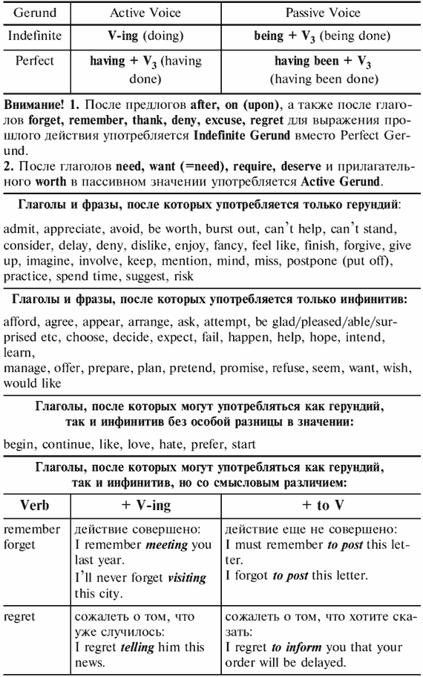
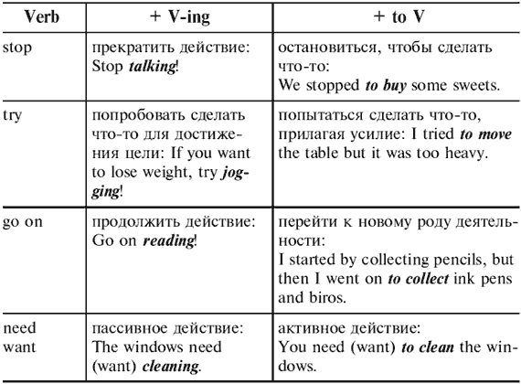
Test 1. Gerund or infinitive: choose the correct answer.

1. They denied (to steal/stealing) the money.

2. He gave up (to smoke/smoking).

3. I don’t want (to go/going) out tonight. I am too tired.

4. Try to avoid (to make/making) him angry.

5. Is there anything here worth (to buy/buying)?

6. I refuse (to answer/answering) any more questions.

7. He finished (to speak/speaking) and sat down.

8. Would you mind (to put/putting) your pet snake somewhere else?

9. I’ve enjoyed (to meet/meeting) you. I hope (to see/seeing) you again soon.

10. The boy’s father promised (to pay/paying) for the broken window.

11. He decided (to steal/stealing) her bag.

12. I don’t feel like (to work/working). What about (to go/ going) to a disco instead?

13. Would you like (to join/joining) us?

14. I hope (to see/seeing) you soon.

15. Please go on (to write/writing). I don’t mind (to wait/ waiting).

16. He keeps (to ask/asking) me the time and I keep (to tell/telling) him (to buy/buying) himself a watch.

17. I wish (to see/seeing) him as soon as possible.

18. I offered (to help/helping) him to translate the text.

19. Tom suggested (to go/going) to the cinema.

20. How old were you when you learnt (to drive/driving)?

Test 2. Gerund or infinitive: choose the correct answer.

1. I remember (to meet/meeting) him last year.

2. I must remember (to meet/meeting) him at the station tomorrow.

3. Please, remember (to close/closing) the door when you go out.

4. I remember (to close/closing) the door, but I’m not sure that I locked it.

5. Don’t forget (to lock/locking) the door before (to go/ going) to bed.

6. He forgot (to bring/bringing) his passport. He left it on the table.

7. I’ll never forget (to go/going) out with my aunt in my childhood.

8. Try (to forget/forgetting) it; it isn’t worth (to worry/ worrying) about.

9. I rang the doorbell but there was no answer. Then I tried (to knock/knocking) on the door, but there was still no answer.

10. We tried (to put/putting) the fire out but we were unsuccessful.

11. Sue needed to borrow some money. She tried (to ask/ asking) Gerry but he was short of money, too.

12. Please, leave me alone. I’m trying (to concentrate/concentrating).

13. I need a change. I need (to go/going) away for a while.

14. The windows are dirty. They need (to clean/cleaning).

15. You don’t need (to ask/asking) his permission every time you want (to leave/leaving) the room.

16. Your hair needs (to cut/cutting). Would you like me (to do/doing) it for you?

17. We stopped there (to buy/buying) some biscuits.

18. Please, stop (to ask/asking) me questions.

19. ‘Did you start your diet?’ ‘Sure, but I can’t help (to eat/eating) sweets.’

20. Can you help me (to get/getting) the dinner ready?

Test 3. Gerund or infinitive: choose the correct answer.

1. I have finished (to decorate/decorating) the house.

2. I can’t stand (to work/working) in an office.

3. We hope (to arrive/arriving) by half past seven.

4. It was a wonderful holiday. I will always remember (to see/seeing) Niagara Falls.

5. They can’t promise (to finish/finishing) the work today.

6. He hates (to use/using) computers.

7. I am really looking forward to (to start/starting) my new course.

8. They can’t help us (to move/moving) in our new flat.

9. They enjoyed (to be/being) on holiday by the sea.

10. She refused (to answer/answering) the phone.

11. The weather was awful. It didn’t stop (to rain/raining) all week.

12. My sister has agreed (to help/helping) with the decorating.

13. They managed (to save/saving) enough to buy a car.

14. His parents don’t allow him (to stay up/staying up) after ten o’clock.

15. I don’t mind (to drive/driving) to the restaurant.

16. Please remember (to post/posting) my letter. It’s very important.

17. We were late. Tom suggested (to take/taking) a taxi.

18. I asked him to stop (to talk/talking), but he kept (to ask/asking) me questions.

19. Sometimes she puts off (to do/doing) her homework.

20. They always forget (to water/watering) the plants.

Test 4. Gerund: choose the correct form. Sometimes more than one answer is possible.

1. This question needs _________.

a) discussing b) being discussed c) having discussed d) having been discussed

2. I like John. I look forward to _________ to his party.

a) inviting b) being invited c) having invited d) having been invited

3. He can’t give up _________ chocolate.

a) eating b) being eaten c) having eaten d) having been eaten

4. I am sorry for not _________ to you. I was very busy last week.

a) writing b) being written c) having written d) having been written

5. My friends and I can’t help _________ videos.

a) watching b) being watched c) having watched d) having been watched

6. She apologised for not _________ her friend at the airport.

a) meeting b) being met c) having met d) having been met

7. This film is worth _________.

a) seeing b) being seen c) having seen d) having been seen

8. I am very busy. I don’t feel like _________.

a) disturbing b) being disturbed c) having disturbed d) having been disturbed

9. Paul avoids _________ to strangers. Moreover, he avoids _________ to.

a) speaking b) being spoken c) having spoken d) having been spoken

10. He was still hungry in spite of _________ several sandwiches.

a) eating b) being eaten c) having eaten d) having been eaten

11. I can’t put off _________ this book.

a) reading b) being read c) having read d) having been read

12. After the cat _________ went to sleep.

a) feeding b) being fed c) having fed d) having been fed

13. He complained of _________ at.

a) laughing b) being laughed c) having laughed d) having been laughed

14. This dress is dirty. It wants _________.

a) washing b) being washed c) having washed d) having been washed

15. She was very glad of _________ that difficult problem.

a) solving b) being solved c) having solved d) having been solved

16. They climbed through the window without _________ by anyone.

a) seeing b) being seen c) having seen d) having been seen

17. I am fond of _________ sports.

a) playing b) being played c) having played d) having been played

18. Jane complained of not _________ to the party last Friday.

a) inviting b) being invited c) having invited d) having been invited

19. After _________ into English, the article was published.

a) translating b) being translated c) having translated d) having been translated

20. I dislike not _________ to.

a) listening b) being listened c) having listened d) having been listened

Test 5. Put the verbs in brackets into the correct form (gerund or infinitive).

1. Thank you for (come).

2. We saw this film last year. Do you remember (see) it?

3. After (examine) the student, the professor gave him a good mark.

4. I’ll never forget (visit) London for the first time.

5. She accused him of (steal) her purse.

6. I tried (explain) but she refused (listen).

7. You don’t need (iron) that shirt. It doesn’t need (iron).

8. Has it stopped (rain) yet?

9. ‘Did you remember (book) seats for the theatre tomorrow?’ ‘Yes, I have the tickets here. Would you like (keep) them?’

10. He was very glad of (help) in his difficulty.

11. You must never forget (say) ‘Thank you’.

12. The problem is not worth (discuss).

13. She complained of (forget) to send this letter.

14. I tried (work) in a department store, but it wasn’t a very good job.

15. Can you help me (do) this exercise?

16. I don’t feel like (see) him.

17. She tried (be) serious but she couldn’t help (laugh).

18. I wish (see) the manager.

19. She tried to avoid (speak) to.

20. Would you mind (shut) the window?

Test 6. Put the verbs in brackets into the correct form (gerund or infinitive).

1. I’ll never forget (go) to school for the first time. I remember that day quite clearly.

2. David was happy (find) his aunt.

3. I tried (reach) the shelf but I wasn’t tall enough.

4. He likes (invite) by his friends.

5. You don’t need (paint) the door. It doesn’t need (paint).

6. Stop (argue) and start (work).

7. ‘Did you remember (lock) the door?’ ‘No, I’ll go back and do it now.’

8. If it is worth (do), it is worth (do) well.

9. ‘How did the thief get into the house?’ ‘I forgot (shut) the window.’

10. They accuse him of (rob) their house.

11. If you can’t turn the key try (put) some oil in the lock.

12. Have you finished (write)?

13. He always helps me (do) my homework.

14. He looks so funny. Whenever I see him, I can’t help (smile).

15. She decided (not buy) the car.

16. Do you mind him (examine) by a cardiologist?

17. I don’t enjoy (go) to the dentist.

18. Excuse me for (break) your beautiful vase.

19. I clearly remember (pay) him. I gave him $20.

20. After (say) this he left the room.

Test 7. Fill the gaps with one of the verbs from the box in the correct form (gerund or infinitive).
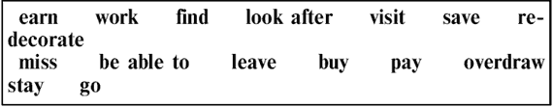
Jane’s а nurse, but she’s trying _________ (1) а new job. Although she enjoys _________ (2) people, nursing is not very well paid, and she can’t afford _________ (3) all her bills. She finds it impossible to live on such а low salary without _________ (4) her account at the bank. Her flat needs _________ (5), and she would like _________ (6) а car. She managed _________ (7) enough last year for а short holiday by _________ (8) some extra money in her spare time, and this year, she’s hoping _________ (9) some friends in France. She has stopped _________ (10) to the theatre, which used to be one of her greatest pleasures. She’s thinking of _________ (11) in America, where she could earn а higher salary in а private hospital, but would prefer _________ (12) in this country if possible. She likes _________ (13) to see her parents whenever she wants to. А friend of hers went to America after _________ (14) university, but began _________ (15) her friends so badly that she had to come back.

8.2. PARTICIPLES
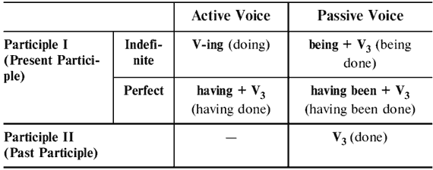
Test 8. Participles as adjectives. Complete the sentences with the present participle (-ing) or past participle (-ed).

1. The book was so (exciting/excited) that I couldn’t put it down.

2. I thought the interview went well, so I was very (disappointing/disappointed) not to get the job.

3. I didn’t want to tell my sister that I’d borrowed her car, as I knew she would be (annoying/annoyed).

4. I wasn’t looking forward to studying history, but in the end I thought it was a (fascinating/fascinated).

5. I just sat in front of the TV all evening. My day had been really (tiring/tired).

6. Failing my driving test was one of my most (disappointing/disappointed) experiences.

7. I wish he’d be quiet. He’s so (annoying/annoyed).

8. After watching the documentary on global warming, we all felt a bit (depressing/depressed).

9. Many people think hill walking was very energetic, but I find it very (relaxing/relaxed).

10. The children were really (exciting/excited) about opening their presents.

11. I was so hurt when he said I was (boring/bored).

12. He works very hard. It’s not (surprising/surprised) that he is always tired.

13. We were (shocking/shocked) when we heard the news.

14. I didn’t find the situation funny. I was not (amusing/ amused).

15. The journey was really (exciting/excited). I enjoyed it.

16. I am not keen on golf. When I played it, I was really (boring/bored).

17. She really learns very fast. She has made (astonishing/ astonished) progress.

18. Tom is good at telling funny stories. He can be very (amusing/amused).

19. When we heard the news, we didn’t know what to do. The news was (shocking/shocked).

20. The weather forecast was (terrifying/terrified). The (worrying/worried) authorities cancelled the match.

Test 9. Choose the correct answer a, b, or c to fill the spaces.

1. Do you know the woman _________ to Tom?

a) talked b) talking c) having talked

2. _________ her work, she went home.

a) finished b) finishing c) having finished

3. The road _________ the two villages is very narrow.

a) joined b) joining c) having joined

4. Most of the goods _________ in this factory are exported.

a) made b) making c) having made

5. _________ nearly all our money, we couldn’t stay in a hotel.

a) spent b) spending c) having spent

6. I was woken up by a bell _________.

a) rung b) ringing c) having rung

7. There were some children _________ in the river.

a) swum b) swimming c) having swum

8. A lot of people _________ to the party cannot come.

a) invited b) inviting c) having invited

9. _________ our tickets, we went into the theatre.

a) bought b) buying c) having bought

10. Everybody looked at the _________ girl.

a) danced b) dancing c) having danced

11. The window _________ in the storm last night has now been repaired.

a) broken b) breaking c) having broken

12. I saw a woman _________ in the corner on her own.

a) stood b) standing c) having stood

13. She was lying in the middle of the road, _________ for help.

a) cried b) crying c) having cried

14. _________ our meal, we went out.

a) Finished b) Finishing c) Having finished

15. He just sits around all day, _________ nothing.

a) done b)doing c) having done

16. Books _________ from the library must be returned in two weeks.

a) borrowed b) borrowing c) having borrowed

17. Not _________ what to do, she burst out crying.

a) known b) knowing c) having known

18. _________ hungry, I decided to make myself a sandwich.

a) felt b) feeling c) having felt

19. _________ dinner, they continued their journey.

a) had b) having c) having had

20. Emma was sitting in an armchair _________ a book.

a) read b) reading c) having read

Test 10. Open the brackets using Participle I or Participle II.

1. (Walk) along the street I saw several (destroy) houses.

2. It was an (excite) incident. No wonder she spoke about it in an (excite) voice.

3. (Sit) near the fire, he felt very warm.

4. (Find) a hotel, we looked for somewhere to have dinner.

5. The (frighten) child could not sleep all night – so (frighten) was the tale.

6. (Be) unemployed, he hasn’t got much money.

7. I don’t know what was in the (burn) letter. I didn’t read it.

8. (Look) out of the window, he saw his mother watering the flowers.

9. The house (surround) by tall trees was very beautiful.

10. The wall (surround) the house was very high.

11. (Translate) by a good specialist, the story preserved all the humour of the original.

12. (Sell) fruit, he looked back from time to time, hoping to see his friends.

13. (Sell) all the fruit, he went to see his friends.

14. (Enter) the room, she turned on the light.

15. (Arrive) late, we missed the train.

16. Jim hurt his arm while (play) tennis.

17. The (lose) book was found at last.

18. (Not wish) to discuss that problem, he changed the conversation.

19. A word (speak) in time may have very important results.

20. The students (speak) good English must help their classmates.

Test 11. Open the brackets using Participle I or Participle II.

1. A crowd of (excite) people stood (watch) the burning house.

2. ‘Why do you look so (worry)?’ ‘I’ve had a number of (worry) telephone calls lately.’

3. (Look) through some magazines, I came across an interesting article.

4. (Have) dinner, they continued their journey.

5. After hearing the (frighten) tale, the (frighten) children wouldn’t go to sleep.

6. (Feel) tired, I went to bed early.

7. A lot of people (invite) to the party cannot come.

8. (Hear) the sounds of music, we stopped talking.

9. The girl (wash) the floor is my sister.

10. The floor (wash) by Helen looked very clean.

11. (Approve) by the critics, the story was accepted by a popular magazine.

12. (Do) his homework, he was thinking hard.

13. (Do) his homework, he went for a walk.

14. (Come) to the theatre, she saw that the performance had already begun.

15. (See) this film twice, I didn’t want to go to the cinema.

16. Be careful when (cross) the road.

17. Translate the words (write) on the blackboard.

18. (Not know) her address, we couldn’t go to see her.

19. A fish (take) out of the water cannot live.

20. A person (take) a sun-bath must be very careful.

Test 12. Fill in each space in the following text, using an appropriate present or past participle of the verbs given in the box. You will need to use one of the verbs twice.
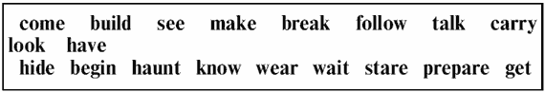
The Haunted House Just after midnight, Julian and Anne, with Tommy the dog, arrived at the _________ (1) house, having first _________ (2) sure that no one would notice their absence. The house, _________ (3) in the seventeenth century, had been abandoned for several years and the _________ (4) windows stood _________ (5) like the eyes of a frightened ghost. Julian, _________ (6) by Anne and Tommy, took out his torch and pointed it towards the fence, _________ (7) for the gap which they had _________ (8) a few days earlier. But how had their latest adventure _________ (9)? Julian had been sitting in a cafe _________ (10) a drink when he overheard some men _________ (11) about hiding ‘the stuff’ in the haunted house till things had quietened down. _________ (12) that the police were looking for drug traffickers in the area, Julian had followed the men to their car, _________ (13) sure to take down the number. Julian, Anne and Tommy the dog spent the next few evenings at the house, _________ (14) in one of the old stables next to the house, _________ (15) patiently for the arrival of the criminals. At last, their efforts were rewarded. They saw the lights of a car _________ (16) closer. When the car stopped, a man got out, _________ (17) what seemed to be a large parcel. A few seconds later they saw another figure _________ (18) out of the car, _________ (19) a long black overcoat and _________ (20) something in his hand that, in the darkness, looked like a gun.
8.3. INFINITIVE/GERUND/PARTICIPLE

Test 13. Choose the correct form of the verb.

1. Paula has given up _________.

a) to smoke b) smoking c) smoke

2. I promised _________ in time.

a) to come b) having come c) come

3. I saw him yesterday. He seems _________ weight.

a) losing b) to have lost c) lose

4. Let me _________ your bag.

a) to carry b) carrying c) carry

5. I don’t enjoy _________ very much.

a) dance b) danced c) dancing

6. It was funny. I couldn’t help _________.

a) laughing b) laugh c) to laugh

7. Would you mind _________ the door, please?

a) close b) closing c) closed

8. I’d prefer _________ a taxi.

a) get b) to get c) having got

9. He is very good at _________ languages.

a) to learn b) learn c) learning

10. He is used _________ alone.

a) having lived b) to live c) to living

11. David insisted on _________ for the meal.

a) to pay b) having paid c) paying

12. It is no use of _________ about it.

a) worrying b) worry c) to have worried

13. I had difficulty in _________ a permit.

a) to get b) getting c) got

14. Let’s go to the pool _________ a swim.

a) to have b) having c) had

15. Ann was surprised _________ you last week.

a) see b) to see c) having seen

16. He prevented them from _________ the same mistake.

a) do b) to do c) doing

17. Did you notice anyone _________?

a) to go out b) go out c) went out

18. _________ her work, she went home.

a) To have finished b) Having finished c) To finish

19. She denied _________ there.

a) to go b) went c) going

20. Tony mentioned _________ the bus to school instead of walking.

a) to take b) took c) taking

Test 14. Choose the correct form of the verb.

1. Ann was made _________ her suitcase.

a) to open b) opening c) open

2. Do you know how _________ to his house?

a) getting b) get c) to get

3. I remember _________ the door.

a) locking b) to lock c) to be locked

4. The coat is dirty. It needs _________.

a) to clean b) clean c) cleaning

5. I bought a new car instead of _________ to America.

a) to fly b) fly c) flying

6. He is looking forward to _________ them again.

a) see b) have seen c) seeing

7. She was busy _________ in the garden.

a) working b) to work c) to be working

8. I don’t enjoy _________ very much.

a) driving b) drive c) drove

9. I can’t afford _________ tonight. I’m too tired.

a) to be going out b) to go out c) go out

10. His mother made him _________ the room.

a) to clean b) cleaning c) clean

11. Has it stopped _________ yet?

a) rain b) to be rain c) raining

12. Can you remind me _________ some coffee?

a) to buy b) buy c) having bought

13. Why do you keep _________ me questions?

a) being asked b) asked c) asking

14. I refuse _________ his questions.

a) to answer b) answer c) having answered

15. I’ve enjoyed _________ them.

a) meet b) meeting c) being met

16. The girl began _________ at night.

a) cry b) to cry c) having cried

17. He is against _________ the discussion of this issue.

a) postpone b) having postpone c) postponing

18. I can’t stand _________ here any longer.

a) work b) being work c) working

19. They translated the story into English without _________ a dictionary.

a) to use b) use c) using

20. _________ in that country all his life, he knew it very well.

a) Having lived b) Being lived c) Live

Test 15. Fill in the blanks with the correct form of the infinitive or V-ing form.

Christmas Whatever else Christmas may _________ (1)(stand for), one thing it still means is _________ (2)(eat). Christmas has traditionally been a time of the year when people have tried _________ (3)(cheer) themselves up during the cold months of winter. Last year more than 10 million turkeys were bought in Britain alone during the festive season _________ (4)(satisfy) the nation’s appetite. Health experts may continue _________ (5)(complain) about all this self-indulgence, but they fail _________ (6)(realise) that there is nothing new about celebratory feasting, practically at this time of the year. The Roman Saturnalia, which was supposed to be a festival _________ (7)(honour) the god of agriculture, started on 19 December. Among other things, the Saturnalia involved _________ (8)(light) candles and _________ (9)(give) gifts. People who had spent the whole year _________ (10)(save) money suddenly became extravagant. In addition to _________ (11)(exchange) gifts, this time of year was also an occasion for masters and slaves alike _________ (12)(eat) excessively. At one Saturnalia feast an emperor is reported _________ (13)(spend) the equivalent of $900,000 on a dinner for twelve guests which consisted of twenty courses and lasted all day. So, when mealtime comes round on 25 December, there’s no point in _________ (14)(have) a guilty conscience. In fact the occasional seasonal feast may promote good health and stop year-round _________ (15)(overeat).

Test 16. Put the verbs in brackets into the V-ing form or the infinitive with or without to.

When David decided _________ (1)(give up) his job and _________ (2)(sell) all his possessions, everyone thought he was mad. But, as it turned out, he was just the first of many friends _________ (3)(do) this. In fact, escaping the pressures of everyday working life has become a priority for many people these days. They can’t stand the idea of _________ (4)(work) until they are 65, only _________ (5)(retire) to some boring country village and _________ (6)(waste) their time _________ (7)(dig) the garden or (8)(gossip) with the neighbours. They would rather _________ (9)(live) life to the full now, before they are too old _________ (10)(enjoy) it. _________ (11)(buy) a motorcycle and _________ (12)(tour) the world is a popular option. Other, less adventurous types might prefer _________ (13)(buy) a small farmhouse and live off the land. Personally, one fancies _________ (14)(sail) around the world in a yacht. As for David, he bought a house in a little country village and spends his time _________ (15)(walk) around the village and talking with the neighbours.
9. MODAL VERBS
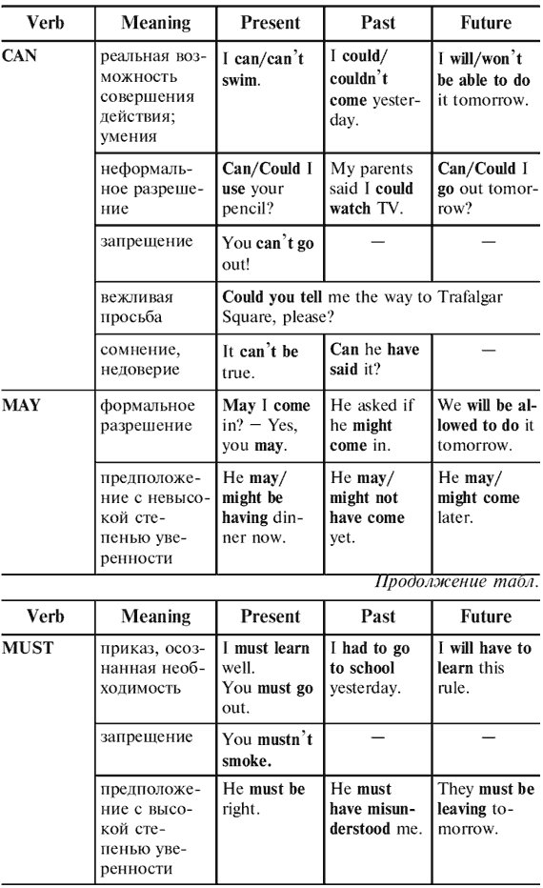
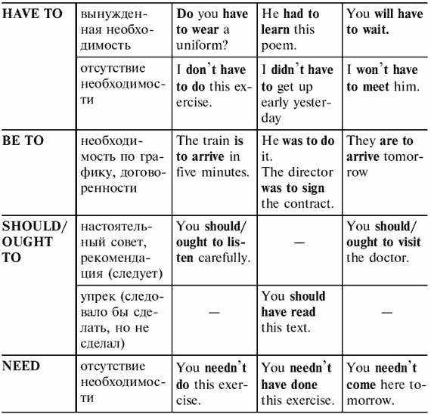
Test 1. Rephrase the following situations using an appropriate modal verb.

1. I advise you to stop eating chocolate. You _________ stop eating chocolate.

2. I insist that you do your homework. You _________ do your homework.

3. Will you let me speak to David, please? _________ I speak to David, please?

4. She can hear you well enough. You _________ shout.

5. Talking is not permitted during the test. You _________ talk during the test.

6. It isn’t right to speak to your mother like that. You _________ speak to your mother like that.

7. It isn’t possible for him to come to the party. He _________ come to the party.

8. He is obliged to go to the police station once a week. He _________ to go to the police station once a week.

9. It’s forbidden to feed the animals in the Zoo. You _________ feed the animals in the Zoo.

10. It isn’t necessary to dust the furniture. You _________ dust the furniture.

11. Would you mind if I read your book? _________ I read your book?

12. Perhaps they’ll come with us. They _________ come with us.

13. Would you mind if I use your glasses? _________ I use your glasses?

14. Let’s try doing this exercise. _________ we try doing this exercise?

15. He can do it himself. Why _________ he ask anybody for help?

16. Perhaps, she will phone them today. She _________ phone them today.

17. Why don’t you go to the sea for a holiday? You _________ go to the sea for a holiday.

18. Would you like me to help you with the dishes? _________ I help you with the dishes?

19. It isn’t right to argue with your parents. You _________ argue with your parents.

20. Perhaps, she is asleep now. She _________ be asleep now.

Test 2. Choose the correct modal verb.

1. Mike _________ play the piano very well. And what about you?

a) can b) should c) must

2. I _________ skate when I was little.

a) can’t b) couldn’t c) mustn’t

3. We _________ hurry. We’ve got plenty of time.

a) can’t b) needn’t c) must

4. _________ you help me with this task?

a) Could b) Must c) May

5. I’m sorry I’m late. _________ I come in?

a) Must b) Should c) May

6. _________ you speak any foreign languages?

a) Can b) Should c) May

7. It’s raining. You _________ take an umbrella.

a) can’t b) don’t have to c) should

8. I’m afraid I _________ come to the party on Friday.

a) can b) can’t c) may

9. You _________ go there at once. It’s really very urgent.

a) don’t have to b) needn’t c) must

10. When I was young, I _________ run for miles.

a) could b) must c) should

11. ‘ _________ I smoke here?’ ‘No, you mustn’t.’

a) Must b) May c) Should

12. ‘ _________ I translate this sentence?’ ‘No, you needn’t.’

a) Can b) May c) Must

13. I looked everywhere for the book but I _________ find it.

a) couldn’t b) mustn’t c) shouldn’t

14. You _________ drive carefully on a busy road.

a) can b) may c) should

15. There’s nothing I _________ do about it.

a) can b) may c) don’t have to

16. Schools _________ teach children the difference between right and wrong.

a) can’t b) mustn’t c) must

17. I don’t feel well today. _________ I leave a bit earlier?

a) Should b) May c) Must

18. That _________ be true! It’s absolutely impossible.

a) can’t b) must c) needn’t

19. Yesterday I stayed at home because I _________ help my father.

a) must b) had to c) can

20. You _________ use my dictionary as long as you like.

a) must b) have to c) may

Test 3. Write should or the correct form of have to in the gaps.

1. Nurses _________ know how to give people injections.

2. You _________ eat more fruit and vegetables.

3. _________ you _________ travel abroad in your job?

4. Tom is ill, he _________ see his doctor.

5. I’m sorry I couldn’t come to your party. I _________ work late.

6. You _________ try to phone your father this weekend.

7. I hope you don’t _________ go home early.

8. Mike is a teacher. He _________ teach different kinds of students.

9. I think Patrick _________ be more polite to his sister!

10. Do I _________ wash up again?

11. A postman _________ get up early every day.

12. I didn’t like the job because I _________ wear a uniform.

13. He ignores me. What _________ I do?

14. I am free on Saturday because I _________ work at the weekend.

15. You look tired. You _________ go to bed now.

16. I think the government _________ do more to help homeless people.

17. He _________ wear a suit to work but he usually does.

18. Last night Don suddenly became ill. We _________ call a doctor.

19. Caroline may _________ go away next week.

20. You _________ read this book. It’s really excellent.

Test 4. Choose the correct modal verb.

1. I don’t want anyone to know it. You (mustn’t/don’t have to) tell anyone.

2. Listen! I (can/must) hear someone crying.

3. When we were at school, we (had to/ought to) wear a uniform.

4. You (don’t have to/mustn’t) wear your seatbelt during the whole of the flight.

5. You (should/have to) tell her that you are sorry.

6. You (need/must) be a member of the library before you can borrow books.

7. I (needn’t/shouldn’t) wear glasses because my eyesight is still quite good.

8. When I first came to Madrid, I (could/couldn’t) say only a few words in Spanish.

9. Helen (must/had to) leave the meeting early because she had a train to catch.

10. I (didn’t need to/couldn’t) get tickets after all – they were sold out.

11. I left my bike outside the house last night and this morning it isn’t there any more. Somebody (can’t/must) have stolen it.

12. ‘I can’t find my umbrella.’ ‘You (should/might) have left it in the restaurant last night.’

13. (Must/May) I see your passport, please?

14. He’s not working tomorrow, so he (doesn’t have to/ should) get up early.

15. Ann was in a very difficult situation. It (must/can’t) have been easy for her.

16. That shirt is dirty. You (ought to/needn’t) wash it.

17. Last year I got a lot of money, so we (had to/were able to) buy a new house.

18. I had forgotten to bring my camera, so I (couldn’t/ shouldn’t) take any pictures.

19. Don’t tell anybody what I said. You (must/can) keep it secret.

20. I’m really hungry. I (could/might) eat a horse!

Test 5. Complete this text using the verbs below.
How to Be а Friend of the Earth There are many simple things we _________ (1) all do to stop the destruction of the environment. First of all, we _________ (2) not dump our rubbish without thinking which things, such as bottles and paper, _________ (3) be recycled. We _________ (4) put objects that we _________ (5) recycle in recycling bins. Secondly, instead of taking our car wherever we go, we _________ (6) to leave it at home whenever possible, and go on foot or by public transport. If there is something wrong with our car’s exhaust pipe, we _________ (7) get it fixed immediately. When we _________ (8) to drive to the supermarket to do our shopping, we _________ (9) always remember to take our own bag, so that we don’t _________ (10) to use the supermarket’s plastic bags.

Test 6. Translate the sentences using modal verbs.

1. Он, наверное, учит это стихотворение уже час.

2. Тебе следовало бы давно забыть об этом.

3. Автобус должен был прийти пять минут назад.

4. Не может быть, чтобы он был занят сейчас.

5. Возможно, он сможет помочь тебе.

6. Вам не надо приходить завтра.

7. Должно быть, ему пришлось сделать это.

8. Не могли бы Вы повторить свой вопрос?

9. Может быть, мне придется работать в воскресенье.

10. Вероятно, он еще делает уроки.

11. Тебе следует закончить эту работу.

12. Через год я смогу говорить по-английски очень хорошо.

13. Что тебе пришлось делать вчера?

14. Можно мне выйти?

15. Он должен был прийти час назад.

16. Неужели он забыл про мой день рождения?

17. Учитель сказал, что мы можем идти домой.

18. Ты не должен читать эту книгу.

19. В прошлом году я не умел плавать, а теперь могу.

20. Возможно, он все еще ждет меня.
10. PREPOSITIONS
10.1. PREPOSITIONS OF TIME
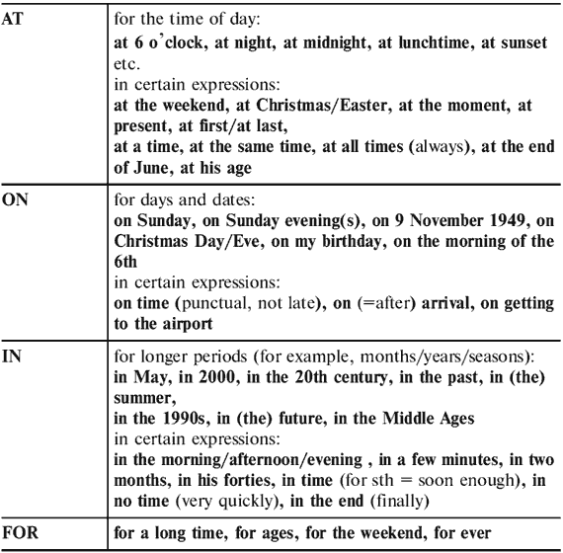
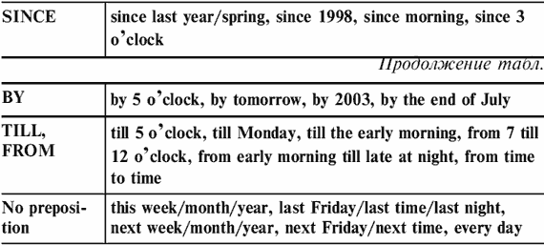
Test 1. Insert prepositions where necessary.

1. She is _________ her sixties, but she looks much younger.

2. The first man walked on the moon _________ 21 July 1969.

3. The telephone and the doorbell rang _________ the same time.

4. What are you doing _________ the weekend?

5. Charles is getting married _________ next year.

6. Columbus made his first voyage from Europe to America _________ 1492.

7. I nearly missed my flight yesterday. I got to the airport just _________ time.

8. I’m busy just now, but I’ll be with you _________ a moment.

9. We often have a short holiday _________ Christmas.

10. Do you work _________ Wednesdays?

11. I didn’t understand the text _________ first, but _________ the end I managed to translate it.

12. I’ll have written a composition _________ 5 o’clock.

13. Mary and Henry always go out for a meal _________ their wedding anniversary.

14. ‘Can I speak to Clare’ ‘I’m afraid, she’s not here _________ the moment.’

15. I work _________ early morning _________ late _________ night.

16. I started learning English _________ the age of five.

17. It was quite a short book and easy to read. I read it _________ a day.

18. We travelled overnight to Paris and arrived _________ 5 o’clock _________ Friday morning.

19. They go out _________ every Wednesday _________ the evening.

20. The train service isn’t very good. The trains are rarely _________ time.

Test 2. Insert prepositions where necessary.

1. I was playing computer games _________ 5 _________ 6 o’clock yesterday.

2. Jazz became popular in the United States _________ the 1920s.

3. I’ll see you _________ next Friday _________ the evening.

4. It’s difficult to listen if everyone is speaking _________ the same time.

5. _________ Saturday night I went to bed _________ 11 o’clock.

6. I don’t know this man, but he seems to be _________ his forties.

7. The bus was late this morning but it’s usually _________ time.

8. I hope the weather will be nice _________ the weekend.

9. I haven’t seen you _________ ages! Where have you been _________ all this time.

10. In Britain most people do not work _________ Sundays.

11. _________ last year we went to France.

12. Jenny’s brother is an engineer, but he’s out of work _________ the moment.

13. I had translated this article _________ 6 o’clock yesterday.

14. Bob is a very fast runner. He can run 100 metres _________ 11 seconds.

15. I went to school _________ the age of 6, so I’ve already been studying _________ 9 years.

16. Pauline got married _________ 18 May 1991.

17. It took me long to find a job. _________ the end I got a job in a hotel.

18. I haven’t met him _________ last Friday.

19. I normally get paid the end of the month.

20. I nearly forgot about Jack’s birthday. Fortunately I remembered just _________ time.

10.2. PREPOSITIONS OF PLACE AND MOVEMENT
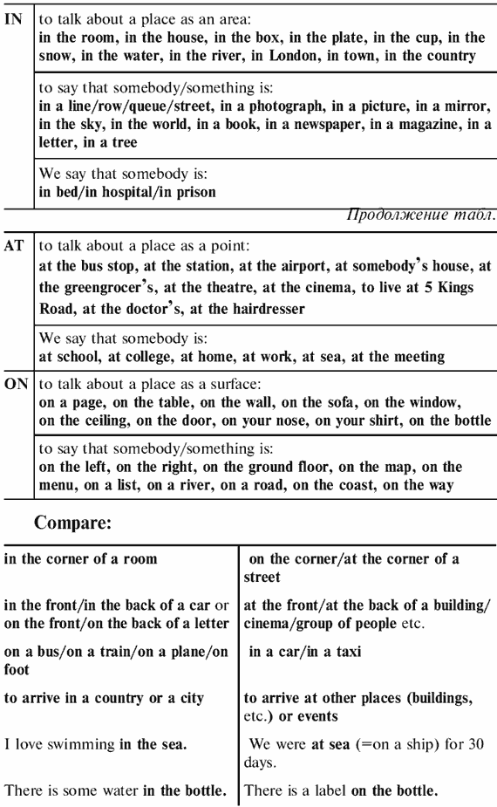
Test 3. Complete the sentences with in, at or on.

1. Mike lives ___ Oxford. He’s a student ___ Oxford University.

2. Write your name ___ the top of the page.

3. Who is this boy ___ that photo?

4. Meet me ___ the bus stop ___ the end of Regent Street.

5. There is somebody ___ the door. Shall I go and see who it is?

6. You’ll find the sports results ___ the back page of the newspaper.

7. Where are the children playing? They are playing ___ the beach.

8. She lives ___ the ground floor.

9. It can be dangerous when children play ___ the street.

10. I usually buy a newspaper ___ my way to work in the morning.

11. London is ___ the river Thames. I like swimming ___ the river.

12. I was sitting ___ the back of the class.

13. His signature was ___ the back of this photo.

14. I don’t know where my umbrella is. Perhaps I left it ___ the chair.

15. Tom is ill. He wasn’t ___ work today. He was ___ home ___ bed.

16. They live ___ Seal, a small village ___ the road to Vladimir.

17. Let’s meet ___ the entrance to the Supermarket.

18. If you walk to the end of the street, you’ll see a small shop ___ the corner.

19. I wasn’t in when you phoned. I was ___ my sister’s house.

20. The exhibition ___ the Museum of Modern Art finished on Saturday.

Test 4. Complete the sentences with in, at or on.

1. The garden is ___ the back of the house.

2. Write your name ___ the back of this envelope.

3. The bus was full. There were too many people ___ it.

4. Tom is ___ work. He works ___ Cambridge ___ the University.

5. When we were ___ the south we stayed ___ a small hotel ___ the coast.

6. Meet me ___ the entrance to the supermarket ___ Oxford Street.

7. There is a public telephone ___ the corner of the street.

8. I haven’t seen Kate for some time. I last saw her ___ Dave’s wedding.

9. It was a very slow train. It stopped ___ every station.

10. When we were ___ France we stayed ___ a hotel.

11. Nick was waiting ___ the bottom of the stairs.

12. Is Tom ___ this photograph? I can’t find him.

13. She waited for him ___ the bus stop ___ the end of Green Street.

14. There was a knock ___ the door.

15. You’ll find details of TV programmes ___ page seven of the newspaper.

16. There’s nobody living ___ the island. It’s uninhabited.

17. I think her flat is ___ the third floor of that building.

18. It was a lovely day. There wasn’t a cloud ___ the sky.

19. We stopped at a small village ___ the way to London.

20. Brighton is ___ the south coast of England. I like swimming ___ the sea.

Test 5. Complete the sentences with in, at or on.

1. They live ___ Baker Street ___ number 12.

2. Sign your name ___ the dotted line ___ the bottom of the page.

3. I saw a taxi ___ the end of the street.

4. Is there anything interesting ___ the paper today?

5. I waited ___ the door for five minutes.

6. There’s an unusual photograph ___ the back page.

7. Don’t sit ___ the grass.

8. My office is ___ the first floor. It’s ___ the left as you come out of the lift.

9. I love to look up ___ the stars ___ the sky at night.

10. ___ my way home I met Nick. He was standing ___ the corner and waiting for somebody.

11. What time did you arrive ___ the hotel?

12. I was standing ___ the back, so I couldn’t see very well.

13. I was sitting ___ the back of the car when we crashed.

14. Have you ever worked ___ a farm?

15. I hate staying ___ home. That’s why I’ve applied for a job ___ the United Nations ___ Geneva.

16. San Francisco is ___ the west coast of the United States.

17. I didn’t see you ___ the party on Saturday. Where were you?

18. (in a restaurant) ‘Where shall we sit?’ ‘Over there, ___ the corner.’

19. I was ___ Ann’s house last night. The rooms ___ her house are very small.

20. We went to the theatre last night. We had seats ___ the front row.

Test 6. Read the text and fill the gaps with a preposition from the list below. There may be several possibilities.
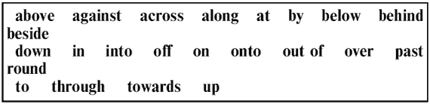
Mary’s Day Out

The sun rose ___ (1) Mary’s house. It was a beautiful day. Mary came ___ (2) her front door and went ___ (3) the path, ___ (4) the gate and ___ (5) the street. She crossed ___ (6) the road and walked ___ (7) the bus stop. The bus arrived and she got ___ (8) the bus. It went ___ (9) the corner, ___ (10) the High Street, ___ (11) all the shops and ___ (12) the countryside. It stopped ___ (13) the duck pond ___ (14) the next village, and Mary got ___ (15). She climbed ___ (16) a stile and started walking ___ (17) a big field. Suddenly, she saw a huge bull running ___ (18) her! She raced ___ (19) the far side of the field and squeezed ___ (20) the hedge. Out of breath, she sat down ___ (21) the grass ___ (22) the river. She leant back ___ (23) a rock. The sun was warm. Mary closed her eyes and listened to the water flowing ___ (24). Soon she was fast asleep. When she awoke, the sun had disappeared ___ (25) the horizon.
10.3. VERBS WITH PREPOSITIONS

Test 7. Fill in the correct prepositions to, about, at, from, for, in, into, on, with.

1. I want to talk ___ the group ___ their exams.

2. All last winter he suffered ___ coughs and colds.

3. When will you write ___ Bill ___ your plans?

4. If you don’t understand any of these words, you could refer ___ a dictionary.

5. The accident sadly resulted ___ the death of a man.

6. The police are appealing ___ witnesses to come forward.

7. It wasn’t his car, in fact I don’t know who it belongs ___.

8. Nurses are very badly paid, I think they should insist ___ higher rates of pay.

9. The poor driver. I really sympathize ___ him, it wasn’t his fault.

10. The buses are often late, so you can’t depend ___ them.

11. Do you qualify ___ a state pension when you are 55?

12. Keep enough money to pay ___ your ticket.

13. Have you heard ___ what had happened ___ him? Oh, I don’t care ___ it.

14. I said ___ you I was thinking ___ going to America. I actually dreamt ___ it.

15. She listened ___ me and then told me ___ her problems.

16. The bus ran ___ the wall of a house.

17. People started to shout ___ the driver.

18. Who was the boy you were all laughing ___?

19. I saw somebody staring ___ me from the other side of the road.

20. He was always arguing ___ his brother.

Test 8. Fill in the correct prepositions to, about, from, in, into, on, with, for.

1. I bumped ___ an old friend of mine the other day.

2. I agree ___ you that we should wait a bit longer ___ her.

3. She never apologizes ___ arriving late.

4. I thought we should look ___ someone else to do the job.

5. If you want to travel, that would be a good job to apply ___.

6. The land belongs ___ a rich man.

7. She then referred ___ the Minister’s report.

8. I congratulate her ___ her success in the exams.

9. The boss disagreed ___ me.

10. The match resulted ___ a draw.

11. His failure resulted ___ lack of attention to details.

12. Tonight I’m going to talk ___ my favourite books.

13. You can count ___ me.

14. You can rely ___ him to be polite.

15. They complained ___ me about the noise.

16. Mary turned her head to speak ___ him.

17. The daughters sided ___ their mothers.

18. Can I speak ___ Jane, please?

19. Can you explain this word ___ me?

20. Can you explain ___ me what you mean?

Test 9. Fill in the correct prepositions to, about, at, from, for, in, of, with.

1. He told me his name but I can’t think ___ it now.

2. This house reminds me ___ the one I lived in when I was a child.

3. We called the doctor because Nick was complaining ___ a pain in his stomach.

4. That’s a good idea. Why didn’t I think ___ that?

5. Look at this photograph of Ann. Who does she remind you ___?

6. She left Boston ___ Paris when she was 19.

7. If something is wrong, why don’t you do anything ___ it?

8. Peter likes his job but he doesn’t talk ___ it much.

9. I like to listen ___ the radio while I’m having breakfast.

10. Please don’t shout ___ me!

11. How often do you borrow books ___ the library?

12. Yes, you are right. I agree ___ you.

13. Cheers! Let’s drink ___ your success.

14. My brother is living ___ a French girl.

15. My children are looking forward ___ Christmas.

16. They arrived ___ the party at 8 p.m.

17. What time did you arrive ___ London?

18. I must introduce you ___ my cousin.

19. Something has happened ___ him.

20. Shall we ring ___ a taxi?

10.4. ADJECTIVES WITH PREPOSITIONS

Test 10. Fill in the correct prepositions of, to, with, at, about, for.

1. He was afraid ___ his enemies.

2. I’ve always been terribly fond ___ you.

3. He is unaccustomed ___ the heat.

4. They may feel jealous ___ your success.

5. I was terrified ___ her.

6. That was clever ___ you.

7. I turned the job down, which was stupid ___ me.

8. My problems are very similar ___ yours.

9. He was dedicated ___ his job.

10. I could never be bored ___ football.

11. He was very pleased ___ her.

12. He was shocked ___ the hatred they had shown.

13. She has always been bad ___ languages.

14. It’s difficult ___ young people to live on their own.

15. It was unusual ___ them to go away at the weekend.

16. It was rude ___ him to leave so suddenly.

17. She was rude ___ him for no reason.

18. She was still angry ___ the results.

19. They’re getting pretty fed up ___ him.

20. If you continue to support someone who is in trouble you are loyal ___ them.

Test 11. Fill in the correct prepositions of, to, with, at, about, for, from.

1. If two things are almost the same, one is similar ___ the other.

2. Someone who is a fine athlete is good ___ games.

3. I was proud ___ my brother.

4. I’m very surprised ___ you. I can’t understand the way you behave.

5. Life is very different ___ what it used to be.

6. Who is responsible ___ this mess?

7. I’m delighted ___ the result. It’s exactly what I wanted.

8. In the army, a sergeant is senior ___ a corporal.

9. If two houses are exactly the same, one is identical ___ the other.

10. If something makes you very unhappy, you are very upset ___ it.

11. If someone makes you very angry, you are furious ___ them.

12. If you feel that you do not trust someone, you are suspicious ___ them.

13. If you treat someone very well, you are being kind ___ them.

14. If you have agreed to marry someone, you are engaged ___ him/her.

15. Everyone was very critical ___ the way he behaved.

16. We were very happy ___ the way they treated us.

17. I was very displeased ___ the way they looked.

18. I feel sorry ___ Nick. He has a lot of problems.

19. I’m sorry ___ the noise last night. We were having a party.

20. That was not very polite ___ you.

10.5. MIXED PREPOSITIONS

Test 12. Fill in the gaps below.

Originally I worked ___ (1) a school teacher, but I applied ___ (2) a grant to study medicine ___ (3) university and was accepted. I specialized ___ (4) mental disorders and then started my present job. I believe completely ___ (5) what I am doing, I never take any time ___ (6) work, and I am totally committed ___ (7) my clients. I have ___ (8) listen carefully to what they say, and sometimes explain ___ (9) them what I think the problem is. Sometimes they start to depend ___ (10) me too much. What is my job? Oh, I forgot to tell you. I am a psychiatrist.

Test 13. Read the letter below and add the preposition which best fits each space.

Dear Mrs Jones,

I am writing ___ (1) reply to your advertisement ___ (2) secretaries to work ___ (3) your central offices. I have already heard ___ (4) you from a friend of mine, Jenny Mansfield, who worked ___ (5) you a few years ago ___ (6) the sales department. I would be interested ___ (7) applying ___ (8) a full-time post. I am quite experienced ___ (9) secretarial work, and would have little difficulty ___ (10) the duties the current job involves. I think I’m quite skilled ___ (11) wordprocessing. I also have wide experience ___ (12) handling members of the public.

I enclose a reference ___ (13) my previous employer and copies ___ (14) my certificates. I would be happy to come for an interview at any time which is convenient for you.

I look forward ___ (15) hearing from you.

Yours faithfully,

Anne Dale

Test 14. Read the text below and add the preposition which best fits each space.

Living a Long Time

It is often said that Japanese people, ___ (1) average, live much longer than Europeans. ___ (2) a large extent this must be due to the food most Japanese people eat since from the point of view of life-style, life ___ (3) modern Japan is no less stressful than ours ___ (4) the west. The Japanese live ___ (5) a diet largely made up ___ (6) fish and rice. ___ (7) lunch-time a typical Japanese family will consume ___ (8) least twice as many vegetables as we do in Europe. ___ (9) comparison with Europeans, the Japanese eat far less meat and fewer potatoes; ___ (10) the same time, they eat seven times more fresh fish than we do which makes their diet much healthier ___ (11) far. It would be fair to say that, ___ (12) general, the Japanese – frequent visitors ___ (13) Europe ___ (14) business or ___ (15) pleasure – are discovering the pleasures and dangers of western-style eating habits.

Test 15. Fill in the gaps in the following letter.

Dear Marjorie,

I’m having problems ___ (1) my studies at school. I find it difficult to get down to work in the evenings and I can’t concentrate ___ (2) anything at the moment. I spend most of my time listening ___ (3) records or watching TV instead ___ (4) doing my homework. The other students in my class are much better than I am and I have difficulty ___ (5) keeping up with them. I sometimes have problems ___ (6) following the lessons as well. I can’t always take ___ (7) the important things my teacher says because I write so slowly. She has told me that I’m falling ___ (8) with my studies. I’m not good ___ (9) writing essays and I usually hand ___ (10) my homework late because I put ___ (11) doing it until the last minute. So I often have to invent silly excuses to explain why I haven’t done the work. I’m sure I’m not going to get ___ (12) my final exams in June. I’m now so far ___ (13) that I don’t know how I’m going to catch up ___ (14) them. My teacher spent some time going ___ (15) my homework with me but she found so many mistakes that I felt even more depressed. What do you suggest I do?

Yours desperately,

George
11. VOCABULARY

11.1. MANY, MUCH, FEW, A FEW, LITTLE, A LITTLE
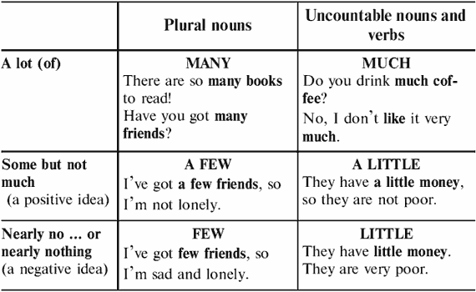
Test 1. Fill in many, much, few, a few, little, or a little.

1. Most people in this city have jobs – there isn’t ___ unemployment.

2. I live in a small village. There is a church, a shop and ___ houses – that’s all.

3. How ___ apples are on the table?

4. We are late. We have very ___ time.

5. He spends too ___ money.

6. ___ effort had been made before the peace treaty was signed.

7. He needs to buy a lot of things but he hasn’t got ___ money.

8. There aren’t ___ chairs in this room.

9. This flat is small so there are very ___ rooms here.

10. I don’t know ___ about these people.

11. He comes here ___ times a week because he has ___ free time.

12. We are destroying ___ trees and forests.

13. We use ___ electricity.

14. We burn ___ coal.

15. People put ___ chemicals into the seas.

16. There is very ___ juice left. I must buy some.

17. There is ___ Coke in the bottle. Do you want some?

18. She hasn’t got ___ homework today.

19. I need ___ eggs and ___ butter to make a cake.

20. ___ people can’t find jobs nowadays.

Test 2. Fill in much, many, few, a few, little or a little.

1. He isn’t popular. He has very ___ friends.

2. Ann is very busy these days. She has ___ free time.

3. Did you take ___ photographs when you were on holiday?

4. I am not very busy today. I haven’t got ___ to do.

5. The museum was very crowded. There were too ___ people.

6. Most of the town is modern. There are ___ old buildings.

7. The weather has been very dry recently. We have had ___ rain.

8. Do you mind if I ask you ___ questions?

9. ‘Would you like milk in your coffee?’ ‘Yes, please. ___.’

10. This is a very boring place to live. There’s ___ to do.

11. Things are not going so well for her. She has ___ problems.

12. This town is not a very interesting place to visit, so ___ tourists come here.

13. Would you like ___ cake?

14. Would you like ___ apples?

15. There are lots of boys in our class, but very ___ girls.

16. Don’t eat too ___ sweets before lunch!

17. Eating too ___ fat is bad for your health.

18. I can’t do much I’m afraid. I have so ___ time.

19. Don’t buy any more cheese. We have ___ left.

20. How ___ cups of coffee do you drink a day?

11.2. SUCH or SO
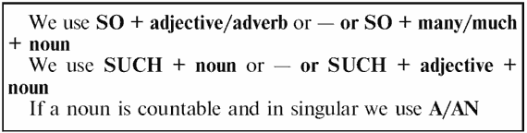
Test 3. Fill in so, such or such a(an).

1. Helena has ___ good sense of humour.

2. She has ___ busy life that she always forgets my birthday.

3. You shouldn’t let ___ small child watch TV ___ much.

4. The weather is ___ nice today. Shall we go for a walk?

5. ‘Has he passed the exam?’ ‘Yes, I think ___.’

6. John is ___ interesting to talk to.

7. They said ___ nasty things about you.

8. Science is changing ___ rapidly.

9. I want to do ___ many different things.

10. He dressed ___ quickly that he put his boots on the wrong feet.

11. She got ___ shock that she dropped the bag.

12. I was ___ excited that I didn’t know it was him.

13. It all sounded ___ crazy that I laughed out loud.

14. They worked ___ quickly that there was no time for talking.

15. ‘Will you be home at 6?’ ‘I hope ___.’

16. The house was ___ untidy. I’ve never seen ___ mess.

17. I haven’t seen her for ___ long.

18. I haven’t seen her for ___ long time.

19. Why did you buy ___ much food?

20. Why did you buy ___ book?

Test 4. Fill in so, such or such a(an).

1. He’s difficult to understand because he speaks ___ quickly.

2. I like Tom and Ann. They’re ___ nice people.

3. It was a great holiday. We had ___ good time.

4. I was surprised that he looked ___ well after his recent illness.

5. Everything is ___ expensive these days, isn’t it?

6. I have to go. I didn’t realise it was ___ late.

7. He always looks good. He wears ___ nice clothes.

8. It was ___ boring film that I fell asleep while I was watching it.

9. I couldn’t believe the news. It was ___ shock.

10. They’ve got ___ much money, they don’t know what to do with it.

11. I didn’t realise you lived ___ long way from the city centre.

12. The food at the hotel was ___ awful. I’ve never eaten ___ awful food.

13. The weather is lovely, isn’t it? I didn’t expect it to be ___ nice day.

14. I think she works too hard. She looks ___ tired all the time.

15. I can’t decide what to do. It’s ___ problem.

16. It’s ___ hot here! Can’t we open a window?

17. She’s got ___ lovely hair!

18. We ate ___ delicious food.

19. There were ___ few people there.

20. We had to pay ___ high price for coffee in London.

11.3. DO or MAKE
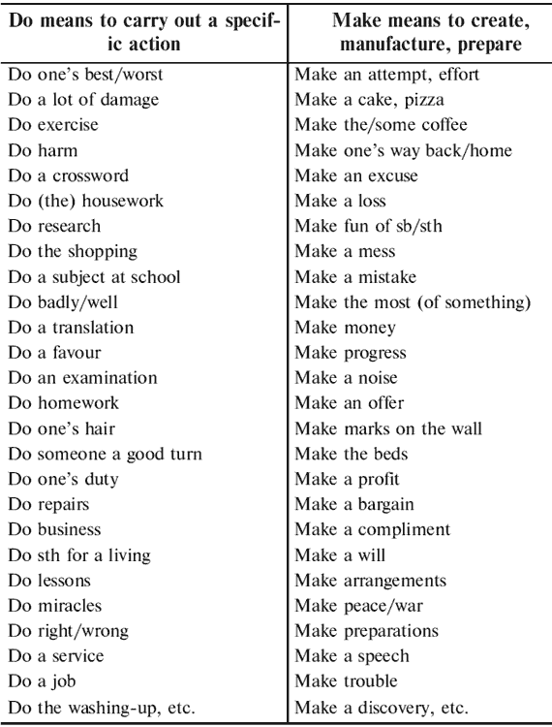
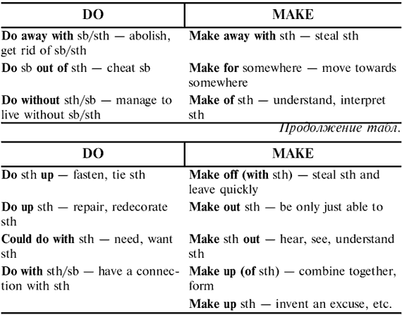
Test 5. Complete the following sentences with an appropriate form of do or make.

1. Her job has something to ___ with marketing.

2. Girls ___ up half of the students in the school.

3. You’ll have to ___ without your dinner if you don’t get back in time.

4. She sits in front of the mirror for ages ___ herself up.

5. The government have decided to ___ away with the old tax law.

6. When the bell rang, the students ___ for the door.

7. Let’s ___ the store room into an extra kitchen, shall we?

8. Speak louder – I can’t ___ out what you’re saying.

9. ___ up your coat – it’s cold.

10. I was ___ out of ten pounds in the shop this morning.

11. They mugged the old lady and ___ off with her handbag.

12. If you ___ your best to explain the problem, I’m sure she’ll understand.

13. What did the robbers ___ off with?

14. It’s about time you ___ some exercise – you’re getting a bit overweight.

15. I don’t know what to ___ of Christina’s odd behaviour just lately.

16. I could have ___ it with more help.

17. I don’t believe him – he’s ___ it up!

18. How many times a week do you ___ the shopping?

19. You must ___ a decision now.

20. To ___ a fortune you have to ___ a lot of hard work.

Test 6. Complete the following sentences with the appropriate form of do or make.

1. I ___ an appointment to see the optician.

2. After he ___ his homework, he found he ___ a mistake.

3. This drug can ___ miracles for people with back problems.

4. They ___ a lot of changes in the town centre recently.

5. You ___ the right thing by telling the police.

6. He ___ an archaeological discovery.

7. After being ill for two weeks, he is now ___ an excellent recovery.

8. She ___ a lot of research in the field of medicine.

9. I ___ an arrangement to meet him at the cinema yesterday.

10. It is important that you ___ exercise in order to keep fit.

11. All that smoking ___ you harm.

12. He ___ an excuse and left the office in a hurry.

13. I always tried ___ my best, but she was never satisfied.

14. He ___ some research into ancient religions at the moment.

15. If you don’t ___ an effort, you won’t any progress.

16. If you pay in cash, we can ___ you a small discount.

17. Please let me know if you have any criticism to ___.

18. Tying a knot in my handkerchief ___ me remember what I have to do.

19. Your explanation simply doesn’t ___ sense.

20. I wonder if you could ___ me a small favour.

Test 7. Fill the gaps in the following text with one suitable word.

Overdoing It

‘OK, you can ___ (1) your shirt up now,’ said Doctor Hymes. He had just given me a thorough check-up and was ___ (2) detailed notes on a big sheet of paper.

‘What do you ___ (3) of it all, doctor?’ I asked anxiously.

‘Well, the first thing is that you could ___ (4) with a good rest. You’ve been overdoing it a bit, haven’t you?’ I admitted. I had been ___ (5) a lot of overtime recently. I had taken a lot on and had ___ (6) a bit of a mess of it all and was suffering from stress. He agreed that that probably had a lot to ___ (7) with it. I had also ___ (8) the mistake of starting to smoke again; in fact my diet was now largely made ___ (9) of coffee and cigarettes. The doctor then reminded me that coffee did a lot of ___ (10) to our nervous system and of course cigarettes ___ (11) a lot of damage to the whole system. He said I should try and ___ (12) without coffee for a few days and make a serious ___ (13) to cut out smoking altogether.

‘And make ___ (14) you have a proper meal every day,’ he warned. His last piece of advice was that I should find time to ___ (15) some jogging every day. I promised him I’d do my best.

11.4. SAY, TELL, SPEAK, TALK
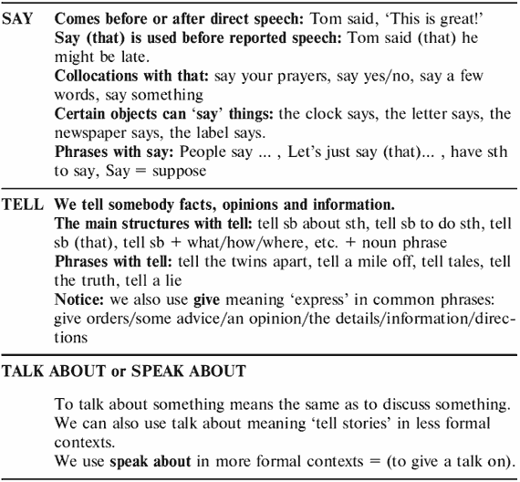
Test 8. Say or tell? Choose the correct variant.

1. George couldn’t help me. He (said/told) me to ask Kate.

2. Kate (said/told) she had many pets at home.

3. Ann (said/told) goodbye to me and left.

4. Sam (said/told) me that Robert didn’t like porridge.

5. I asked him to (say/tell) the truth.

6. Don’t just stand there! (Say/Tell) something!

7. I (said/told) Jim not to shout.

8. Mother (said/told) her son to go to the dentist.

9. (Say/Tell) us about your holiday, please. Did you have a nice time?

10. My cousin (said/told) he could ski well.

11. She (said/told) us her knowledge of French was good.

12. I wonder where Sue is. She (said/told) she would be here at 8 o’clock.

13. Jack (said/told) me that he was fed up with his job.

14. The doctor (said/told) that I should rest for at least a week.

15. Don’t (say/tell) anybody what I (said/told). It’s a secret just between us.

16. ‘Did she (say/tell) you what had happened?’ ‘No, she didn’t (say/tell) anything to me.’

17. Please listen to me! I’ve got something important to (say/tell) you.

18. Fred (said/told) me that you were ill.

19. What did you (say/tell) the police?

20. He (said/told) he had just heard the news.

Test 9. Fill in a suitable form of a verb from the list: say, tell, speak, talk. You can use some verbs more than once.

1. Tom ___ ‘This is great!’

2. She ___ that she might be late.

3. He ___ us the answer.

4. I’m going to ___ something to the neighbours about the noise.

5. She ___ us about her travels around North.

6. ___ us about Africa.

7. I’m going to ___ something about my trip to Africa.

8. The clock ___ it’s five past ten.

9. The newspaper ___ there’s been a hijacking.

10. People ___ he’s a bit crasy.

11. ___ me what you need.

12. It’s impossible to ___ the twins apart.

13. ___ we do this, what would happen?

14. Have you ___ anything to in your defense?

15. She ___ them that she might be late.

16. The policeman ___ me to go with him.

17. I ___ you the reason why I was out late.

18. I’ve never ___ a lie in my whole life.

19. Let’s ___ about the problem.

20. She often ___ about her days as a student.

21. The lecturer is going to ___ about the modern art.

22. Let’s just ___ he doesn’t always ___ the truth.

23. The label ___ it was produced in America.

24. He ___ me to close the door.

25. ‘Close the door,’ he ___.

26. If you have something to ___, say it now.

27. ___ her how to do it.

28. The letter ___ we’ve won first prize.

29. I didn’t do it – somebody’s been ___ tales.

30. She ___ goodbye to her parents.

Test 10. Read the text and add the word which best fits each space: talk, give, say, turn down, persuade, tell, discuss, deny, refuse, convince.

A Friend In Need I can’t ___ (1) when I first realised that Billy was in trouble with the police. He had often ___ (2) to me about his problems and, as his friend, I had ___ (3) him the best advice I could. I also ___ (4) I’d let him come and stay with me but he ___ (5) my offer. I tried to ___ (6) him to stop spending so much money at his club and to sit down and ___ (7) his problems with me but he ___ (8) me to mind my own business. It was difficult to ___ (9) to him after this but I was ___ (10) he was getting into deeper trouble all the time. He had often ___ (11) having anything to do with the local gangs. But then the police came round and asked me to ___ (12) them information about Billy and I couldn’t ___ (13), though I avoided ___ (14) them anything that might do him harm. They asked me to ___ (15) them more details but I managed to convince them that I had (16) the truth.
11.5. PHRASAL VERBS

Test 11. Phrasal verb to come: fill in the correct prepositions or adverbs.

1. It was some time before he came ___ after being knocked out.

2. He came ___ to my way of thinking after a good deal of argument.

3. It’s no use trying to keep this secret; it’s sure to come ___ in the end.

4. The question of salary increases will come ___ at the next general meeting.

5. Those rust marks will come ___ if you rub them with lemon.

6. Seeing me from across the room, she came ___ me.

7. He came ___ a fortune last year. (He inherited it).

8. Wait till prices come ___ again before you buy.

9. Come ___. It’s far too cold to wait here any longer.

10. The handle of the tea-pot came ___ in my hand as I was washing it.

11. I came ___ a vase exactly like yours in an antique shop.

12. I’m at home all day. Come ___ whenever you have time.

13. The expected answer came ___.

14. Has she come ___ the book yet?

15. Come ___ the taxi’s waiting for us.

16. They are coming ___ Sunday.

17. I came ___ to the country cottage in the morning.

18. The button has come ___.

19. He has come ___ the property.

20. The buds are coming ___ now.

Test 12. Phrasal verb to go: fill in the correct prepositions or adverbs.

1. I had to wait for permission from the Council before I could go ___ with my plans.

2. The guard dog went ___ the intruder and knocked him down.

3. He had a sandwich and a cup of tea, then he went ___ working.

4. I went ___ the proposal very carefully with my solicitor and didn’t accept the order.

5. The gun went ___ by accident and wounded him in the leg.

6. Wearing black for mourning went ___ many years ago.

7. She went ___ a beauty contest and got a prize.

8. The price of tomatoes usually goes ___ in summer in England.

9. If there isn’t enough soup to go ___ just put some hot water in it.

10. The early colonists of America went ___ many hardships.

11. You can’t go ___ ___ your promise now; we are depending on you.

12. I’ve changed my mind about marrying him; I simply can’t go ___ ___ it.

13. The plane crashed and went ___ in flames.

14. I refused to go ___ now. I’m going forward.

15. They have gone ___ all the calculations again but they still can’t find the mistake.

16. The party went ___ very well; we all enjoyed ourselves.

17. Mary went ___ in such a hurry that she left her passport behind.

18. Why don’t you go ___ ___ stamp collecting if you want to have a quiet hobby?

19. Her weight went ___ to 70 kilos when she stopped playing tennis.

20. Don’t go ___ food if you want to economize. Just drink less.

Test 13. Phrasal verb to give: fill in the correct prepositions or adverbs.

1. She won $300 and gave it all ___.

2. Riding is getting too expensive; I’ll have to give it ___.

3. He gave ___ all the books he had borrowed.

4. After two days of freedom, the escaped prisoner gave himself ___ to the police.

5. Your secret is safe with me. I won’t give you ___. (betray you).

6. He didn’t want to go to the cinema but they begged him so hard that he gave ___.

7. After his third attempt he gave ___ trying to pass the driving test.

8. The names of the winners were given ___ on the radio.

9. If you want to save money, give ___ eating in expensive restaurants.

10. There was a man giving ___ leaflets outside the church.

11. Don’t give ___ the ending of the story, it will spoil it.

12. What wouldn’t I give ___ a cool drink!

13. The news was given ___ that the political leader had died.

14. Ann gave ___ her college course and left the town.

15. I hope that the holiday will give me ___ my good spirits.

16. Give your examination papers ___ to the teacher when you finish.

17. You would never give ___ your friend’s secret, would you?

18. The liquid gave ___ a strong smell.

19. When are you going to give him ___ his camera?

20. Don’t forget to give ___ your exercise-book.

Test 14. Phrasal verb to put: fill in the correct prepositions or adverbs.

1. Put ___ the clock, it is twenty minutes fast.

2. I’ll put ___ my visit till you can go with me.

3. She had invited me to dinner but had to put me ___ as she was taken ill.

4. Put ___ the light. It’s getting quite light again.

5. That vase is very valuable. Put it ___ before you drop it.

6. He was very much put ___ when she rang off angrily during their conversation.

7. I wish you would put ___ the dishes instead of leaving them on the table.

8. He is not really angry. He’s only putting it ___.

9. The boy is hyperactive. I put it ___ ___ wrong diet.

10. Here’s a crash helmet. Put it ___.

11. I don’t know how you put ___ ___ the noise; it would drive me mad.

12. If you can’t find a room in a hotel, I could always put you ___.

13. The shortage of eggs has put ___ their price considerably.

14. The government put ___ the rebellion with great severity.

15. This clock is always slow; I put it ___ ten minutes every day.

16. He put ___ his name for the excursion.

17. Can you put ___ impractical people?

18. Automation puts ___ profits.

19. Then he put ___ the water to boil and brought out my laundry bucket.

20. He put ___ a whole week of work on that article.

Test 15. Phrasal verb to take: fill in the correct prepositions or adverbs.

1. I couldn’t take ___ the lecture. It is out of my capacity.

2. When he offered me only $3, I was too taken ___ to say a word.

3. She took ___ riding because she wanted to lose some weight.

4. He takes ___ his mother; he has blue eyes and fair hair too.

5. I am sorry I called you a liar. I take it ___.

6. He took ___ going for a walk every night before he went to bed.

7. I wish we could sell the piano; it takes ___ too much space here.

8. You’d better take ___ your coat if you’re too hot.

9. We took ___ each other the first time we met and have been friends ever since.

10. When his father died, Tom took ___ his business.

11. I saw in the water only an old tree. I took it ___ the Lock Ness Monster.

12. People often take me ___ my sister. We look alike.

13. He always takes ___ his false teeth before he goes to bed.

14. I took ___ Tom at chess and beat him.

15. Even a child wouldn’t be taken ___ by such an obvious lie.

16. The policeman took ___ the number of the stolen car.

17. If she takes ___ the job of director, she’ll have to work harder.

18. She makes a little extra money by taking ___ paying guests in summer.

19. He took ___ sister to the concert.

20. Try to take the chairman ___ after the meeting to discover what he thinks.

11.6. CONFUSING WORDS

Test 16. Choose the correct word in each of the following sentences.

1. I thought you said you (were going to/should) give up smoking.

2. Our new neighbours invited me in for a cup of tea. I must say they seem a very (nice/sympathetic) couple.

3. Was it Bell who (invented/discovered) the telephone?

4. I wonder if I might have a (recipe/receipt) for the things I’ve bought.

5. Oh, Jan, could you (remember/remind) me to phone the dentist this afternoon?

6. I wonder if you’d mind (bringing/fetching) John from next door? He’s wanted on the phone.

7. What (more/else) did you do in Spain, apart from swimming and sun-bathing?

8. I’ve just bought a record of Beethoven’s Fifth symphony (conducted/directed) by Karajan.

9. When we moved into our new flat I had to sell my (grand/wind) piano.

10. We’ll have to change the curtains, darling. They don’t (pass/match) the new suite.

11. A (classical/classic) example of actors and actresses playing love scenes was when Richard Burton and Elizabeth Taylor were filming ‘Anthony and Cleopatra’.

12. Many people nowadays are changing from large cars to small ones because they are far more (economic/economical).

13. If you try long enough then you’ll (eventually/possibly) succeed.

14. Miss Bright’s really (effective/efficient), isn’t she?

15. 1066 is one of the most (historical/historic) moments in British history.

16. I can’t read David’s handwriting at all; it’s quite (eligible/illegible).

17. The Centre Party has been (consequential/consistent) in its policy of opposing nuclear power.

18. The new price increases will take (affect/effect) on April 1st.

19. If animals have to be killed for food, then it should be done as (humanly/humanely) as possible.

20. Did you have (an opportunity/possibility) to visit the Louvre when you were in Paris?

Test 17. Choose the correct word in each of the following sentences.

1. There is a very good (Technological/Technical) College not far from where I live.

2. Did you know that Peter had arranged the party (specially/especially) for you?

3. I couldn’t care less one way or the other. I’m completely (uninterested/disinterested).

4. I hear that Manchester United beat Liverpool two – (nil/nought) in the last Cup match.

5. There is a very strong (possibility/opportunity) that man will land on the planet Mars.

6. South Wales was once a flourishing coal-mining area, but today there are hundreds of (misused/disused) coal mines scattered throughout the valleys.

7. My uncle has just got a divorce, which is very strange since he is a marriage guidance (councillor/counsellor).

8. I’m afraid the boot is full. There is no (room/space) for any more suitcases.

9. It’s much too hot. Let’s go and sit in the (shadow/ shade) for a while.

10. I’ll see you next week – (eventually/possibly) on Friday.

11. The tennis match was held up for ten minutes when the (umpire/referee) fainted.

12. Any idea what the present Government’s (politics/policy) is on defence?

13. They climbed up the steep stone (stairs/steps) leading to the old church.

14. I hope he has got a good (solicitor/barrister) to represent him in court.

15. What did you think of the (critic/write-up) we got in the paper this morning?

16. His (financial/economic) worries were solved when he suddenly won $25,000.

17. During the war, Vera Lynn’s songs contributed greatly to the (morals/morale) of the troops.

18. My flat is just around the corner from my office, which is (convenient/comfortable) for me.

19. The house I have just bought is close to shops, schools and other local (amenities/facilities).

20. Do you think the new tax changes will (affect/effect) you very much?
12. WORD FORMATION
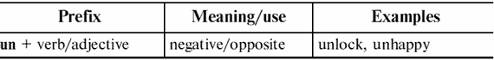
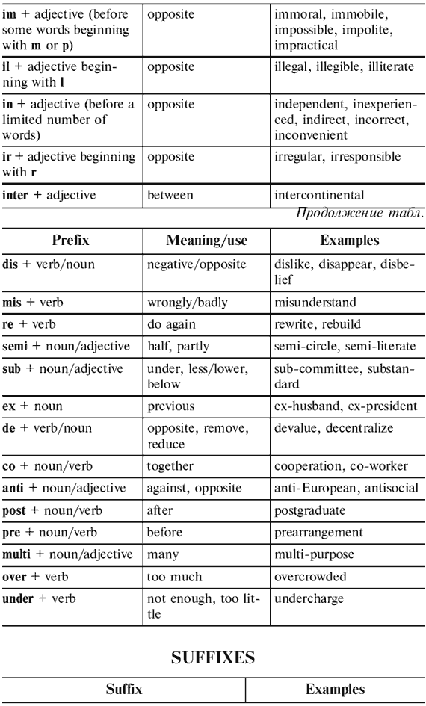
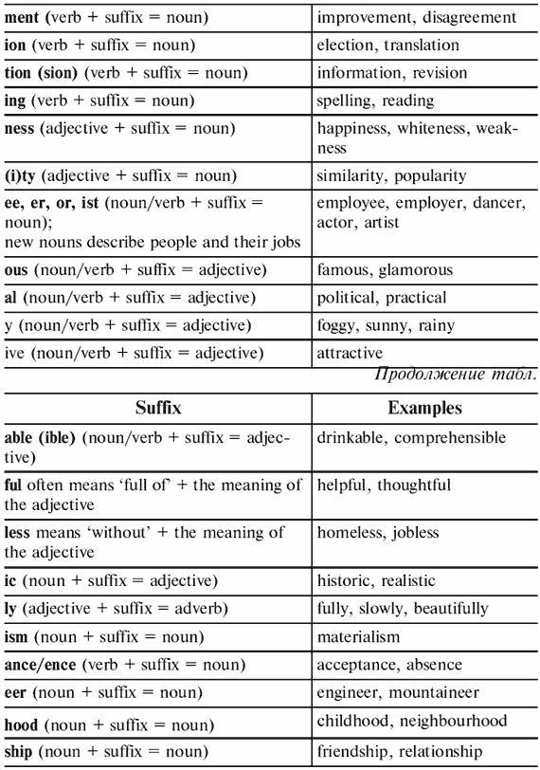
Test 1. Add a prefix to the verb and put it in a proper tense. appoint

Attempts to communicate in a foreign language can easily misfire.

My friend is always ___ (1) by his attempts to speak French. understand

Once a waiter in Paris ___ (2) what he wanted and instead of

beetroots brought him potatoes. He ___ (3) potatoes but when like

he asked a waiter to ___ (4) them with beetroots the waiter smiled, place

and ___ (5) with a plate of aubergines. The waiter also ___ (6) turn

my friend attitude towards everyone he meets and when my take

friend complained that they had ___ (7) the meat, Paul (that was his cook

name if my friend isn’t ___ (8)) grinned. To cap it all my friend take

___ (9) the bill and accused the waiter of ___ (10) him. It was just my read

friend’s awful French again! charge

Test 2. Add a correct prefix to the following adjectives.

1. dependent; 2. polite; 3. logical; 4. historic; 5. Atlantic; 6. moral; 7. national; 8. relevant; 9. regular; 10. direct

Test 3. Add a prefix de-, ex-, multi-, semi-, sub– to the following words. You can use each of them more than once.

1. final; 2. partner; 3. standard; 4. national; 5. section; 6. ethnic; 7. zero; 8. regulate; 9. wife; 10. code

Test 4. Complete the chart with the correct noun. Words in bold will help you.
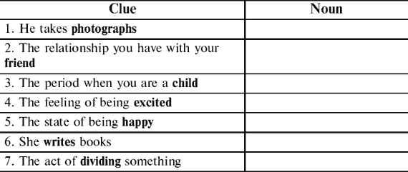
Test 5. Fill in the spaces in the following text using a suitable form of the words given at the end of the lines to form nouns.

It is no exaggeration to say that the world has become а global

village. Modern methods of ___ (1) have made the world much communicate

smaller and the problems we face such as ___ (2) are not restricted pollute

to one country. The ___ (3) of the rainforests in Brazil is destroy

everyone’s problem and the ___ (4) which is common in starve

many African countries is а challenge for Europe too.

The ___ (5) of rare species is а tragedy for the planet as а extinct

whole and the ___ (6) of oil supplies will shake the ___ (7) exhaust

of the world’s economy. The ___ (8) of the environment found

is the responsibility of all nations, rich and poor. protect

However, uncontrolled economic ___ (9) between strong compete

and weak nations leads to the ___ (10) of greater inequality create

between the rich and poor nations of the world.

Test 6. Fill in the spaces in the following sentences with the suitable adjectives formed from given words.

1. It is a very ___ road. danger

2. It was so ___ that she couldn’t see anything. fog

3. Everyone knows this actress. She is very ___. attract

4. This case is very ___. comfort

5. He is a ___ politician. fame

6. Great Britain is an ___ country. industry

7. She plays the guitar and she is very ___. music

8. Her mother is very ___. She economy

always tries to save money.

9. The shop is in the ___ part of the city. centre

10. The people were very ___ and knowledge

answered all her questions.

Test 7. Fill in the spaces in the following text using a suitable negative prefix of the words given at the end of the lines.

The British government has decided to take the ___ (1) decision

to ban smoking in a lot of public places. Though a popular

lot of people find smoking ___ (2), and though experts please

all agree it is ___ (3) and that it costs the state a lot health

to treat victims of smoking, it is also ___ (4) that many people deny

get pleasure from the habit and find smoking resist

___ (5) when they are in company. However, it is now ___ (6) to possible

deny the antisocial nature of the habit. As advertising

has proved ___ (7) with many smokers, the government effect

has now made smoking ___ (8) in most public places. legal

Smokers who are ___ (9) to stop smoking may feel the ability

new measures are unjust, but for the passive smokers for

whom a room full of smoke is ___ (10) they will come as bear

a breath of fresh air.

Test 8. Fill in the spaces in the following text using a suitable form of the words given at the end of the lines.

Speaking English Well

I have a Dutch friend who speaks English ___ (1). I have always beauty

wondered how the Dutch manage to learn languages

so ___ (2). The Dutch, like the Germans, often success

speak English ___ (3) than some native-speakers or well

at least they seem to speak the language more ___ (4) than correct

some English people. Wilfred says that if you

want to speak English ___ (5) with a reasonable fluency

accent, you should listen to tapes as ___ (6) as frequency

possible. If you can afford ___ (7) to go to an occasion

English speaking country, you should go but you should

also study the rules of English ___ (8), especially if care

you want to speak ___ (9). Wilfred also feels accuracy

very ___ (10) that there are no magic solutions strength

but that you simply have to work at the new language.

Test 9. Fill in the spaces in the following text using a suitable form of the words given at the end of the lines.

Memorial Day in the USA

Honoring the dead has been a practice of many ___ (1). civil

The ancient Druids, Greeks, and Romans ___ (2) decoration

the graves of their loved ones with flowers.

In the United States, the ___ (3) have been death

honored on Memorial Day since the time of the Civil

War. In 1967 a ___ (4) of President Johnson proclaim

and a ___ (5) congressional resolution officially join

recognized Waterloo as ‘the birthplace of Memorial

Day’. And the Memorial Day is ___ (6) on observation

the last Monday of May. Each year the President of

the US issues a special Memorial Day ___ (7) which proclaim

includes a call for ___ (8) to observe the city

occasion as a day of prayer for ___ (9). peaceful

Memorial Day observances are by no means ___ (10) limit

to the big ___ (11) cemeteries. In towns and cities,

across the land, veterans’ groups, civic ___ (12), nation

family groups, and individuals decorate graves organize

with flowers or with small American flags. In many

communities there are parades. Parade ___ (13) include participate

veterans and armed forces and a lot of other

people. Memorial Day has also ___ (14) marked tradition

the ___ (15) of summer. begin

Test 10. Fill in the spaces in the following text using a suitable form of the words given at the end of the lines.

This ___ (1) was built in the 1920s and became showcase for ___ (2). neighbour, architecture

Each architect had one plot on which to ___ (3) one house. In spite of this, builder

the area has a ___ (4) unified style. Look, for example, at these wonderful

houses on our left. At that time very few people lived in their owner

___ (5) apartments; those flats had no ___ (6) water, bathrooms and other run, convenient

___ (7). And here was a ___ (8) building project which attempted mass

both to show the ___ (9) styles in which apartments could be difference

built, and to improve ___ (10) conditions. live

Test 11. Fill in the spaces in the following text using a suitable form of the words given at the end of the lines.

Life used to be ___ (1) for teenag ers. They used to have money to funny

spend, and ___ (2) time to spend it in. They used to wear ___ (3) freedom

clothes, and meet in coffee bars and discos. Some of them still teenager

do. But for many young people, life is harder now. Jobs are ___ (4) to find. difficulty

There’s not so much money around. Teachers say that students work ___ (5) hard

than they used to. They are ___ (6) interested in politics, little

and more interested in ___ (7) exams. They know that good exams pass

may get them ___ (8) jobs. Most young people worry more about good

money than their parents did twenty years ago. They try to spend little

___ (9) and save ___ (10). They want to be able to get many

homes of their own one day. Three quarters of ___ (11) young Britain

people do more or less what their parents did. They did their ___ (12) good

at school, find some kind of work in the end, and get married in

their early ___ (13). They get on well with their parents and twenty

enjoy their ___ (14). They eat fish and chips, watch football on live

TV, go the pub and like ___ (15). After all, if they didn’t, they read

wouldn’t be British, would they?

Test 12. Fill in the spaces in the following text using a suitable form of the words given at the end of the lines.

As your children move towards ___ (1) it is ___ (2) to make depend

sure that they understand what decent values are. To importance

prevent children from becoming ___ (3) and ___ (4) you should spoil

not indulge them too much. To make sure that they grow up greed

well– ___ (5) they should be taught to be ___ (6) from an manner

early age. Children should be scolded for bad ___ (7), politeness

which will be an effective way of helping ___ (8) to distinguish behave

right from wrong. You need to reward your ___ (9) when they they

do things well to give them a sense of ___ (10) but you must child

be careful not to overdo it or they may become ___ (11). proud

You should try to make your children ___ (12) and respectful conceit

of other peoples beliefs by exposing them to ___ (13) tolerate

races and cultures. Parents should try to place great difference

___ (14) on setting a good example to their children, important

because children’s behaviour is often an ___ (15) of that imitate

of their parents.

Test 13. Fill in the spaces in the following text using a suitable form of the words given at the end of the lines.

The ___ (1) of children starts as soon as they are born. Boys are educate

allowed to make more ___ (2), to play with guns and cause more noisy

trouble. Such education prepares boys for ___ (3) in the world powerful

but for little else. But all boys are ___ (4). Some boys are differen

good at ___ (5) and poetry whereas others are good at football cook

or maths. Boys aren’t just ___ (6) and rebels, ‘machos’ and conform

‘wimps’. If we can ___ (7) them that all these types are okay, assurance

it may help to reduce the ___ (8) of those boys who are the least macho. bully

Test 14. Fill in the spaces in the following text using a suitable form of the words given at the end of the lines.

The ___ (1) of fingerprints reached Britain in 1901 and systematize

proved ___ (2). In 1930, Scotland Yard set up its first use

___ (3) system to enable officers to compare fingerprints found on classify

the scene of the crime with those of ___ (4) known to the crime

police. Fingerprint technology has advanced ___ (5) since then. great

Different types of powder are used to ___ (6) the impression of the strength

fingerprint before it is taken. Another ___ (7) revolutionary

has been in the way that fingerprints are identified. Today, the

first ___ (8) is done by the computer, which then produces searching

a ___ (9) of possible matches. The final ___ (10) however is select

done by police experts. identify

Test 15. Fill in the spaces in the following text using a suitable form of the words given at the end of the lines.

In the past, any mother would be ___ (1) if her children were pride

round and slightly fat. Those days are gone. ___ (2) have now research

reached the ___ (3) that too much fat and sugar in children’s conclude

diets are a major factor in the ___ (4) of heart diseases and develop

other ___ (5) when they are older. However, growing children need ill

to eat a wide range of foods, and their general health could be

___ (6) by cutting out particular ones. Psychologists say that the danger

___ (7) is not to change eating habits too fast, but to do it ___ (8), solve

so that children do not lose muscle in addition to fat. Parents should care

present food a little ___ (9), spread butter thinly and avoid difference

putting sugar on the table. Children should also be ___ (10) to courage

take part in sports: this way they will be using the calories

that they have eaten.

Test 16. Fill in the spaces in the following sentences using a suitable form of the words given at the end of the lines.

1. What can we do to reduce the ___ of the atmosphere? pollute

2. The change in the climate has produced ___ floods. disaster

3. Many rare species are threatened with ___. extinct

4. Many of the gases produced by factories are ___ to our health. harm

5. Exhaust fumes have ___ effects on the environment. damage

6. Many countries must try and control the growth of the ___. populate

7. Protecting the environment is essential to our ___. survive

8. The protection of the environment is everyone’s ___. responsible

9. While some countries get richer, the ___ in others get worse. poor

10. Millions of people in the world are threatened with ___. Starve
13. EXAM PRACTICE
Test 1

1. Read the text and put the words at the end of each line into the correct form.

The Bald Eagle

In 1782, soon after the United States won its independence, the bald

eagle ___ (1) as the national bird of the new country. American choose

leaders wanted the eagle to be а symbol of ___ (2) country because it they

is one of the ___ (3) birds. Today the bald eagle strong

almost ___ (4) from the country. In 1972 there ___ (5) only 3,000 disappear be

bald eagles in the entire United States. The reason for the

bird’s ___ (6) population was pollution of rivers by pesticides. Pesticides decrease

poison the fish. Eagles eat these fish and then the eggs eagles

lay have very thin shells and ___ (7). Today, the American government not hatch

and the American people ___ (8) to protect the bald eagle. The try

number of bald eagles slowly ___ (9). The American increase

national bird ___ (10), and remains а symbol of strength and courage. survive

2. Read the text. Use the word given at the end of each line to form a word that fits the space in the same line.

Our ___ (1) in New York was spectacular. Its skyscrapers and the arrive

Statue of Liberty make а ___ (2) sight. New York has а ___ (3) beauty

of over seven million and it is probably the world’s most populate

famous city. The ___ (4) of the ‘Big Apple’ come from many inhabit

different countries. There are more ___ (5) in New York than in any nation

other place on earth. It also has more ___ (6) than any tour

other city except London, ___ (7) in the summer. ___ (8) special

come from all over the world and have а ___ (9) time. There visit

are so many sights for them to get ___ (10) about wonder

whether it’s some of the best museums in the world or the enthusiasm

charming little streets of Greenwich Village.

3. Choose the most suitable word for each space.

Viewed from the outside, the Houses of Parliament give а firm impression of all those ___ (1) which we are supposed to value in the British form of government. The architecture gives the place а ___ (2) look, and the buildings are sandwiched between а busy square and the river making them а ___ (3) between the country house of an eccentric duke and а Victorian railway station. You have only to learn that the ___ (4) refer to each other as ‘The Honourable Member for So and So’ to complete the picture of а dignified gentlemen’s club, with of course а few ladies to ___ (5) the numbers. Sadly, over the past few years first radio, and now television, have shown the general ___ (6) what in fact goes on when bills are ___ (7) and questions are asked. The first obvious fact is that the chamber is very rarely full, and there may be only а ___ (8) of members present, some of ___ (9) are quite clearly asleep, telling jokes to their neighbour, or engaged in shouting like badly-behaved schoolchildren. There is not enough ___ (10) for them all in the chamber in any case, which is а second worrying point. Of course, television does not follow the work of ___ (11) which are small discussion groups that do most of the real work of the House. But the ___ (12) impression that we as ___ (13) receive of the workings of government is not а good one. To put it bluntly, parliament looks disorganised, is clearly behind the times and seems to be ___ (14) with bores and comedians. This is presumably why members resisted for so long the efforts of the ВВС to broadcast parliamentary ___ (15) on television.

1. a) views b) appearances c) identities d) features

2. a) fashionable b) traditional c) close-up d) notorious

3. a) mixture b) combination c) cross d) match

4. a) members b) candidates c) delegates d) senators

5. a) take away b) bring about c) make up d) set in

6. a) situation b) public с) interest d) rule

7. a) paid b) determined c) voted d) discussed

8. a) handful b) majority c) few d) number

9. a) these b) whom с) them d) others

10. a) seats b) places c) room d) around

11. a) elections b) those c) everyone d) committees

12. a) overall b) visual c) positive d) striking

13. a) audience b) often c) voters d) well

14. a) working b) inevitably c) filled d) much

15. a) matters b) committees c) speeches d) debates
Test 2

1. Read the text and put the words at the end of each line into the correct form.

Tricks on April Fool’s Day In 1698, a number of Londoners received invitations

to see the lions washed in the Thames. This event ___ (1) in news describe

papers. However, the same trick ___ (2) in 1860, and again a lot of repeat

curious Londoners ___ (3) to enjoy the lions washed. In 1957 BBC come

Television played an even ___ (4) joke on its viewers. It showed hilarious

a film about a spaghetti crop ___ (5) in Southern Switzerland. grow

Agricultural workers ___ (6) long strands of spaghetti from bushes pick

and the presenter of the film ___ (7) on the uniform length of the comment

spaghetti and on the successful cultivation of ‘these vegetables’. After be

the programme there ___ (8) a lot of calls from people who not get

___ (9) the joke and wanted to know where they ___ (10) buy spaghetti bushes. can

2. Read the text. Use the word given at the end of each line to form a word that fits the space in the same line.

Americans talk with ___ (1) of their government and ___ (2). They proud, institute

seem certain that they have more ___ (3), better laws and free

stronger leaders. But even the most ___ (4) Americans have а few doubts. patriot

___ (5) is one problem area, and so is the law. There are not educate

enough clever teachers, and too many clever ___ (6). But Americans law

feel ___ (7) that they can change things that don’t work. Americans confidence

want to be proud of their President. They like him to be good-looking,

___ (8), and a good family man. They want him to be a good ___ (9). religion, talk

They expect him to keep the prices down at home and to keep the

country looking ___ (10) abroad. power

3. Choose the most suitable word for each space.

Have you ever asked yourself what you are working for? If you have ever had the time to ___ (1) this taboo question, or put it to others in moments of weakness or confidentiality, you ___ (2) well have heard some or all of the ___ (3). It’s the money of course, some say with а smile, as if explaining something to а small child. Or it’s the satisfaction of ___ (4) well done, the sense of achievement behind the clinching of an important ___ (5). I worked as а bus conductor once, and I can’t say I ___ (6) the same as I staggered along the swaying gangway trying to ___ (7) out tickets without falling over into someone’s lap. It’s the company of other people perhaps, but if that is the ___ (8), what about farmers? Is it the conversation in the farmyard that keeps them captivated by the job? Work is power and а sense of status say those ___ (9) have either attained these elusive goals, or feel aggrieved that nobody has yet recognised their leadership ___ (10). Or we can blame it all on someone else, the family or the taxman. I suspect, and I say this under my ___ (11), that most of us work hoping for something to ___ (12) up. We’ll win the pools, and tell the boss what we really think. We’ll scrape together the ___ (13) and open that little shop we always dreamed of, or go ___ (14) the world, or spend more time in the garden. One day we’ll get that ___ (15) we deserve, but until then at least we have something to do. And we are so busy doing it that we won’t have time to wonder why.

1. a) propose b) meditate c) consider d) launch

2. a) might b) can c) will d) should

3. a) below b) rest c) following d) latter

4. a) a work b) а job c) а task d) an effort

5. a) deal b) position c) job d) engagement

6. a) enjoyed b) wished c) hoped d) felt

7. a) make b) turn с) issue d) give

8. a) one b) case с) question d) former

9. a) people b) must c) who d) to

10. a) qualities b) status c) property d) requirements

11. a) oath b) suspicion c) breath d) pressure

12. a) move b) turn с) ease d) end

13. a) resources b) opportunities c) rest d) money

14. a) round b) over c) into d) to

15. a) ambition b) station c) vocation d) promotion
Test 3

1. Read the text and put the words at the end of each line into the correct form.

Mountain Biking In the past people ___ (1) watching TV or reading enjoy

in their free time. Nowadays people are more interested in doing ___ (2) activity

which take them out of their homes. That’s why mountain biking

___ (3) a very popular sport in recent years. It is one of the ___ (4) become, reward

ways to explore the countryside. Cyclists must pay attention to the

type of path they ___ (5) on. Some paths ___ (6) for people be, design

who are on foot, so if you cycle along these, you ___ (7) inconvenience cause

to walkers. On any other path, you should still respect walkers.

Another thing which you ___ (8) to do is ___ (9) gates behind you, so ask, close

that farm animals cannot escape. If the weather is fine, you will

enjoy a wonderful day out, especially if you ___ (10) to take not forget

some food and drinks with you.

2. Read the text. Use the word given at the end of each line to form a word that fits the space in the same line.

When the famous explorer, Columbus claimed Florida for Spain in 1492,

he had never ___ (1) eyes on it. The area’s most important early ___ (2) lay, visit

thus set а pattern that has continued for centuries. There is а

general ___ (3) amongst people, apparently quite ___ (4) with whether believe, connect

or not they’ve been there themselves, that Florida is а good place

to go. In fact, it is almost ___ (5) not to enjoy yourself in Florida possible

today, given the wonderful ___ (6) of facilities available to tourists. select

Some of the world’s most popular tourist ___ (7) are located in the attract

state whose ___ (8) beaches welcome 40 million people each year. sand

These days it seems ___ (9) to describe Florida’s geography and point

climate. After all, few people would have ___ (10) in finding it on difficult

а map and most would know what weather to expect there.

3. Choose the most suitable word for each space.

After more than fifty years of television, it might seem only obvious to conclude that it is here to ___ (1). There have been many objections to it during this time and ___ (2) а variety of grounds. Did it cause eye-strain? Was the ___ (3) bombarding us with radioactivity? Did the advertisements ___ (4) subliminal messages, persuading us to buy more? Did children turn to violence through watching it, either because so ___ (5) programmes taught them how to shoot, rob, and kill, or because they had to do something to counteract the hours they had ___ (6) glued to the tiny screen? Or did it simply create а vast passive ___ (7), drugged by glamorous serials and inane situation ___ (8)? On the other hand, did it increase anxiety by sensationalising the news (or the news which was ___ (9) by suitable pictures) and filling our living rooms with war and political unrest? ___ (10) in аll, television proved to be the all-purpose scapegoat for the second half of the century, ___ (11) for everything, but above all, eagerly watched. For no ___ (12) how much we despised it, were bored by it, or felt that it took us away from the old paradise of family conversation and hobbies ___ (13) as collecting stamps, we never turned it off. We ___ (14) staring at the screen, aware that our own tiny ___ (15) was in it if we looked carefully.

1. a) long b) stay c) exist d) be

2. a) with b) over c) by d) on

3. a) screen b) danger c) machine d) reason

4. a) contain b) of c) take d) having

5. a) that b) far c) many d) what

6. a) almost b) spent c) quite d) madly

7. a) programme b) personality c) audience d) tense

8. a) comedies b) programmes c) perhaps d) consequently

9. a) taken b) presented c) capable d) accompanied

10. a) Taken b) All c) Somewhat d) Thus

11. a) broadcasting b) looking c) blamed d) ready

12. a) one b) matter c) difference d) reason

13. a) known b) even c) described d) such

14. a) refused b) received c) turned d) kept

15. a) fault b) reflection c) situation d) consciousness
Test 4

1. Read the text and put the words at the end of each line into the correct form.

The American People Black, white, rich, poor – you can find them all in the USА, one of big

the ___ (1) countries in the world. The great American idea ___ (2) that all these people always be

should become something new. They should leave their old ___ (3) behind and become life

American. In some ways, the idea ___ (4). work

Many people ___ (5) where their grandparents came from. forget

They share the ideas, experiences, and feelings that make up the American culture. now ask

But new questions ___ (6). Some people wonder if too much ___ (7). lose

They are becoming more interested in the countries their families leave

once ___ (8). They are not sure if new immigrants should try ___ (9) their own forget

languages and cultures so completely. Americans talk а great deal about

how wonderful it is to be American. The reason may be because they need to

keep ___ (10) themselves that that is what they are. remind

2. Read the text. Use the word given at the end of each line to form a word that fits the space in the same line.

Dear Sir or Madam,

I read your ___ (1) in International Business advertise

magazine and I am writing for more information concerning entry ___ (2) require

for the course in English Language. Could you tell me what language ___ (3) qualify

are required? I do not possess the First Certificate and would like to know

if ___ (4) on the course depends on having the FCE? In fact, as I am an accept

___ (5) for an international company I would be interested in a course account

which focuses on language ___ (6) for both social and develop

___ (7) purposes. I would also like to know the ___ (8) from the busy, distant

college to London and if ___ (9) at all classes is obligatory, attend

or whether an occasional ___ (10) for purposes of travel be acceptable. absent

I look forward to hearing from you.

Yours faithfully,

Nelson Fernandez

3. Choose the most suitable word for each space.

Nobody knows for certain what the origin of music was. Music is certainly older than poetry and painting but as early man had no way of ___ (1) it, we can only ___ (2) what it sounded like. Watching а child ___ (3) on а drum with its hands or а ___ (4) of wood, it is easy to see that this is the simplest of instruments. It does not ___ (5) much effort to produce а rhythm on it. Wall paintings show what some of the first instruments ___ (6) like. Early civilisations had already discovered the three basic ___ (7) of producing music: blowing into а tube, striking an object, and scraping а string. We know that western music comes from the ___ (8) Greeks. The musical scales we use now are ___ (9) on certain sequences of notes which the Greeks used to create а particular ___ (10). Until the 16th century, most players of instruments were ___ (11) performers, but as music became more ___ (12), orchestras and musical groups began to ___ (13). This ___ (14) about the writing of music to be played by several musicians at one time. This can certainly be ___ (15) the birth of modern music.

1. a) recording b) playing c) producing d) performing

2. a) think b) reckon c) guess d)realise

3. a) hitting b) knocking c) crashing d) banging

4. a) slice b) point c) piece d) shape

5. a) make b) call c) take d) do

6. a) looked b) appeared c) felt d) sounded

7. a) forms b) manners c) systems d) ways

8. a) ancient b) old c) aged d) antique

9. a) raised b) based c) established d) supported

10. a) spirit b) temper c) mood d) humour

11. a) separate b) lonely c) unique d) single

12. a) widespread b) enlarged c) expanded d) extended

13. a) turn b) appear c) spring d) be

14. a) produced b) affected c) caused d) brought

15. a) appointed b) called c) decided d) named
Test 5

1. Read the text and put the words at the end of each line into the correct form.

One morning Mr Sherlock Holmes was sitting in his room in Baker Street.

His friend Dr Watson was standing near the window ___ (1) at a walking stick. look

This stick ___ (2) by a strange visitor the day before. The words forget

‘To Dr Mortimer’ ___ (3) on it. Dr Watson had already been examining write

it for half an hour but ___ (4) say anything about it. Suddenly not can

Sherlock Holmes ___ (5), ‘The owner of this stick has a dog which is say

___ (6) than a terrier. I have noticed the marks of a dog’s ___ (7) large, tooth

on the stick. Probably the dog often ___ (8) the stick behind the carry

master.’ ‘I wonder why this man wanted to visit us,’ asked Dr Watson.

‘Well, we soon ___ (9),’ answered Sherlock Holmes. ‘I can hear know

the bell ___ (10).’ ring

2. Read the text. Use the word given at the end of each line to form a word that fits the space in the same line.

School Then and Now Parents and teachers are always making ___ (1) compare

between the time when they were ___ (2) and the child

present ___ (3). They say everything was better than it generate

is today, especially in ___ (4). For example, they say they educate

used to work much ___ (5) in school, and that nowadays, we hard

aren’t very interested. I ___ (6), because we spend hours agree

every day doing homework after our lessons or ___ (7) for revise

___ (8). I wonder if our parents really had to study so much examine

after school every day. In my opinion, it is no ___ (9) to exaggerate

say we have forgotten how to play. I think one reason why kids behave

___ (10) in class is because they need to get rid of stress.

3. Choose the most suitable word for each space.

According to а group called The Voices Foundation, everyone has а singing voice as well as а speaking voice somewhere inside them. This, they say, should be encouraged from an early ___ (1) because it provides the best, and the cheapest, ___ (2) on which to build an understanding of music. ___ (3) the Foundation’s ideas, lies the teaching of the Hungarian composer Zoltan Kodaly. He observed that song can ___ (4) а key part of the relationship between mother and child almost from birth. This is especially ___ (5) of more traditional societies, like those of West Africa, where some small children are ___ (6) to sing literally hundreds of songs, all of which have been learnt by ___ (7). But many modern children first ___ (8) to an understanding of music when they learn to play an instrument, and ___ (9) some teaching of the theory of music is usually а part of this, their relationship with the music on the ___ (10) is often а mechanical one. The ___ (11) of the Voices Foundation is that а natural ___ (12) for rhythm, harmony and musical structure, the very ___ (13) we appreciate in the greatest musicians, can only be achieved through the exploration of music with the voice from the start. The Foundation has, therefore, ___ (14) itself the task of developing а singing-centred musical education programme that could ___ (15) junior pupils all over the world.

1. a) start b) life c) time d) age

2. a) ground b) basis c) root d) plot

3. a) Behind b) Beneath c) Besides d) Between

4. a) grow b) do c) form d) make

5. a) fact b) true c) real d) actual

d) fit 6. a) able b) expert c) skilled

7. a) repeat b) heart c) memory d) mind

8. a) come b) reach c) go d) arrive

9. a) however b) despite c) although d) whether

10. a) lines b) notes c) book d) page

11. a) rule c) trust d) belief b) certainty

12. a) awareness b) touch c) grasp d) feeling

13. a) degrees b) qualities c) measures d) practices

14. a) let b) set c) put d) cut

15. a) benefit b) favour c) gain d) profit
Test 6

1. Read the text and put the words at the end of each line into the correct form.

A Practical Joke Mr and Mrs Parker were having a quiet day at home. Their

18-year-old daughter was away in Wales ___ (1) with a friend. Suddenly stay

the phone ___ (2). A hoarse voice told Mr Parker that his daughter ring

___ (3) and that he had to pay a ransom of $2,000. He was also warned that kidnap

if he ___ (4), he would never see his daughter again. The voice then not pay

gave him instructions about where and when to hand over the money. one

Mr Parker took the ___ (5) train to Wales. He went to the hotel and gave

the briefcase with the money to a woman in a scarf and a raincoat. At 11 p.m.

the same evening, to his great relief, his daughter came back home. She happy

looked ___ (6) than ever and could hardly stop herself from ___ (7) laugh

when she handed him his briefcase with $2,000. It turned out that she decide

and her friend ___ (8) to play a practical joke. The joke ___ (9) but, work

strangely enough, Mr and Mrs Parker ___ (10) it as much as their not enjoy

daughter did!

2. Read the text. Use the word given at the end of each line to form a word that fits the space in the same line.

How to Learn Vocabulary Students are under enormous pressure to learn

huge amounts of vocabulary but they are rarely given ___ (1) as to how to guide

go about it. They have a ___ (2) to try and learn long lists by tend

heart, but this is hardly the most ___ (3) approach to the problem. efficiency

The golden rule is to do lots of ___ (4) at regular intervals. Secondly, revise

students should concentrate on words with the highest ___ (5), particularly frequent

everyday words which also improve the students’ spoken ___ (6). fluent

They should also take every opportunity to use the words in communication –

there is considerable ___ (7) evidence that learners who like psychology

using the foreign language improve their oral ___ (8) and their perform

overall ___ (9) of the language much more rapidly than acquire

students who are ___ (10) to practise the language in real situations. reluctance

3. Choose the most suitable word for each space.

Keeping fit and staying healthy have become а growing industry. ___ (1) apart from the amount of money spent each year on doctors’ ___ (2) and approved medical treatment, huge sums are now spent on health foods and ___ (3) of various kinds, from vitamin pills to mineral water, not to mention health clubs and keep-fit ___ (4) and videos. We are more concerned than ever, it seems, ___ (5) the water we drink and the air we breathe, and are smoking less, though not yet drinking less alcohol. This does not appear to mean that ___ (6) and sneezes have been banished, or that we can all expect to live to а hundred. To give а personal example, one of my friends, who is а keep-fit ___ (7), а non-smoker and teetotaller, and who is very ___ (8) about what he eats, is at present languishing in bed with а wrist in ___ (9) and а badly sprained ankle. Part of his healthy ___ (10) is to play squash every day after work, and that ___ (11) for the ankle. He also cycles everywhere, and if you have ever tried to cycle through the rushhour traffic with а sprained ankle, you will understand ___ (12) he acquired the broken wrist. For _____ (13), it seems, is not just а matter of а good ___ (14) and plenty of exercise. Too much exercise can be harmful, as many joggers have discovered. Eating the right food can easily become an obsession, as can overworking, which you might have to do so as to be able to afford your ___ (15) of the squash club, your mountain bike, your health food, and а few holidays in peaceful and healthy places.

1. a) Poles b) Far с) Quite d) So

2. a) prescriptions b) surgeries c) hospitals d) payments

3. a) medications b) cures c) drugs d) remedies

4. a) books b) television c) advice d) enthusiasts

5. a) than b) about c) for d) hence

6. a) colds b) coughs c) flu d) fevers

7. a) fanatic b) follower c) fad d) person

8. a) interested b) varied c) detailed d) particular

9. a) crutches b) plaster c) treatment d) danger

10. a) living b) lifetime c) lifestyle d) liveliness

11. a) is b) caters c) depends d) accounts

12. a) how b) that c) whenever d) thus

13. a) fit b) this c) health d) all

14. a) diet b) eating c) menu d) recipe

15. a) share b) visit c) membership d) subscription
Test 7

1. Read the text and put the words at the end of each line into the correct form.

What Can Computers Do?

Computers and microchips _____ (1) part of our everyday lives: we become

read magazines which _____ (2) on computer, we buy things with the produce

help of computers, we pay bills _____ (3) by computers. Just _____ (4) prepare

а phone number involves the use of а sophisticated computer system. dial

In the past, life without computers was much _____ (5) than it is today. difficult

The _____ (6) computers were able to multiply long numbers, but they one

_____ (7) do anything else. Nobody _____ (8) stories about robots not can

and space travel, but now computers are able to do almost all difficult jobs. believe

What makes your computer such а miraculous device? It is а calculating machine speed

that _____ (9) up financial calculations. It is а personal communicator

that _____ (10) you to interact with other computers and with people around enable

the world. And you can even use your PC to relax with computer games.

2. Read the text. Use the word given at the end of each line to form a word that fits the space in the same line.

A Challenge for Europe

Although recently there has been a small _____ (1) in the number of people out reduce

of work in Europe, _____ (2) is still the number one _____ (3) employ, society

problem facing the 15 member states of the European Union. Moreover,

_____ (4) of opportunity between men and women is still an issue that equal

_____ (5) in many countries have not come to grips with. In _____ (6) political, professional

such as law and engineering women are still noticeable by their

absence. _____ (7) still discriminate against women in a number of employ

ways even if their _____ (8) are the same as those of men. It would qualify

be a pity if the _____ (9) of the EU on an economic level were marred achieve

by _____ (10) in the vital area of social policy. fail

3. Choose the most suitable word for each space.

Trees are amongst the biggest and longest-living things on Earth, some dating back longer than the oldest buildings. But _____ (1) being nice to look at, trees also _____ (2) an important role in improving the quality of our lives. On a world-wide _____ (3), forests help to slow down the effects of global warming by using up the gas _____ (4) as carbon dioxide and giving _____ (5) the oxygen we need to breathe. At local neighbourhood level, trees also _____ (6) important environmental benefits. They offer shade and shelter, which in _____ (7) reduces the amount of energy needed to heat and cool _____ (8) buildings; at the same time, they also remove other impurities from the air we breathe. Urban trees are especially important because for many people they provide the only daily _____ (9) with the natural world. What’s _____ (10), urban trees also provide a home for birds, small animals and butterflies. _____ (11) the trees we would lose the pleasure of seeing these creatures in our cities. Regrettably, _____ (12), trees in cities are now coming under _____ (13). There is a limit to the level of pollution they can _____ (14) and, down at street level, their roots are being seriously _____ (15) by the digging needed to make way for modern telephone, television and other cables.

1. a) as far as b) as long as c) as soon as d) as well as

2. a) play b) show c) act d) serve

3. a) scale b) size c) range d) area

4. a) called b) known c) titled d) referred

5. a) in b) away c) up d) out

6. a) bring b) make c) take d) find

7. a) turn b) place c) order d) reach

8. a) opposite b) close c) next d) nearby

9. a) junction b) touch c) contact d) taste

10. a) more b) else c) most d) other

11. a) Throughout b) Beyond c) Without d) Outside

12. a) therefore b) whilst c) however d) despite

13. a) risk b) threat c) danger d) warning

14. a) stand in for b) face up to c) put up with d) fall back on

15. a) concerned b) disturbed c) interfered d) involved
Test 8

1. Read the text and put the words at the end of each line into the correct form.

Street Styles

Many people, especially young people, wear things which express their ideas

and feelings about life. If a boy _____ (1) very short, almost shaven hair, have

people expect him _____ (2) right wing politics. But boys with very have

long hair _____ (3) to have left wing politics. A boy who wears a leather think

jacket _____ (4) in bits of metal will probably ride a motorbike. The cover

rules of fashion are not as rigid as they once _____ (5) and today’s be

teenagers _____ (6) any particular trend at all. But teens are very not follow

influenced by _____ (7) and they have a desire to buy more luxurious celebrity

items. Street styles _____ (8) by the big fashion designers. In fact, not create

the fashion designers often use ideas from street fashions. But some

leaders of British fashion have enough ideas of _____ (9) own. One of them they

is Jean Muir, whose designs let her be one of the _____ (10) designers. good

2. Read the text. Use the word given at the end of each line to form a word that fits the space in the same line.

I have only been once to an art _____ (1). In fact, the Tate in London exhibit

was my _____ (2) to modern art, but although the gallery was introduce

quite interesting, I found the pictures difficult to understand. The _____ (3) paint

in the exhibition were by famous _____ (4) from all over the world. Our art

guide told us about each painting, and I listened carefully to her _____ (5). explain

After she had given us а _____ (6) of а painting by Picasso, 1 asked her describe

what it all _____ (7). She said we should not look for meaning but for _____ (8), mean, please

as the most important thing was to enjoy the shapes and colours.

_____ (9), I found this advice а complete _____ (10). person, reveal

3. Choose the most suitable word for each space.

Whenever we read about the natural world nowadays, it is generally to be _____ (1) dire predictions about its imminent destruction. Some scientists go so _____ (2) as to assert that from now on, the world can no longer be called ‘natural’, insofar as future processes of weather, _____ (3), and all the interactions of plant and animal life will no longer carry on in their time-honoured way, unaffected by _____ (4). There will never be such а thing as ‘natural weather’ again, say such writers, only weather _____ (5) by global warming. It is hard to know whether to believe such _____ (6) of doom, possibly because what they are saying seems too terrible to be _____ (7). There are other equally influential scientists who argue that climate has changed many times over the _____ (8), and that what we are experiencing now may simply be part of an endless cycle of change, rather than а disaster on а global _____ (9). One cannot help wondering whether these attempts to wish the problem away _____ (10) underline the extent to which western industrialised countries are to blame for upsetting the world’s _____ (11). It is not our fault, they seem to be saying, because everything is all right, really! One certain _____ (12) which is chilling in its implications, is that there is no longer anywhere on the earth’s _____ (13), whether in the depths of the oceans or in the polar wastes, which is not _____ (14) by polluted air or _____ (15) with empty cans and bottles. Now we have to come to terms with understanding just what that means, and it is far from easy.
1. a) made b) given c) told d) granted

2. a) much b) often c) really d) far

3. a) change b) atmosphere c) climate d) even

4. a) beings b) man c) people d) humans

5. a) built b) manufactured с) affected d) organised

6. a) prophets b) champions c) warriors d) giants

7. a) stopped b) true c) guessed d) here

8. a) top b) again c) centuries d) world

9. a) sense b) form c) scale d) existence

10. a) simply b) to с) chat d) or

11. a) future b) ecology с) balance d) population

12. a) fact b) must с) fault d) and

13. a) planet b) atmosphere c) anywhere d) surface

14. a) full b) stained c) breathing d) only

15. a) even b) recycled c) littered d) bothered
Test 9

1. Read the text and put the words at the end of each line into the correct form.

Things That Go Bump In The Night

It was quite late on a Friday night. Bill and Lora were having supper in their

new house. Things still felt a bit strange so they _____ (1) much notice not take

when they heard someone _____ (2) about noisily in the move

house next door. From the windows they _____ (3) see figures in the can

front garden. Bill and Lora assumed that their neighbours _____ (4) have

some sort of party. ‘That’s all right,’ said Bill. ‘Our neighbours dislike big

_____ (5). I hope they _____ (6) us long.’ Not long after, party, not disturb

they heard the front door shut and the house went very quiet. Bill and Lora

went to bed and _____ (7) all about it. At breakfast early the next day, forget

they heard someone _____ (8) loudly. Their neighbours arrived back shout

home and discovered that some _____ (9) _____ (10) all their furniture thief, take

and valuables from the house.

2. Read the text. Use the word given at the end of each line to form a word that fits the space in the same line.

The most _____ (1) pop group in history was the Beatles and the success

most _____ (2) bands of the 1960s and 1970s were male bands. The excite

Spice Girls were _____ (3) when they became _____ (4) in the usual, fame

1990s, but now female pop groups are not only common but quite interest

_____ (5) from а _____ (6) point of view as well. But what happens music

when а schoolgirl suddenly becomes very _____ (7) and well known? wealth

She leaves behind the _____ (8) life other girls lead, earns bore

а lot of money and buys x_____ (9) clothes. She gets _____ (10) to expense, expense

trendy parties. Will she forget all her old schoolfriends?

3. Choose the most suitable word for each space.

Have you ever thought about the future? One of the most amazing predictions I have heard _____ (1) the twenty-first century is that we will be living longer and longer. Scientists will have _____ (2) up with а cure for а lot of the most _____ (3) diseases that people die of at the moment. They say that _____ (4) the year 2050, the average person’s lifespan will have _____ (5) to one hundred years. They also _____ (6) that work will take _____ (7) less of our lives and we will have more _____ (8) time to spend. Robots, which will look more and more _____ (9) human beings, will have taken _____ (10) а lot of the boring everyday _____ (11) we do today. In the next five years, the Japanese will have _____ (12) а robot that understands human speech. This will _____ (13) about а big change in the way we live, and some people see robots as а _____ (14) to human freedom. They are afraid that we will not be _____ (15) to control them and that in the end, they will control us.

1. a) to b) about c) across d) up

2. a) turned b) made c) come d) found

3. a) common b) usual c) everyday d) known

4. a) until b) by c) up to d) on

5. a) gone b) come c) turned d) risen

6. a) predict b) tell c) wait d) advise

7. a) on b) over c) up d) away

8. a) break b) enjoy c) fun d) free

9. a) as b) like c) similar d) how

10. a) up b) off c) over d) in

11. a) jobs b) works c) employment d) occupations

12. a) discovered b) found c) done d) invented

13. a) bring b) turn c) take d) come

14. a) damage b) dream c) threat d) problem

15. a) reaching b) able c) manage d) succeed
Test 10

1. Read the text and put the words at the end of each line into the correct form.

The National Health Service in GB

The NHS (the national health service) in GB _____ (1) centrally and organize

medical insurance is compulsory. There _____ (2) a number be

of private medical insurance schemes in the country. The _____ (3) one big

is BUPA. These days such schemes _____ (4) increasingly popular become

as being more convenient. The modern _____ (5) of the NHS are difficulty

the same as those faced by equivalent systems in other countries. The need

number of old people _____ (6) medical care _____ (7) dramatically grow

since 1998. But the country spends _____ (8) money per person on health care little

than any other country in the western world. One possible reason for this is

the way that GPs _____ (9). The money which they get from the pay

government _____ (10) on the number of consultations they not depend

perform, it depends on the number of registered patients.

2. Read the text. Use the word given at the end of each line to form a word that fits the space in the same line.

Primary schools in London are trying out an ambitious plan through which

young children get an _____ (1) to serious music. The idea comes introduce

from а group of famous (_____ 2) who are concerned about the music

_____ (3) of certain types of classical music. They see the plan as survive

one possible _____ (4) to the problem of declining audiences at classical solve

concerts. Their _____ (5) is that an interest in classical music should argue

be developed in early _____ (6). They reject the idea that children child

are _____ (7) in serious music or necessarily find it boring. The group interest

goes into а school and gives а live _____ (8) of а short classical perform

piece and then this is followed by an _____ (9) of how the instruments explain

work. These sessions have proved so _____ (10) that they have now success

become а regular feature in some schools.

3. Choose the most suitable word for each space.

When faced with some new and possibly bewildering technological change, most people react in one of two _____ (1). They either recoil from anything new, claiming that it is unnecessary, or too _____ (2) or that it somehow makes life less than _____ (3). Or they learn to _____ (4) to the new invention, and eventually _____ (5) how they could possibly have existed without it. _____ (6) computers as an example. For many of us, they still represent а _____ (7) to our freedom, and give us а frightening sense of а future in which all _____ (8) will be taken by machines. This may be because they seem mysterious, and difficult to understand. Ask most people what you can (_____ 9) а home computer for, and you usually get _____ (10) answers about how ‘they give you information’. In fact, even those of us who are familiar with computers, and use them in our daily work, have very little idea of how they _____ (11). But it does not take long to learn how to operate а business programme, even if things occasionally go wrong for no apparent reason. Presumably much the same happened when the telephone and the television became _____ (12). What seems to alarm most people is the speed of _____ (13) change, rather than change itself. And the _____ (14) that are made to new technology may well have а point to them, since change is not always an improvement. As we discover during power cuts, there is а lot to be said for the oil lamp, the coal fire, and forms of entertainment, such as books or board games, that don’t have to be _____ (15) in to work.

1. a) moments b) kinds c) ways d) types

2. a) complicated b) much c) obscure d) tiresome

3. a) formerly b) lively c) personal d) human

4. a) adapt b) react c) conform d) use

5. a) decide b) wonder c) suppose d) admit

6. a) Discuss b) Propose c) Take d) Thus

7. a) hazard b) risk c) control d) threat

8. a) measures b) decisions c) chances d) instructions

9. a) run b) apply c) learn d) use

10. a) vague b) such c) up with d) hundreds

11. a) are b) work c) manage d) consist

12. a) in existence b) widespread c) through d) extensive

13. a) future b) machinery c) physical d) technological

14. a) objections b) appliances c) criticisms d) fears

15. a) wired b) batteries c) plugged d) connected
Test 11

1. Read the text and put the words at the end of each line into the correct form.

The Benefits System in GB

The _____ (1) way in which people get help is by direct payments of easy

government money. This help comes in various ways and _____ (2) by pay

the Department of the Social Security. Anyone below the retirement age

who _____ (3) for a certain minimum period of time can receive unemployment work

benefit _____ (4) colloquially as ‘the dole’. All retired people _____ (5) know, entitle

to the standard old-age pension, provided that they _____ (6) pay

their insurance contributions for most of their working _____ (7). After life

a certain age, even people who still _____ (8) can receive their pension earn

though at a slightly reduced rate. The government pension, however,

_____ (9) very high. That’s why Personal Pension Plans not be

_____ (10) in July 1988 to extend pension choice and encourage people introduce

to build up a retirement fund.

2. Read the text. Use the word given at the end of each line to form a word that fits the space in the same line.

If you’re interested in getting, then what you need is а training

programme. Although aimed at improving physical fit _____ (1), this programme fit

can also be _____ (2) in such а way that it helps in the _____ (3) design, develop

of particular athletic skills. There is а range of different _____ (4) to active

choose from and а growing amount of scientific (_____ 5) to explain know

the effects of each one. When you begin training, it is important gentle

to start _____ (6), raising the _____ (7) of the programme in а intense

gradual way. Although it is important to work sufficiently hard impress

to make an _____ (8) on your physical condition, the activities shouldn’t

be _____ (9). It is _____ (10), therefore, to ignore warning pain, wise

symptoms such as sharp or persistent pain in particular muscles.

3. Choose the most suitable word for each space.

Modern technology has brought about enormous improvements in communications and yet many people are still very worried _____ (1) using the latest computer technology. I am often _____ (2) to meet colleagues who still don’t know what the ‘е’ in e-mail stands for and they are too _____ (3) to ask. They assume you have to be skilled _____ (4) computers to send а message via е-mail but in fact it is _____ (5) thing in the world. It is also _____ (6) to send an e-mail message _____ (7) to send an ordinary letter or а ‘snail’ message which also takes _____ (8) longer. An e-mail message is only _____ (9) more expensive than а local telephone call to send; on top of the call itself you also have to pay а fee to your ‘server’. If you send а letter by _____ (10) mail it will take а couple of days to get there whereas an e-mail will not take _____ (11) than а few seconds. Once you become _____ (12) to using the system you will be _____ (13) at how much more _____ (14) it is than other means of communication. Of course, before you have access to е-mail, you will need а fairly _____ (15) computer, which can be quite expensive.

1. a) for b) about c) at d) with as

2. a) surprising b) irritating c) surprised d) irritated

3. a) embarrassing b) embarrassed c) tired d) tiring

4. a) about b) into c) to d) in

5. a) simplest b) the more simple c) simpler d) the simplest

6. a) cheaper b) more cheaper c) the cheapest d) the cheaper

7. a) as b) than c) that d) from

8. a) much b) more c) as d) lot

9. a) little b) slightly c) less d) least

10. a) second-hand b) low-paid c) part-time d) first-class

11. a) more long b) longest c) as long d) longer

12. a) capable b) accustomed c) clever d) good

13. a) amazed b) puzzled c) experienced d) pleased

14. a) confident b) certain c) efficient d) skilful

15. a) strong b) great c) powerful d) large
Test 12

1. Read the text and put the words at the end of each line into the correct form.

The History of Father’s Day

Father’s Day is an occasion to honor your dad and express gratitude for his

love and support. Most _____ (1) including the US, the UK and Canada country

celebrate Father’s Day on the _____ (2) Sunday of June. The idea of three

celebrating Father’s Day _____ (3) by Ms Sonora Louise Smart Dodd suggest

in 1909. Mrs. Dodd’s father, William Smart, _____ (4) when his wife died

in childbirth. Despite the obvious hardships, Mr. Smart proceeded widow

to raise the newborn along with his five other _____ (5) by himself. child

It wasn’t until Sonora Dodd _____ (6) an adult that she realized the become

strength and selflessness her father _____ (7) in raising his children show

as a single parent. President Wilson approved of the festival in 1916 but

it was President Johnson who signed a Proclamation _____ (8) the declare

celebration of Father’s Day in 1966. Thanks to Sonora, Father’s become

Day _____ (9) a hugely popular festival and _____ (10) around celebrate

the world.

2. Read the text. Use the word given at the end of each line to form a word that fits the space in the same line.

Medical research has found that happiness has а strongly beneficial

effect on health. The healing properties of _____ (1) are such that laugh

humour is now being used alongside more _____ (2) courses of tradition

_____ (3) in some hospitals. In а London children’s hospital, for example, treat

two clowns are provided for the _____ (4) of patients. Doctors entertain

say that these clowns are _____ (5) in making the children feel success

better. It seems that when we laugh, there can be а _____ (6) in reduce

both blood pressure and the amount of _____ (7) in our muscles. tense

Although it is _____ (8) to prove it at the moment, this may also mean that possible

people who feel unhappy and who are, therefore, _____ (9) to laugh likely

so much, suffer more often from physical _____ (10). ill

3. Choose the most suitable word for each space.

Until the early part of this century there was certainly а distinction between popular music, the songs and dance _____ (1) of the masses, and what we have come to call _____ (2) music. Up to that point, however, there were at least some points of contact _____ (3) the two, and perhaps general recognition of what made а good voice, or а good song. With the development of _____ (4) entertainment, popular music split away and has gradually _____ (5) а stronger life of its _____ (6), to the point where it has become incompatible with _____ (7) classics. In some respects, it is now dominated by the _____ (8) of youth culture, so that а concert by Elton John is just as much а fashion _____ (9), and other artists may be promoting dance styles, or social _____ (10). For this reason, it is impossible to talk about popular music as if it were а unified art. The kind of music you like may _____ (11) on what kind of person you are. Curiously, there are now classical musicians who have _____ (12) the status of rock stars, and have been marketed in the same way. This seems to suggest that many young people enjoy classical music but do not wish to be associated with the _____ (13) of those who are traditionally supposed to enjoy it. Or it may simply be that recording companies have discovered that there is an insatiable _____ (14) for ‘sounds’, and that classical music is beginning to sound exciting to а generation _____ (15) on rock but now settling into affluent middle-age.

1. a) halls b) tunes c) musicians d) artists

2. a) rock b) modern c) underground d) classical

3. a) with b) between с) by d) of

4. a) mass b) live с) recorded d) the

5. a) founded b) lived с) developed d) suggested

6. a) supporters b) self с) fans d) own

7. a) other b) the с) some d) further

8. a) promotion b) discovery с) tendency d) survival

9. a) as b) however с) event d) design

10. a) service b) grace с) protest d) science

11. a) depend b) identity с) suppose d) be

12. a) lost b) admired с) penetrated d) achieved

13. a) number b) dislike с) lifestyle d) meaning

14. a) desire b) sale с) interest d) outlet

15. a) raised b) carrying с) dependent d) listening
Test 13

1. Read the text and put the words at the end of each line into the correct form.

The stars of American journalism can build up reputations which make

them _____ (1) known than most members of the Cabinet. Although good

each one _____ (2) for а single big city newspaper, their articles work

may _____ (3) in hundreds of local papers across the nation. reproduce

To be successful it _____ (4) always necessary to be а graduate in not be

journalism. In 1955 the Chicago Sun Times _____ (5) an untrained engage

housewife from Iowa Esther Lederer to take over the give

‘Anne Landers’ column, _____ (6) comforting answers to all _____ (7) query

on personal problems. Thirty years later her ‘Anne Landers’ column

_____ (8) by eighty million people. Meanwhile, her twin-sister read

_____ (9) an almost identical column, ‘Dear Abby’. By 1987 these amazing have

twins, then aged 67, _____ (10) yet. not retire

2. Read the text. Use the word given at the end of each line to form a word that fits the space in the same line.

А magazine _____ (1) asked people what they thought the most recent

useful _____ (2) of the last century was. It is а very _____ (3) invent, interest

question, since technology has _____ (4) our lives today. Lots of transform

people said cars, but I _____ (5). Although cars have made life easier agree

in some ways, I believe they have serious _____ (6). The worst advantage

thing about cars is that they are so _____ (7). They also cause noise

а lot of _____ (8). Other people said TV. Of course, _____ (9) will pollute, entertain

never be the same again and it can be _____ (10) to watch TV after relax

а long day. And what’s your opinion?

3. Choose the most suitable word for each space.

Thirteen-year-olds do not spend as much money as their parents suspect – at least not _____ (1) the findings of a _____ (2) survey, Money and Change. The survey _____ (3) three hundred teenagers, 13–17 years old, from _____ (4). By the time they _____ (5) their teens, most children see their weekly allowance rise dramatically to an amazing national average of $8. Two thirds think they get _____ (6) money, but most expect to have to do something to get it. Although they have more cash, worry about debt is _____ (7) among teenagers. Therefore, the _____ (8) of children _____ (9) an effort to save for the future. Greater access to cash _____ (10) teenagers does not, however, mean that they are more irresponsible _____ (11) a result. The economic recession seems to have encouraged _____ (12) attitudes to money, even in case of children at these ages. Instead of wasting what pocket _____ (13) they have on sweets or magazines, the 13-year-olds who took _____ (14) in the survey seem to _____ (15) to the situation by saving more than half of their cash.

b) based on c) relying on d) according to

1. a) counting on 2. a) late b) recent c) latest d) fresh

3. a) included b) contained c) counted d) enclosed

4. a) entire b) all over c) complete d) the whole

5. a) reach b) get c) make d) arrive

6. a) acceptable b) adequate c) satisfactory d) enough

7. a) gaining b) heightening c) increasing d) building

8. a) most b) maximum c) many d) majority

9. a) make b) do c) have d) try

10. a) among b) through c) between d) along

11. a) like b) as c) for d) in

d) cautious 12. a) aware b) knowing c) helpful

13. a) cash b) money c) change d) savings

14. a) part b) place c) share d) piece

15. a) reply b) answer c) respond d) return
Test 14

1. Read the text and put the words at the end of each line into the correct form.

The United States has strong political and military ties to governments in

all areas of the world. America’s alliances _____ (1) by its formidable back

military and nuclear forces. Over 2 million _____ (2) are members of the man

armed forces. About one _____ (3) of the United four

States military personnel serve over seas. Most of its overseas

forces _____ (4) in Western Europe under provisions of the NATO. This concentrate

military alliance _____ (5) the defense of member nations. guarantee

Since 1949, when the alliance _____ (6), the United States create

_____ (7) as Western Europe’s military leader. America’s political act

and military strength _____ (8) by its powerful economy. Although it is neither generate

the world’s _____ (9) nor _____ (10) nation, its economic output large

is twice Russia’s, three times Japan’s, and six times Germany’s. populous

2. Read the text. Use the word given at the end of each line to form a word that fits the space in the same line.

Thanks to the Internet, we are now living in a _____ (1) village. globe

We have more _____ (2) about other countries than ever before. inform

We know as much about the _____ (3) in the US as in Russia. _____ (4) situate, pollute

which is produced in one country will affect other countries, too.

For example, nuclear power is not _____ (5) only for one country danger

but is an _____ (6) problem. If we do not take action soon, nation

the _____ (7) of a nuclear disaster is very real. We should all possible

_____ (8) our rubbish – not hope ‘green’ people will do it for us. cycle

Some people think _____ (9) resources will go on forever, but they won’t. nature

We all have an _____ (10) to protect the environment. oblige

3. Choose the most suitable word for each space.

The three blank spaces _____ (1) the wall of the Frankfurt Schirn Gallery are probably more photographed than the old paintings which _____ (2) there until last Thursday. That was the day when thieves _____ (3) two paintings by JMW Turner, which were _____ (4) loan from London’s Tate Gallery. In fact, as theft increases, empty walls are _____ (5) an increasingly familiar _____ (6) in Europe’s galleries. The thieves are usually _____ (7) of professional gangs who study the layout of their target in _____ (8) beforehand. They are becoming better at overcoming the tightest security. The thieves of Frankfurt waited _____ (9) the gallery closed at 10 pm, overpowered the security guard before he could _____ (10) on the alarm system and _____ (11) with the paintings to a waiting car. The pictures are _____ (12) at $65 million and, since they are _____ (13) famous to sell, police suspect that the thieves will hold them to ransom. A $100,000 reward is being _____ (14) for information. Unfortunately European Union policy has made it easier for thieves to _____ (15) borders and harder for police to follow them. To discourage thieves, galleries may have to turn themselves into high security fortresses.

1. a) in b) over c) on d) along

2. a) hung b) stayed c) held d) fixed

3. a) robbed b) stole c) burgled d) borrowed

4. a) for b) at c) in d) on

5. a) getting b) becoming c) having d) growing

6. a) sight b) scene c) site d) look

7. a) guest b) members c) partners d) owners

8. a) fact b) addition c) detail d) general

9. a) for b) while c) before d) until

10. a) turn b) go c) rely d) set

11. a) escaped b) parted c) got d) hid

12. a) measured b) charged c) valued d) appreciated

13. a) too b) enough c) very d) quite

14. a) stated b) offered c) held d) taken

15. a) swap b) alter c) change d) cross
Test 15

1. Read the text and put the words at the end of each line into the correct form.

The White House In Washington, D.C., 1600 Pennsylvania Avenue is а

very special address. It is the address of the White House, the home of

the president of the United States. President Washington never _____ (1) in live

the Presidential Palace. The _____ (2) president to live there was John one

Adams, the _____ (3) president of the United States, but his wife Mrs Adams two

really _____ (4) her new house because it was not warm enough! not like

In 1812 the United States and Britain _____ (5) to war. Many buildings go

_____ (6), including the Presidential Palace. After the war James burn

Hoban, the original architect, partially _____ (7) the president’s home. rebuild

To cover the marks of the fire, the building _____ (8) white. Since paint

that time it _____ (9) as the White House. Nowadays the White House know

_____ (10) lots of tourists from all over the world. attract

2. Read the text. Use the word given at the end of each line to form a word that fits the space in the same line.

More and more animals are fighting for _____ (1) nowadays, and it is not survive

only _____ (2) who are to blame. Thousands of fish die every hunt

year as а result of the _____ (3) _____ (4) of waste in legal, dump

rivers by factories all over Europe. _____ (5) are often carried investigate

out to discover who is _____ (6) for these ecological disasters, response

but even when the offenders are found, the _____ (7) for this punish

kind of _____ (8) is not as severe as it should be. Factories will only reform behave

once the public _____ (9) to stop buying their products, and not before. threat

It is the only _____ (10) to а very serious problem. solve

3. Choose the most suitable word for each space.

If you tried to visualise a Paris caf e, you would probably _____ (1) plates of golden croissants and cups of steaming hot coffee. Whatever you picture, a teapot is _____ (2) to be part of the scene. Although the _____ (3) of taking afternoon tea is in many _____ (4) an English custom, its popularity is now _____ (5) through Paris. Tea salons have been fashionable in Paris _____ (6) early this century. One of the oldest tearooms in Paris, ‘Angelina’, was _____ (7) in 1903. The atmosphere has a charming turn-of-the-century feel and the menu includes a mouth-watering _____ (8) of cream cakes, meringues and almond macaroons. Tearooms in Paris are unfortunately often overlooked by tourists snared by the bright lights and bistros. But for those who know, tea drinking in saloons is serious _____ (9). Menus often give you _____ (10) descriptions of the teas’ _____ (11), or even what time of the day is _____ (12) for drinking a certain tea. For serious connoisseurs there is only one tearoom _____ (13) visiting ‘Marriage Freres’. In this sunny tearoom you’ll be surrounded by towering green plants and _____ (14) by white-suited waiters. In the adjoining shop, enormous chests of China tea are displayed alongside old canisters containing 350 _____ (15) of tea from more than 30 countries.

1. a) think b) imagine c) consider d) figure

2. a) rarely b) not c) unlikely d) hardly

3. a) means b) fact c) view d) habit

4. a) ideas b) ways c) types d) forms

5. a) spreading b) moving c) going d) swelling

6. a) for b) until c) since d) before

7. a) founded b) set c) run d) found

8. a) mass b) selection c) mixture d) collection

9. a) affair b) trade c) business d) commerce

10. a) tiny b) particular c) special d) detailed

11. a) origins b) births c) sources d) beginnings

12. a) conventional b) relevant c) appropriate d) reliable

13. a) right b) worth c) deserving d) worthy

14. a) shown b) ordered c) served d) brought

15. a) makes b) variations c) types d) breeds
ANSWER KEY
Nouns

Test 1. 1. churches; 2. difficulties; 3. mice; 4. months; 5. children; 6. roofs; 7. boys; 8. women; 9. deer; 10. leaves; 11. geese; 12. potatoes; 13. feet; 14. dresses; 15. radios; 16. oxen; 17. fish/fishes; 18. wolves; 19. countries; 20. teeth; 21. curricula

Test 2. 1. nannies; 2. fathers-in-law; 3. headaches; 4. dictionaries; 5. pincushions; 6. hold-ups; 7. hoofs/hooves; 8. radios; 9. train robberies; 10. painkillers; 11. bushes; 12. pen-friends; 13. videos; 14. pillowcases; 15. violins; 16. wives; 17. media; 18. mice; 19. godfathers; 20. wishes; 21. phenomena

Test 3. 1. deer; 2. ladies; 3. roofs; 4. chiefs; 5. studios; 6. zoos; 7. buses; 8. sheep; 9. species; 10. days; 11. families; 12. dishes; 13. paws; 14. forks; 15. data; 16. Eskimos; 17. leaves; 18. lives; 19. zeroes/zeros; 20. buffaloes/buffalos; 21. criteria

Test 4. 1. trout; 2. composers; 3. insects; 4. oases; 5. analyses; 6. bacteria; 7. waiters; 8. babies; 9. handkerchiefs; 10. churches; 11. memos; 12. ball games; 13. passers-by; 14. letdowns; 15. vowels; 16. buzzes; 17. glasses; 18. men; 19. geese; 20. feet; 21. volcanoes

Test 5. 1. benches; 2. celebrities; 3. lice; 4. baths; 5. women; 6. cliffs; 7. plays; 8. scarves; 9. beliefs; 10. sheep; 11. halves; 12. tomatoes; 13. means; 14. photos; 15. fruit/fruits; 16. swine; 17. activities; 18. thieves; 19. kilos; 20. parties; 21. appendices/appendixes

Test 6. 1. are; 2. are; 3. is; 4. is; 5. are; 6. is; 7. is; 8. are; 9. is; 10. is; 11. is; 12. is; 13. is; 14. are; 15. is; 16. are; 17. is; 18. is; 19. are; 20. is

Test 7. 1. are; 2. are; 3. is; 4. is; 5. are; 6. is; 7. is; 8. is; 9. are; 10. is; 11. is; 12. is; 13. is; 14. are; 15. is; 16. are; 17. is; 18. is; 19. are; 20. are

Test 8. 1. is; 2. don’t; 3. want; 4. was; 5. aren’t; 6. wasn’t; 7. does/ do; 8. isn’t; 9. they are; 10. are; 11. do; 12. is; 13. are; 14. was; 15. is; 16. is; 17. is; 18. are; 19. is; 20. needs

Test 9. 1. were; 2. is; 3. does; 4. makes; 5. enjoy; 6. is; 7. are looking; 8. get; 9. is passing; 10. is; 11. is, is; 12. were (each member of the audience individually); 13. is; 14. was; 15. are; 16. gives; 17. were; 18. was; 19. is; 20. is
Pronouns

Test 1. 1. her; 2. them; 3. she, me; 4. he, us; 5. she, him; 6. you; 7. she; 8. them; 9. him; 10. it, it, me; 11. him; 12. it; 13. it; 14. it, it; 15. it; 16. you; 17. it; 18. it, it; 19. it; 20. it

Test 2. 1. her; 2. him; 3. me; 4. them; 5. it; 6. them; 7. us; 8. them; 9. him; 10. them; 11. them, me; 12. it, them; 13. it, him; 14. it; 15. I, them; 16. they; 17. him; 18. us; 19. he, me; 20. them

Test 3. 1. my; 2. his, his; 3. its; 4. her; 5. his; 6. theirs; 7. my; 8. their; 9. its; 10. their; 11. my; 12. its 13. his; 14. your, mine; 15. theirs; 16. mine; 17. yours; 18. your; 19. their; 20. her

Test 4. 1. their; 2. his; 3. his; 4. your; 5. their; 6. your; 7. our; 8. her; 9. hers; 10. our; 11. mine; 12. his; 13. their; 14. her; 15. our; 16. its; 17. my; 18. its; 19. her; 20. their

Test 5. 1. your; 2. your; 3. my; 4. my; 5. her; 6. his; 7. our; 8. our; 9. our; 10. our; 11. her; 12. your

Test 6. 1. yourself; 2. themselves; 3. ourselves; 4. myself; 5. himself; 6. myself; 7. herself; 8.itself; 9. himself; 10.himself; 11. herself; 12. itself; 13. himself; 14. themselves; 15. herself; 16. herself; 17. herself; 18. yourself; 19. yourself; 20. himself

Test 7. 1. herself; 2. himself/herself; 3. herself; 4. itself; 5. themselves; 6. herself; 7. herself; 8. himself; 9. himself; 10. themselves; 11. ourselves; 12. itself; 13. herself; 14. yourselves; 15. myself; 16. herself; 17. ourselves; 18. herself; 19. ourselves; 20. myself

Test 8. 1. these, those; 2. this; 3. this, that; 4. these, those; 5. that; 6. this; 7. that; 8. that; 9. these; 10. these; 11. this, that; 12. that; 13. that; 14. that; 15. that; 16. that; 17. that; 18. that; 19. this; 20. this

Test 9. 1. that; 2. this; 3. those; 4. this; 5. that; 6. this; 7. this/that; 8. that; 9. those; 10. those; 11. this; 12. these; 13. these; 14. those; 15. those; 16. this, that; 17. that; 18. this; 19. this; 20. that

Test 10. 1. some, any; 2. any, some; 3. no; 4. any; 5. some, any; 6. any, some; 7. no; 8. some; 9. every; 10. no; 11. every; 12. any; 13. no/ some; 14. some; 15. some; 16. any; 17. some; 18. every; 19. any; 20. any/ every

Test 11. 1. any; 2. any; 3. some; 4. any; 5. something; 6. anything; 7. nothing; 8. anybody/anyone; 9. some, any; 10. anybody/anyone; 11. somebody/someone, anywhere; 12. any; 13. something/somebody; 14. somebody/someone; 15. nobody/no one; 16. somebody/someone; 17. anybody/anyone/anything; 18. every; 19. anything, nothing; 20. every

Test 12. 1. no; 2. some, any; 3. any; 4. anyone/anybody; 5. some, any; 6. some; 7. somewhere; 8. any; 9. no; 10. anyone/anybody; 11. everywhere, anywhere; 12. anything; 13. any; 14. some, any; 15. someone; 16. everyone/everybody; 17. no; 18. anything; 19. nobody; 20. something

Test 13. 1. any; 2. some, any; 3. no; 4. any; 5. some; 6. every; 7. some, any; 8. anyone/anybody; 9. anything; 10. anyone/anybody, nobody/no one; 11. anyone/anybody; 12. somewhere; 13. anything; 14. anywhere; 15. nothing; 16. anywhere; 17. anything; 18. nobody/no one, nothing; 19. everyone/everybody; 20. somewhere/anywhere
Numerals

Test 1. 1. eight; 2. ten; 3. eleven; 4. seventeen; 5. twelve; 6. sixteen; 7. twenty; 8. thirteen; 9. nineteen; 10. fourteen; 11. forty; 12. eighty; 13. one hundred and twenty; 14. ninety; 15. four hundred; 16. sixty; 17. zero; 18. three; 19. one/a hundred; 20. seventy; 21. thirty; 22. thirty-seven; 23. fifty; 24. fifty-six; 25. sixty-one; 26. seventy-four; 27. ninety-one; 28. ninety-seven; 29. one/a hundred; 30. sixty

Test 2. 1. three – third; 2. four – fourth; 3. nine – ninth; 4. eleven – eleventh; 5. nineteen – nineteenth; 6. thirty – thirtieth; 7. forty-one – forty-first; 8. forty-two – forty-second; 9. seventy-four – seventy-fourth; 10. eighty-five – eighty-fifth; 11. ninety-nine – ninety-ninth; 12. one hundred – one hundredth; 13. five hundred and ten – five hundred and tenth; 14. nine hundred – nine hundredth; 15. nine hundred and ninety-nine – nine hundred and ninety-ninth; 16. one thousand – one thousandth; 17. two thousand five hundred and thirty-seven – two thousand five hundred and thirty-seventh; 18. five thousand two hundred – five thousand two hundredth; 19. ten thousand – ten thousandth; 20. one million – one millionth

Test 3. 1. first; 2. fifth; 3. tenth; 4. twentieth; 5. second; 6. ninth; 7. twenty-first; 8. eleventh; 9. eighth; 10. one hundred and first.
Adjectives and Adverbs

Test 1. 1. colder, the coldest; 2. bigger, the biggest; 3. more wonderful, the most wonderful; 4. happier, the happiest; 5. better, the best; 6. more comfortable, the most comfortable; 7. easier, the easiest; 8. fatter, the fattest; 9. worse, the worst; 10. nicer, the nicest; 11. newer, the newest; 12. more expensive, the most expensive; 13. hungrier, the hungriest; 14. hotter, the hottest; 15. less, the least

Test 2. 1. cheaper, the cheapest; 2. farther/further, the farthest/the furthest; 3. hotter, the hottest; 4. more cheerful, the most cheerful; 5. prettier, the prettiest; 6. redder, the reddest; 7. noisier, the noisiest; 8. more terrible, the most terrible; 9. later/the latter, the latest/the last; 10. worse, the worst; 11. more difficult, the most difficult; 12. fewer,the fewest; 13. older/elder, the oldest/the eldest; 14. sleepier, the sleepiest; 15. thinner, the thinnest

Test 3. 1. better; 2. worst; 3. more correct; 4. younger; 5. fattest; 6. tastiest; 7. prettier; 8. most beautiful; 9. younger; 10. highest; 11. worst; 12. best; 13. taller; 14. fastest; 15. smaller

Test 4. 1. better, better; 2. most famous; 3. less; 4. eldest/oldest; 5. fewer; 6. white; 7. funnier; 8. best; 9. worst; 10. older; 11. nervous; 12. busiest; 13. bigger; 14. farthest/furthest; 15. more difficult; 16. greatest; 17. healthier; 18. slimmest; 19. shortest; 20. latest

Test 5. 1. best; 2. happier; 3. more exciting; 4. further; 5. oldest; 6. worse; 7. fattest; 8. most attractive; 9. bigger; 10. fast; 11. more; 12. worst; 13. more comfortable; 14. light; 15. most reserved; 16. harder, harder; 17. driest; 18. sooner, better; 19. cheaper; 20. older

Test 6. 1. more difficult/difficult; 2. warmer; 3. cleverest/most clever; 4. hottest; 5. cheaper; 6. interesting; 7. healthier; 8. happiest; 9. more comfortable; 10. most exciting; 11. better; 12. youngest; 13. farther/further; 14. quicker, sooner; 15. worst; 16. louder; 17. best; 18. most boring; 19. worse; 20. bad

Test 7. 1. most boring; 2. higher, further/farther; 3. richer; 4. cheap; 5. bigger; 6. largest; 7. happier; 8. hotter; 9. best, worse; 10. youngest; 11. elder/older; 12. funniest; 13. more interested; 14. most expensive; 15. Better; 16. nearest; 17. worst; 18. long; 19. noisier; 20. biggest

Test 8. 1. interested; 2. depressed; 3. exciting; 4. tired; 5. exhausting; 6. surprising; 7. annoyed; 8. fascinating; 9. bored; 10. amusing

Test 9. 1. interesting; 2. exciting; 3. worried; 4. bored; 5. surprising; 6. disappointed; 7. boring; 8. amusing; 9. interested; 10. surprised

Test 10. 1. quickly; 2. badly; 3. late; 4. angrily; 5. well; 6. carefully; 7. nicely; 8. correctly; 9. fast; 10. easily; 11. hard; 12. slowly; 13. happily; 14. early; 15. beautifully

Test 11. 1. carefully; 2. angry; 3. clearly; 4. dangerously; 5. slow; 6. hard; 7. suddenly; 8. useful; 9. easily; 10. perfectly; 11. expensive; 12. late; 13. well; 14. regularly; 15. nicely

Test 12. 1. quietly; 2. heavily; 3. careful; 4. perfect; 5. recently; 6. slow; 7. well; 8. nice; 9. near; 10. late; 11. lately; 12. hard; 13. hardly; 14. widely; 15. pretty

Test 13. 1. comfortably; 2. easy; 3. strange; 4. politely, beautifully; 5. sweet; 6. happy; 7. seriously; 8. well; 9. perfect, correctly; 10. upset; 11. fast; 12. great; 13. heavily; 14. Quietly; 15. nice

Test 14. 1. beautifully, good; 2. short, quickly; 3. beautiful, nice; 4. completely; 5. happily; 6. quietly; 7. smart, great; 8. brightly; 9. difficult, nervous; 10 well

Test 15. 1. largest; 2. biggest; 3. most important; 4. oldest; 5. highest; 6. smallest; 7. most expensive; 8. more residential; 9. biggest; 10. more; 11. greatest; 12. largest; 13. heaviest; 14. most famous; 15. best

Test 16. 1. most fashionable; 2. latest; 3. wider; 4. longer; 5. widest; 6. prettier; 7. more relaxed; 8. freer; 9. shorter; 10. long; 11. wide; 12. brighter; 13. least; 14. aggressive; 15. less
Tenses

Test 1. 1. was, is, will be; 2. Were; 3. Will you be; 4. was; 5. will be; 6. is; 7. won’t be; 8. am; 9. Were; 10. will be; 11. am; 12. won’t be; 13. was; 14. are; 15. Will the soup be, will be

Test 2. 1. are; 2. is; 3. was; 4. was; 5. were; 6. were; 7. are; 8. is; 9. is; 10. is; 11. is; 12. is; 13. were; 14. is; 15. are

Test 3. 1. is; 2. aren’t; 3. has (got); 4. isn’t; 5. has (got); 6. Is; 7. are; 8. have; 9. has (got); 10. are/aren’t

Test 4. 1. has; 2. was; 3. Have; 4. are; 5. were; 6. have; 7. is; 8. was; 9. has; 10. Is

Test 5. 1. plays; 2. is listening; 3. fly; 4. don’t smoke; 5. Is Mr Black using; 6. goes; 7. is helping; 8. Is it raining; 9. see; 10. Are you wearing; 11. has; 12. gets up; 13. am washing up; 14. Are you going; 15. have; 16. paints; 17. doesn’t play; 18. is cooking; 19. Do you always wear; 20. is watching

Test 6. 1. want; 2. is having; 3. tastes; 4. look; 5. is washing; 6. don’t like; 7. go; 8. am thinking; 9. Are you studying; 10. Do you see; 11. am listening; 12. thinks; 13. meet; 14. belongs; 15. am making; 16. don’t enjoy; 17. rains; 18. prefer; 19. Do you know; 20. have.

Test 7. 1. is ringing; 2. am watching; 3. does he usually have; 4. are looking, don’t want; 5. take; 6. are you smiling, have; 7. do you go; 8. wear, am wearing; 9. are you doing, am cleaning; 10. lives, phones, isn’t; 11. are you going, go; 12. isn’t working; 13. want; 14. does she speak, speaks; 15. don’t think, likes; 16. is standing; 17. works, is writing; 18. is having; 19. doesn’t get; 20. tastes

Test 8. 1. is waiting; 2. Are you watching; 3. do you usually do; 4. flows; 5. am going; 6. leaves; 7. am using; 8. does he want; 9. are you thinking; 10. don’t remember; 11. doesn’t drink; 12. is doing; 13. am looking, Do you know; 14. tells, don’t believe; 15. Does Tom usually help, doesn’t; 16. isn’t sleeping; 17. do your children usually get; 18. is that man looking, Do you recognize; 19. am learning, is teaching; 20. are they speaking

Test 9. 1. is; 2. doesn’t pay; 3. will/shall phone; 4. Will you help; 5. go; 6. don’t pay; 7. arrives; 8. will you say; 9. will/shall call; 10. won’t/ shan’t wait; 11. misses; 12. is; 13. won’t/shan’t be; 14. am; 15. goes; 16. rings; 17. will be; 18. feels; 19. doesn’t come; 20. goes

Test 10. 1. speaks, will say; 2. will talk, leaves; 3. won’t/shan’t go, isn’t; 4. will/shall have, finish; 5. arrive, will give; 6. will feel, gets; 7. will be, starts; 8. won’t/shan’t go, improves; 9. sees, will give; 10. will you do, don’t get; 11. won’t know, arrives; 12. wants, grows; 13. start; 14. am; 15. will come; 16. will phone, arrives; 17. doesn’t pass; 18. will come; 19. comes, has; 20. finishes, will enter

Test 11. 1. will phone, gets; 2. am, are you doing; 3. isn’t, works; 4. do you go; 5. will/shall go; 6. will/shall come, finish; 7. are working; 8. does he usually do, plays; 9. am reading; 10. has; 11. Are you hungry, Do you want; 12. come; will be; 13. is having; 14. Do you see; 15. is dancing, dances; 16. does it usually take; 17. won’t go, comes; 18. Do you understand; 19. don’t smoke; 20. isn’t raining

Test 12. 1. does he get, gets; 2. aren’t drinking, think, are watching; 3. returns, will call; 4. go; 5. is playing; 6. does your brother usually drink; 7. are having; 8. is speaking, am listening, hear; 9. doesn’t rain, won’t/ shan’t stay; 10. is raining/will rain, will get, don’t take; 11. want; 12. have, am having; 13. is your sister, is doing; 14. will she come; 15. are you doing, see, aren’t sleeping; 16. starts, will visit; 17. knows; 18. do your lessons begin; 19. will go, finishes; 20. will you be, will/shall be

Test 13. 1. hasn’t met; 2. lived; 3. have lost; 4. has broken; 5. did Shakespeare write; 6. has given up; 7. Have you seen; 8. Have you washed; 9. worked; 10. have never met; 11. did you write; 12. was; 13. has gone; 14. Have you seen; 15. have cut; 16. were you; 17. got; 18. wrote; 19. haven’t eaten; 20. forgot

Test 14. 1. hasn’t snowed; 2. Did you see; 3. left; 4. Have you seen; 5. have lost; 6. visited; 7. has gone; 8. did the last train leave; 9. have just had; 10. Was the weather, were; 11. haven’t seen; 12. have ever read; 13. has drunk; 14. did you do; 15. hasn’t eaten; 16. didn’t go; 17. have you known; 18. has always wanted; 19. Have you heard; 20. lived

Test 15. 1. Has he ever been, has; 2. have won; 3. did you speak, met; 4. hasn’t called; 5. have you been; 6. saw; 7. have known; 8. Were you happy when you were; 9. have always travelled; 10. Have you seen; 11. have ever seen; 12. started; 13. hasn’t called, arrived; 14. didn’t go; 15. have had; 16. did you do; 17. wrote; 18. have lost; 19. Did you go; 20. Have you met

Test 16. 1. went; 2. met; 3. was; 4. Have you been; 5. haven’t; 6. Have you seen; 7. saw; 8. have just climbed; 9. was; 10. have you visited; 11. haven’t found; 12. took; 13. spent; 14. left; 15. enjoyed

Test 17. 1. was listening, rang; 2. broke, was skiing; 3. were listening, became; 4. was playing, was painting; 5. saw, were waiting; 6. was working, opened, ran; 7. was preparing, cut; 8. met, were living; 9. did they visit, were travelling; 10. Were you working, came; 11. walked, was wearing; 12. Didn’t you meet, were working; 13. saw, were sitting; 14. were living, met; 15. was listening, was doing; 16. were you writing, crashed; 17. was passing/passed, knocked; 18. didn’t they visit, were staying; 19. was driving, saw; 20. arrived, were having

Test 18. 1. were you doing, rang, was watching; 2. was studying; 3. did Tom come, came, was having; 4. didn’t go; 5. were you driving, stopped, wasn’t driving; 6. Did your team win, didn’t play; 7. did you break the window, were playing, hit; 8. Did you see, was wearing; 9. were you doing, was still sleeping; 10. lost, did you get

Test 19. 1. got; 2. walked; 3. didn’t want; 4. was shining; 5. were singing; 6. was walking; 7. saw; 8. passed; 9. was singing; 10. continued; 11. met; 12. stopped; 13. turned; 14. saw; 15. was standing; 16. (was) waiting; 17. told; 18. were; 19. came; 20. got

Test 20. 1. enjoyed, had seen; 2. arrived, had already left; 3. phoned, had gone; 4. had met, saw; 5. had lived, decided; 6. bought, had already read; 7. knew, had met; 8. opened, had already begun; 9. had painted, came; 10. hadn’t finished, rang; 11. met, had just returned; 12. heard, ran; 13. tried, had already left; 14. hadn’t cleaned, came; 15. finished; 16. had written; 17. understood, hadn’t done; 18. returned, went; 19. told, had never played; 20. had been, became

Test 21. 1. saw; 2. noticed; 3. was wearing; 4. wondered; 5. was; 6. didn’t see; 7. began; 8. stopped; 9. got; 10. was; 11. noticed; 12. had watched; 13. decided; 14. arrived; 15. had gone.

Test 22. 1. b; 2. c; 3. c; 4. a; 5. a; 6. b; 7. a; 8. b; 9. c; 10. a; 11. b; 12. b; 13. a; 14. b; 15. c; 16. b; 17. a; 18. b; 19. c; 20. b

Test 23. 1. take; 2. will have; 3. arrive; 4. will feel; 5. are; 6. stay/are staying; 7. will/shall do; 8. runs; 9. don’t get; 10. has; 11. want; 12. will be; 13. want; 14. will/shall be; 15. will have already planned/will already be planning

Test 24. 1. spent; 2. is your brother doing; 3. won’t have written; 4. washes; 5. Will you go; 6. rang, was still learning; 7. don’t help, won’t/ shan’t have done; 8. went, had done; 9. won’t/shan’t go, will/shall be watching; 10. had already left; 11. won’t/shan’t grow; 12. Have you ever been; 13. did you buy; 14. doesn’t rain, we won’t/shan’t stay; 15. comes, will be still doing; 16. are playing; 17. hasn’t read; 18. Will you have written, comes; 19. Does Lena usually do, doesn’t; 20. were you doing

Test 25. 1. won’t/shan’t play; 2. Has he ever been; 3. are you going; 4. travelled; 5. doesn’t see, will leave; 6. reads; 7. will you be doing; 8. found, had lost; 9. does your brother do; 10. arrives, will be still sleeping; 11. is playing; 12. did you go; 13. hasn’t met; 14. will you have read; 15. had already stopped; 16. was Nick doing, rang; 17. doesn’t help, won’t/ shan’t have written; 18. I didn’t go, was watching; 19. hasn’t done; 20. will you buy

Test 26. 1. was; 2. had; 3. was walking; 4. noticed; 5. realized; 6. had met; 7. had just missed; 8. knew; 9. recognize/have recognized; 10. told; 11. studied; 12. am; 13. are you doing; 14. work; 15. have lived; 16. don’t believe; 17. have been; 18. have never seen; 19. agreed; 20. were looking

Test 27. 1. been reading, read; 2. been painting; 3. been doing; 4. played; 5. broken; 6. been waiting; 7. stopped; 8. lost, seen; 9. been repairing; 10. written; 11. seen, been looking; 12. been writing; 13. been playing; 14. known; 15. lived; 16. seen; 17. been playing; 18. been driving; 19. seen; 20. been drinking

Test 28. 1. broken; 2. been reading; 3. been working, finished; 4. been smoking; 5. smoked; 6. been running; 7. lost, seen; 8. been eating/eaten; 9. been waiting; 10. done; 11. read; 12. known; 13. been learning; 14. been arguing; 15. been doing; 16. been painting; 17. painted; 18. been swimming; 19. been shopping, bought; 20. been raining

Test 29. 1. decided; 2. have been worrying; 3. took; 4. have already sold; 5. have arranged; 6. have heard/have been hearing; 7. have begun; 8. grew up; 9. have spent; 10. have always wanted; 11. offered; 12. grabbed; 13. have just heard; 14. have stopped; 15. have chosen/have been choosing; 16. told; 17. accepted; 18. told; 19. seemed; 20. have been hoping

Test 30. 1. read; 2. been reading; 3. been playing; 4. played; 5. been working; 6. been raining; 7. spent; 8. been trying, managed; 9. been waiting; 10. left; 11. known; 12. been climbing; 13. been feeling; 14. been smoking; 15. got; 16. been travelling; 17. had; 18. been running; 19. been cleaning; 20. cleaned

Test 31. 1. started; 2. been flying; 3. been acting; 4. been; 5. been working; 6. made; 7. gone; 8. repaired; 9. been repairing; 10. planted; 11. had; 12. arrived; 13. been learning; 14. been climbing; 15. climbed; 16. finished; 17. cooked; 18. been playing; 19. slept; 20. been teaching

Test 32. 1. was; 2. had lost; 3. will come; 4. has; 5. would leave; 6. was going; 7. had stayed; 8. has just returned; 9. had lived; 10. will be; 11. was born; 12. would come; 13. couldn’t; 14. was; 15. had been; 16. had bought; 17. was staying; 18. must; 19. would read; 20. will come

Test 33. 1. What are you doing, am reading, have been reading, have read; 2. left, had already stopped, was blowing; 3. How long have you been waiting; 4. had been working; 5. rings, will tell; 6. Have you ever been, was; 7. told, would come; 8. Does he help; 9. will be discussing; 10. What were you doing; 11. had been teaching; 12. What have you been doing; 13. will have read; 14. When did you see; 15. will be sleeping; 16. Have you found, am still looking, have already been looking, have not found it yet; 17. will have been sailing; 18. had been waiting; 19. had been writing, would finish; 20. found, had got, were waiting

Test 34. 1. Had finished, came, was reading; 2. When does he usually get up, gets; 3. what are you doing, have been waiting; 4. won’t be writing, will have already written; 5. What are you doing, am preparing, How long have you been preparing; 6. had been waiting, saw; 7. would read; 8. came, had already returned, was sitting; 9. comes, will be still packing; 10. writes, has been writing, has already written; 11. had been waiting, would ring; 12. will have translated; 13. Have you ever spent, have, was; 14. What will he do next year, finishes, will enter; 15. When did you see Mary, saw; 16. have done; 17. will have been working; 18. What were you reading; 19. Have you learnt, am learning, have already been learning; have not learnt it yet; 20. had been raining

Test 35. 1. were, had been crying; 2. has finished; 3. comes, will be still cooking; 4. helps, has been helping, has already washed, are cooking; 5. What were you doing; 6. What does Nick usually do, reads, watches, plays; 7. will have already been studying; 8. had been reading, would return; 9. Have you done, am still doing, have already been doing, have not done it yet; 10. What will you do, will/shall go, brings; 11. have been playing; 12. rang, was still learning, had begun; 13. would spend; 14. Have you seen, have, saw; 15. will be watching, will have already done, come; 16. Where did you spend, spent; 17. What are you reading, am reading, How long have you been reading; 18. had done, was playing; 19. How many pages will you have read; 20. came, told, had been waiting

Test 36. 1. had been saving up; 2. had put by; 3. were living; 4. insisted; 5. had been searching; 6. were looking for/had been looking for; 7. was asking; 8. were; 9. looked; 10. saw; 11. had been living/had lived; 12. had made; 13. liked; 14. managed; 15. was

Test 37. 1. know; 2. have been having; 3. are turning/have turned/ have been turning; 4. involves; 5. did hear/heard; 6. holds; 7. have turned up; 8. was passing; 9. thought; 10. didn’t believe; 11. has already studied; 12. has heard; 13. find; 14. stayed; 15. found; 16. race; 17. is waiting; 18. run; 19. haven’t eaten; 20. were obviously enjoying

Test 38. 1. will be doing; 2. will be; 3. ask; 4. belong; 5. died; 6. have met; 7. love; 8. has visited; 9. suffered; 10. borrowed; 11. was not working; 12. got; 13. have been working/have worked; 14. went; 15. are thinking; 16. have always wanted; 17. performed; 18. has been; 19. was; 20. owns

Test 39. 1. will be taken; 2. are grown; 3. has been reduced; 4. was shocked; 5. be translated; 6. were held; 7. has not been cleaned; 8. are made; 9. be dusted; 10. are being decorated; 11. had been done; 12. were impressed; 13. will be imported; 14. be improved; 15. be returned; 16. have been sent/will be sent; 17. are manufactured; 18. will be held; 19. has been mined; 20. Is it being repaired?

Test 40. 1. was the telephone invented; 2. are being translated; 3. won’t be written; 4. is spoken; 5. had been painted; 6. has been washed; 7. be answered; 8. were built; 9. will have been prepared; 10. has been played; 11. was being painted; 12. are usually sold; 13. will be discussed; 14.. Has your composition been written yet? 15. had not been cleaned; 16. be seen; 17. is usually made; 18. will have been received; 19. is being discussed; 20. is washed

Test 41. 1. will the first restaurant be opened; 2. are not grown; 3. Has the room been cleaned; 4. will have already been published; 5. are they being repaired; 6. will be announced; 7. had been done; 8. be watered; 9. are usually made; 10. has been produced; 11. When was the first car constructed; 12. had already been translated; 13. is being built; 14. be cleaned; 15. was being moved; 16. were bought; 17. have been found; 18. is ruled; 19. was still being discussed; 20. won’t have been written

Test 42. 1. was taken; 2. was pronounced; 3. be seen; 4. was cordoned; 5. had been shot; 6. had been held; 7. has been notified; 8. have been sent; 9. is known; 10. is surrounded

Test 43. 1. was written; 2. have been killed; 3. built; 4. was bought; 5. have arrested; 6. arrived; 7. will be cleaned; 8. wasn’t invited; 9. employs; 10. has lost; 11. are caused; 12. are shown; 13. don’t use; 14. was built; 15. be done; 16. has disappeared; 17. has been shot; 18. will be built; 19. am being served; 20. had already gone

Test 44. 1. is being used; 2. Have you painted; 3. covers; 4. is covered; 5. had been cancelled; 6. are locked; 7. was posted, arrived; 8. was being redecorated; 9. will be working; 10. died, were brought up; 11. was stolen; 12. has been built/is being built; 13. were these photographs taken, Did you take; 14. were arrested; 15. is working, has been repaired; 16. disappeared, has seen; 17. had been cleaned; 18. are being followed; 19. be explained; 20. will have already been sold

Test 45. 1. How does she usually get; 2. was still being cooked; 3. had been running; 4. Has Jane ever heard; 5. comes; 6. is being discussed; 7. Will she have painted; 8. will be published; 9. How long have you had; 10. is usually done; 11. When did he get; 12. doesn’t come; 13. will be working; 14. Was this novel written; 15. has been writing; 16. What novel is she writing; 17. What were you doing; 18. will have been repaired; 19. had not written; 20. Has your bag been found

Test 46. 1. belong; 2. are troubled; 3. exists; 4. is known; 5. wants; 6. are suited; 7. has averaged; 8. was; 9. has doubled; 10. supported; 11. are designed; 12. does not reward; 13. encourages; 14. are concerned; 15. has not been solved

Test 47. 1. films; 2. has been exploring; 3. has been bitten; 4. have attacked; 5. enjoys; 6. didn’t/don’t have; 7. would/will be; 8. worked; 9. was filming; 10. had not known; 11. eat; 12. don’t eat; 13. is preparing; 14. is studying; 15. has already read
Conditional Sentences/Subjunctive Mood

Test 1. 1. runs; 2. didn’t go; 3. would feel; 4. stops; 5. would take; 6. refused; 7. don’t go; 8. wouldn’t get; 9. will arrest; 10. wouldn’t have; 11. see; 12. didn’t come; 13. likes; 14. would be; 15. don’t come; 16. doesn’t open; 17. would understand; 18. would you do; 19. told; 20. will you repay

Test 2. 1. rains, won’t be able; 2. see her, I’ll give; 3. had, would go; 4. were/was, could; 5. don’t start, will go; 6. have, I’ll help; 7. could, would open; 8. is, we’ll leave; 9. Will he have, works; 10. wouldn’t buy, were/was; 11. weren’t, wouldn’t be; 12. were/was, would have; 13. phones, am; 14. would taste, weren’t/wasn’t; 15. is, won’t/shan’t stay; 16. didn’t go, wouldn’t be; 17. were/was, would apologize; 18. had, would know; 19. feel, won’t/shan’t go; 20. would be, had

Test 3. 1. weren’t; 2. had had; 3. would buy; 4. had been; 5. hadn’t taken; 6. would take; 7. had run; 8. didn’t have; 9. would you do; 10. hadn’t felt; 11. would have said; 12. hadn’t taken; 13. wouldn’t come; 14. gave; 15. wouldn’t have missed; 16. had asked; 17. knew; 18. would have helped; 19. were/was invited; 20. had passed

Test 4. 1. had, would go; 2. had known, would have gone; 3. had missed, would have been; 4. knew, would help; 5. would have forgotten, had not reminded; 6. had had, would have sent; 7. knew, would phone; 8. would have enjoyed, had been; 9. would have been, had walked; 10. were/ was tired, would go; 11. had been, would have eaten; 12. would have got, hadn’t had; 13. would have lost, had sold; 14. were, could fly; 15. had asked, would certainly have told; 16. had been ill, wouldn’t have played; 17. were/was, wouldn’t have; 18. hadn’t contacted, wouldn’t have caught; 19. wouldn’t feel, didn’t smoke; 20. had called, would have told

Test 5. 1. passes; 2. will happen; 3. didn’t rain; 4. wouldn’t have; 5. were/was; 6. won’t/shan’t be; 7. hadn’t been; 8. wouldn’t break; 9. hadn’t helped; 10. doesn’t bring; 11. isn’t; 12. wouldn’t have done; 13. would be; 14. had had; 15. comes; 16. don’t hurry; 17. weren’t/wasn’t; 18. didn’t love, wouldn’t have married; 19. would you do, would run; 20. am not

Test 6. 1. hadn’t borrowed; 2. hadn’t caught; 3. wouldn’t have used; 4. would have won; 5. don’t put up; 6. changed; 7. would tell; 8. will wake up; 9. had asked; 10. feel; 11. hadn’t threatened; 12. wouldn’t trust; 13. will be able; 14. will punish; 15. had intended; 16. overhears; 17. were/was; 18. hadn’t been; 19. is; 20. spent

Test 7. 1. had; 2. had been; 3. were/was; 4. would stop; 5. hadn’t gone; 6. would come; 7. were/was; 8. had had; 9. would go/could go; 10. had kept; 11. weren’t/wasn’t; 12. hadn’t lost; 13. would improve; 14. hadn’t eaten; 15. would stop; 16. hadn’t said; 17. weren’t; 18. had taken; 19. were/was; 20. would answer

Test 8. 1. would have already brought; 2. gets; 3. knew; 4. were/was; 5. is; 6. had known; 7. were/was; 8. had gone; 9. won’t/shan’t put; 10. would have done; 11. hadn’t missed; 12. didn’t have; 13. snows; 14. were/ was, would be; 15. would meet; 16. would not know; 17. had been, would have played; 18. doesn’t go; 19. had; 20. had been
Test 9. 1. had seen; 2. lived; 3. will/shall go, doesn’t change; 4. would have taken; 5. would meet; 6. would read; 7. were/was; 8. rains; 9. were/ was not; 10. won’t be; 11. had not missed; 12. had met, would have told; 13. hadn’t given; 14. were/was; 15. had worked; 16. is; 17. were/was not; 18. lived; 19. rings; 20. would not have missed

Test 10. 1. would have been; 2. had gone; 3. would have happened; 4. had walked; 5. wouldn’t have been; 6. had not been; 7. would not be; 8. would probably live; 9. Would I ever have found; 10. hadn’t met; 11. had decided; 12. would/could not have done; 13. had not met; 14. were not; 15. would not be

Test 11. 1. would do; 2. told; 3. had; 4. would spend; 5. being; 6. to do; 7. will tell; 8. don’t/won’t just carry; 9. have/will have; 10. were; 11. goes; 12. will have; 13. to relax; 14. would do; 15. is
Complex Object

Test 1. 1. —; 2. to; 3. —; 4. to; 5. —, —; 6. —; 7. to; 8. to; 9. —; 10. —; 11. to; 12. to; 13. —, —; 14. —; 15. to; 16. to; 17. to; 18 —; 19. to; 20. —

Test 2. 1. go; 2. singing; 3. touch; 4. come; 5. reading; 6. happen; 7. crying; 8. cycling; 9. digging; 10. call; 11. burning; 12. lying; 13. run, open, climb; 14. explode; 15. crawling; 16. slam; 17. walking; 18. walk, take; 19. sleeping; 20. raining

Test 3. 1. a; 2. b; 3. b; 4. a; 5. a; 6. c; 7. b; 8. a; 9. a; 10. a; 11. c; 12. a; 13. b; 14. b; 15. b; 16. a; 17. a; 18 c; 19. c; 20. a

Test 4. 1. screeching; 2. shouting; 3. standing; 4. approach; 5. kneel; 6. to phone; 7. using; 8. running; 9. pushing; 10. to be; 11. screaming; 12. stop; 13. get out; 14. run; 15. run

Test 5. 1. I want you to read this book. 2. I saw Nick come. 3. I saw George walking along the street. 4. Would you like me to tell you this story? 5. The dog made the cat climb up the tree. 6. We didn’t expect you to do so much. 7. He doesn’t like children to laugh. 8. Did you notice him put the letter on the table? 9. Mother wants me to be a teacher. 10. Dad, let Tom join us. 11. He knew her to be a famous singer. 12. Have you ever heard her sing/singing? 13. Do you want me to give you my dictionary? 14. I wouldn’t like you to wait for me. 15. We watched the students dancing. 16. I hate you to ask silly questions. 17. The teacher made her rewrite the exercise. 18. She didn’t hear me come into the room. 19. Granny doesn’t like the children to play with the dog. 20. I felt someone watching me.
Infinitive/Gerund/Participles

Test 1. 1. stealing; 2. smoking; 3. to go; 4. making; 5. buying; 6. to answer; 7. speaking; 8. putting; 9. meeting, to see; 10. to pay; 11. to steal; 12. working, going; 13. to join; 14. to see; 15. writing, waiting; 16. asking, telling, to buy; 17. to see; 18. to help; 19. going; 20. to drive

Test 2. 1. meeting; 2. to meet; 3. to close; 4. closing; 5. to lock, going; 6. to bring; 7. going; 8. to forget, worrying; 9. knocking; 10. to put; 11. asking; 12. to concentrate; 13. to go; 14. cleaning; 15. to ask, to leave; 16. cutting, to do; 17. to buy; 18. asking; 19. eating; 20. to get

Test 3. 1. decorating; 2. working; 3. to arrive; 4. seeing; 5. to finish; 6. using; 7. starting; 8. to move; 9. being; 10. to answer; 11. raining; 12. to help; 13. to save; 14. to stay up; 15. driving; 16. to post; 17. taking; 18. talking, asking; 19. doing; 20. to water

Test 4. 1. a; 2. b; 3. a; 4. c; 5. a; 6. c; 7. a; 8. b; 9. a, b; 10. c; 11. a; 12. b; 13. b/d; 14. a; 15. c; 16. b; 17. a; 18 d; 19. b; 20. b

Test 5. 1. coming; 2. seeing; 3. examining; 4. visiting; 5. having stolen; 6. to explain, to listen; 7. to iron, ironing; 8. raining; 9. to book, to keep; 10. being helped/having been helped; 11. to say; 12. discussing; 13. having forgotten; 14. working; 15. to do; 16. seeing; 17. to be, laughing; 18. to see; 19. being spoken; 20 shutting

Test 6. 1. going; 2. to have found/to find; 3. to reach; 4. being invited; 5. to paint, painting; 6. arguing, working; 7. to lock; 8. doing, doing; 9. to shut; 10. having robbed; 11. putting; 12. writing; 13. to do; 14. smiling; 15. not to buy; 16. being examined; 17. going; 18. breaking; 19. paying; 20. saying

Test 7. 1. to find; 2. looking after; 3. to pay; 4. overdrawing; 5. redecorating; 6. to buy; 7. to save; 8. earning; 9. to visit; 10. going; 11. working; 12. to stay; 13. being able to; 14. leaving; 15. to miss

Test 8. 1. exciting; 2. disappointed; 3. annoyed; 4. fascinating; 5. tiring; 6. disappointing; 7. annoying; 8. depressed; 9. relaxing; 10. excited; 11. boring; 12. surprising; 13. shocked; 14. amused; 15. exciting; 16. bored; 17. astonishing; 18. amusing; 19. shocking; 20. terrifying, worried

Test 9. 1. b; 2. c; 3. b; 4. a; 5. c; 6. b; 7. b; 8. a; 9. c; 10. b; 11. a; 12. b; 13. b; 14. c; 15. b; 16. a; 17. b; 18 b; 19. c; 20. b.

Test 10. 1. walking, destroyed; 2. exciting, excited; 3. sitting/having sat; 4. having found; 5. frightened, frightening; 6. being; 7. burnt; 8. looking out; 9. surrounded; 10. surrounding; 11. translated; 12. selling; 13. having sold; 14. entering; 15. having arrived; 16. playing; 17. lost; 18. not wishing; 19. spoken; 20. speaking

Test 11. 1. excited, watching; 2. worried, worrying; 3. looking; 4. having had; 5. frightening, frightened; 6. feeling; 7. invited; 8. hearing; 9. washing; 10. washed; 11. approved; 12. doing; 13. having done; 14. coming; 15. having seen; 16. crossing; 17. written; 18. not knowing; 19. taken; 20. taking

Test 12. 1. haunted; 2. made; 3. built; 4. broken; 5. staring; 6. followed; 7. looking; 8. prepared; 9. begun; 10. having; 11. talking; 12. knowing; 13. making; 14. hiding; 15. waiting; 16. coming; 17. carrying; 18. getting; 19. wearing; 20. holding

Test 13. 1. b; 2. a; 3. b; 4. c; 5. c; 6. a; 7. b; 8. b; 9. c; 10. c; 11. c; 12. a; 13. b; 14. a; 15. b; 16. c; 17. b; 18. b; 19. c; 20. c

Test 14. 1. a; 2. c; 3. a; 4. c; 5. c; 6. c; 7. a; 8. a; 9. b; 10. c; 11. c; 12. a; 13. c; 14. a; 15. b; 16. b; 17. c; 18. c; 19. c; 20. a

Test 15. 1. stand for; 2. eating; 3. to cheer; 4. to satisfy; 5. complaining/to complain; 6. to realise; 7. to honour; 8. lighting; 9. giving; 10. saving; 11. exchanging; 12. to eat; 13. to have spent; 14. having; 15. overeating

Test 16. 1. to give up; 2. sell; 3. to do; 4. working; 5. to retire; 6. waste; 7. digging; 8. gossiping; 9. live; 10. to enjoy; 11. buying/to buy; 12. touring/tour; 13. to buy; 14. sailing; 15. walking
Modal Verbs

Test 1. 1. should/ought to; 2. must; 3. may/can/could; 4. needn’t; 5. mustn’t/can’t; 6. mustn’t/shouldn’t; 7. can’t; 8. has; 9. mustn’t/can’t; 10. needn’t; 11. may; 12. may; 13. may; 14. shall; 15. should; 16. may; 17. should; 18. shall; 19. mustn’t/shouldn’t; 20. may

Test 2. 1. a; 2. b; 3. b; 4. a; 5. c; 6. a; 7. c; 8. b; 9. c; 10. a; 11. b; 12. c; 13. a; 14. c; 15. a; 16. c; 17. b; 18. a; 19. b; 20. c

Test 3. 1. should; 2. should; 3. Do you have to; 4. should; 5. had to; 6. should; 7. have to; 8. has to; 9. should; 10. have to; 11. has to; 12. had to; 13. should; 14. don’t have to; 15. should; 16. should; 17. doesn’t have to; 18. had to; 19. have to; 20. should

Test 4. 1. mustn’t; 2. can; 3. had to; 4. don’t have to; 5. should; 6. must; 7. needn’t; 8. could; 9. had to; 10. couldn’t; 11. must; 12. might; 13. May; 14. doesn’t have to; 15. can’t; 16. ought to; 17. were able to; 18. couldn’t; 19. must; 20. could

Test 5. 1. can; 2. should; 3. can; 4. should; 5. can; 6. ought; 7. should; 8. have; 9. should; 10. need

Test 6 (The following are possible answers. Other variants are often possible.) 1. He must have already been learning this poem for an hour. 2. You should have forgotten about it long ago. 3. The bus was to arrive 5 minutes ago. 4. He can’t be busy now. 5. He may/might be able to help you. 6. You needn’t come tomorrow./You don’t have to come tomorrow. 7. He must have had to do it. 8. Could you repeat your question, please? 9. I may/ might have to work on Sunday. 10. He must be still doing his homework. 11. You should finish this work. 12. I will be able to speak English very well in a year. 13. What did you have to do yesterday? 14. May I go out? 15. He was to come an hour ago. 16. Can he have forgotten about my birthday? 17. The teacher said we might go home. 18. You mustn’t read this book. 19. Last year I couldn’t swim but now I can. 20. He may be still waiting for me.
Prepositions

Test 1. 1. in; 2. on; 3. at; 4. at; 5. —; 6. in; 7. in; 8. in; 9. at; 10. on; 11. at, in; 12. by; 13. on; 14. at; 15. from, till, at; 16. at;.17. in; 18. at, on; 19. —, in; 20. on

Test 2. 1. from, till; 2. in; 3. —, in; 4. at; 5. on, at; 6. in; 7. on; 8. at; 9. for, – ; 10. on; 11. —; 12. at; 13. by; 14. in; 15. at, for; 16. on; 17. in; 18. since; 19. at; 20. in

Test 3. 1. in, at; 2. at; 3. in; 4. at, at; 5. at; 6. on; 7. on; 8. on; 9. in; 10. on; 11. on, in; 12. at; 13. on; 14. on; 15. at, at, in; 16. in, on; 17. at; 18. on/at; 19. at; 20. at

Test 4. 1. in; 2. on; 3. in; 4. at, in, at; 5. in, in/at, on; 6. at, in; 7. on/ at; 8. at; 9. at; 10. in, at/in; 11. at; 12. in; 13. at, at; 14. on/at; 15. on; 16. on; 17. on; 18. in; 19. on; 20. on, in

Test 5. 1. in, at; 2. on, at; 3. at; 4. in; 5. at; 6. on; 7. on; 8. on, on; 9. at, in; 10. On, at/on; 11. at; 12. at; 13. in; 14. on; 15. at, at, in; 16. on; 17. at; 18. in; 19. at, in; 20. in

Test 6. 1. above/over/behind; 2. out of; 3. along/down/up; 4. out of/ through; 5. into/along/up/down; 6. over; 7. to; 8. on; 9. round; 10. along/ up/down; 11. past; 12. into; 13. beside/by/at; 14. in; 15. off; 16. over; 17. across; 18. towards; 19. to; 20. through; 21. on; 22. by/beside; 23. against; 24. by/past; 25. over

Test 7. 1. to, about; 2. from; 3. to, about; 4. to; 5. in; 6. to, for; 7. to; 8. on; 9. with; 10. on; 11. for; 12. for; 13. about, to, about; 14. to, about, about; 15. to, about; 16. into; 17. at; 18. at; 19. at; 20. with

Test 8. 1. into; 2. with, for; 3. for; 4. for; 5. for; 6. to; 7. to; 8. on; 9. with; 10. in; 11. from; 12. about; 13. on; 14. on; 15. to; 16. to; 17. with; 18. to; 19. to; 20. to

Test 9. 1. of; 2. of; 3. of; 4. of; 5. of; 6. for; 7. about; 8. about; 9. to; 10. at; 11. from; 12. with; 13. to; 14. with; 15. to; 16. at; 17. in; 18. to; 19. to; 20. for

Test 10. 1. of; 2. of; 3. to; 4. of; 5. of; 6. of; 7. of; 8. to; 9. to; 10. with; 11. with; 12. by; 13. at; 14. for; 15. for; 16. of; 17. to; 18. about; 19. with; 20. to

Test 11. 1. to; 2. at; 3. of; 4. at; 5. from; 6. for; 7. with; 8. to; 9. to; 10. about; 11. with; 12. of; 13. to; 14. to; 15. of; 16. about; 17. with; 18. for; 19. about; 20. of

Test 12. 1. as; 2. for; 3. at; 4. in; 5. in; 6. off; 7. to; 8. to; 9. to; 10. on

Test 13. 1. in; 2. for; 3. in; 4. of; 5. for; 6. in; 7. in; 8. for; 9. in; 10. with; 11. in; 12. in; 13. from; 14. of; 15. to

Test 14. 1. on; 2. To; 3. in; 4. in; 5. on; 6. of; 7. At; 8. at; 9. In; 10. at; 11. by; 12. in; 13. to; 14. on; 15. for

Test 15. 1. with; 2. on; 3. to; 4. of; 5. in; 6. with; 7. down; 8. behind; 9. at; 10. in; 11. off; 12. through; 13. behind; 14. with; 15. through
Vocabulary

Test 1. 1. much; 2. few; 3. many; 4. little; 5. much/little; 6. much; 7. much; 8. many; 9. few; 10. much; 11. many, much; 12. many; 13. much/little; 14. much/little; 15. many; 16. little; 17. much/a little; 18. much; 19. a few/many, a little/much; 20. many

Test 2. 1. few; 2. little; 3. many; 4. much; 5. many; 6. few; 7. little; 8. a few; 9. a little; 10. little; 11. many/a few; 12. few; 13. a little; 14. a few; 15. few; 16. many; 17. much; 18. little; 19. a little; 20. many

Test 3. 1. such a; 2. such a; 3. such a, so; 4. so; 5. so; 6. so; 7. such; 8. so; 9. so; 10. so; 11. such a; 12. so; 13. so; 14. so; 15. so; 16. so, such a; 17. so; 18. such a; 19. so; 20. such.

Test 4. 1. so; 2. such; 3. such a; 4. so; 5. so; 6. so; 7. such; 8. such a; 9. such a; 10. so; 11. such a; 12. so, such; 13. such a; 14. so; 15. such a; 16. so; 17. such; 18. such; 19. so; 20. such a.

Test 5. 1. do; 2. make/made; 3. do; 4. making; 5. do; 6. made; 7. make; 8. make; 9. do; 10. done; 11. made; 12. do; 13. make; 14. do; 15. make; 16. done; 17. making/made; 18. do; 19. make; 20. make, do

Test 6. 1. made/have to make/’ll make; 2. had done, had made; 3. do; 4. have made; 5. did/have done; 6. made/has made; 7. making; 8. does/did/has done; 9. made; 10. do; 11. is doing/does/did; 12. made; 13. to do; 14. is doing; 15. make, make; 16. do; 17. make; 18. makes; 19. make; 20. do

Test 7. 1. do; 2. making; 3. make; 4. do; 5. doing; 6. made; 7. do; 8. made; 9. up; 10. damage/harm; 11. did; 12. do; 13. effort; 14. sure; 15. do

Test 8. 1. told; 2. said; 3. said; 4. told; 5. tell; 6. Say; 7. told; 8. told; 9. Tell; 10. said; 11. told; 12. said; 13. told; 14. said; 15. tell, said; 16. tell, say; 17. tell; 18. told; 19. tell; 20. said

Test 9. 1. said/says; 2. said; 3. told; 4. say; 5. told; 6. tell; 7. say; 8. says; 9. says; 10. say; 11. tell; 12. tell; 13. say; 14. say; 15. told; 16. told; 17. told; 18. told; 19. talk; 20. talked; 21. speak; 22. say, tell; 23. says; 24. told/tells; 25. said/says; 26. say; 27. tell; 28. says; 29. telling; 30. said/says

Test 10. 1. say; 2. talked; 3. given; 4. said; 5. turned down/refused; 6. persuade/tell; 7. discuss; 8. told; 9. talk; 10. convinced; 11. denied; 12. give; 13. refuse; 14. telling; 15. give; 16. told

Test 11. 1. to/round; 2. round; 3. out; 4. up; 5. out; 6. up to/over to; 7. into; 8. down; 9. along/on; 10. off; 11. across/upon; 12. round; 13. back; 14. for; 15. along; 16. on; 17. down; 18. off; 19. into; 20. out

Test 12. 1. ahead/on; 2. for; 3. on; 4. over; 5. off; 6.out; 7. in for; 8. down; 9. round 10. through; 11. back on; 12. through with; 13. down/off; 14. back; 15. over/through; 16. off; 17. off/away; 18. in for; 19. up; 20. without

Test 13. 1. away; 2. up; 3. back; 4. up; 5. away; 6. in; 7. up; 8. out; 9. up; 10. out; 11. away; 12. for; 13. out; 14. up; 15. back; 16. in; 17. away; 18. off; 19. back; 20. in

Test 14. 1. back; 2. off; 3. off; 4. off; 5. down; 6. out; 7. away; 8. on; 9. down to; 10. on; 11. up with; 12. up; 13. up; 14. down; 15. forward; 16. down; 17. up with; 18. up; 19. on; 20. in

Test 15. 1. in; 2. aback; 3. up; 4. after; 5. back; 6. to; 7. up; 8. off; 9. to; 10. over; 11. for; 12. for; 13. out; 14. on; 15. in; 16. down; 17. on/over; 18. in; 19. along/out; 20. aside

Test 16. 1. were going to; 2. nice; 3. invented; 4. receipt; 5. remind; 6. fetching; 7. else; 8. conducted; 9. grand; 10. match; 11. classic; 12. economical; 13. eventually; 14. efficient; 15. historic; 16. illegible; 17. consistent; 18. effect; 19. humanely; 20. an opportunity

Test 17. 1. Technical; 2. specially; 3. disinterested; 4. nil; 5. possibility; 6. disused; 7. counsellor; 8. room; 9. shade; 10. possibly; 11. umpire; 12. policy; 13. steps; 14. barrister; 15. write-up; 16. financial; 17. morale; 18. convenient; 19. amenities; 20. affect
Word Formation

Test 1. 1. disappointed; 2. misunderstood; 3. disliked; 4. replace; 5. returned; 6. mistook; 7. overcooked; 8. mistaken; 9. misread; 10. overcharging

Test 2. 1. independent; 2. impolite; 3. illogical; 4. prehistoric; 5. transatlantic; 6. immoral; 7. international; 8. irrelevant; 9. irregular; 10. indirect

Test 3. 1. semi-final; 2. ex-partner; 3. substandard; 4. multinational; 5. subsection; 6. multi-ethnic; 7. subzero; 8. deregulate; 9. ex-wife; 10. decode

Test 4. 1. photographer; 2. friendship; 3. childhood; 4. excitement; 5. happiness; 6. writer; 7. division; 8. activity; 9. greatness; 10. importance

Test 5. 1. communication; 2. pollution; 3. destruction; 4. starvation; 5. extinction; 6. exhaustion; 7. foundations; 8. protection; 9. competition; 10. creation

Test 6. 1. dangerous; 2. foggy; 3. attractive; 4. comfortable; 5. famous; 6. industrial; 7. musical; 8. economical; 9. central; 10. knowledgeable

Test 7. 1. unpopular; 2. displeasing; 3. unhealthy; 4. undeniable; 5. irresistible; 6. impossible; 7. ineffective; 8. illegal; 9. unable; 10. unbearable

Test 8. 1. beautifully; 2. successfully; 3. better; 4. correctly; 5. fluently; 6. frequently; 7. occasionally; 8. carefully; 9. accurately; 10. strongly

Test 9. 1. civilizations; 2. decorated; 3. dead; 4. proclamation; 5. joint; 6. observed; 7. proclamation; 8. citizens; 9. peace; 10. limited; 11. national; 12. organizations; 13. participants; 14. traditionally; 15. beginning

Test 10. 1. neighbourhood; 2. architects; 3.build; 4. wonderfully; 5. own; 6. running; 7. conveniences; 8. massive; 9. different; 10. living

Test 11. 1. fun; 2. free; 3. teenage; 4. difficult; 5. harder; 6. less; 7. passing; 8. better; 9. less; 10. more; 11. British; 12. best; 13. twenties; 14. life; 15. reading

Test 12. 1. independence; 2. important; 3. spoilt; 4. greedy; 5. mannered; 6. polite; 7. behaviour; 8. them; 9. children; 10. pride; 11. conceited; 12. tolerant; 13. different; 14. importance; 15. imitation

Test 13. 1. education; 2. noise; 3. power; 4. different; 5. cooking; 6. conformists; 7. assure; 8. bullying

Test 14. 1. system; 2. useful; 3. classification; 4. criminals; 5. greatly; 6. strengthen; 7. revolution; 8. search; 9. selection; 10. identification

Test 15. 1. proud; 2. Researchers; 3. conclusion; 4. development; 5. illnesses; 6. endangered; 7. solution; 8. carefully; 9. differently; 10. encouraged

Test 16. 1. pollution; 2. disastrous; 3. extinction; 4. harmful; 5. damaging; 6. population; 7. survival; 8. responsibility; 9. poverty; 10. starvation
Exam Practice

Test 1.1. 1. was chosen; 2. their; 3. strongest; 4. has almost disappeared; 5. were; 6. decreasing; 7. don’t hatch; 8. are trying; 9. is slowly increasing; 10. has survived

Test 1.2. 1. arrival; 2. beautiful; 3. population; 4. inhabitants; 5. nationalities; 6. tourists; 7. especially; 8. Visitors; 9. wonderful; 10. enthusiastic

Test 1.3. 1. d; 2. b; 3. c; 4. a; 5. c; 6. b; 7. d; 8. a; 9. b; 10. c; 11. d; 12. a; 13. c; 14. c; 15. d

Test 2.1. 1. was described; 2. was repeated; 3. came; 4. more hilarious; 5. grown; 6. were picking; 7. commented/was commenting; 8. were; 9. did not get; 10. could

Test 2.2. 1. pride; 2. institutions; 3. freedom; 4. patriotic; 5. Education; 6. lawyers; 7. confident; 8. religious; 9. talker; 10. powerful

Test 2.3. 1. c; 2. a; 3. c; 4. b; 5. a; 6. d; 7. d; 8. b; 9. c; 10. a; 11. c; 12. b; 13. d; 14. a; 15. d

Test 3.1. 1. enjoyed; 2. activities; 3. has become; 4. most rewarding; 5. are; 6. are designed; 7. will cause; 8. are asked; 9. closing/to close; 10. don’t forget

Test 3.2. 1. laid; 2. visitor; 3. belief; 4. unconnected; 5. impossible; 6. selection; 7. attractions; 8. sandy; 9. pointless; 10. difficulty

Test 3.3. 1. b; 2. d; 3. a; 4. a; 5. c; 6. b; 7. c; 8. a; 9. d; 10. b; 11. c; 12. b; 13. d; 14. d; 15. b

Test 4.1. 1. biggest; 2. has always been; 3. lives; 4. has worked; 5. have forgotten; 6. are now being asked; 7. has been lost; 8. left; 9. to forget; 10. reminding

Test 4.2. 1. advertisement; 2. requirements; 3. qualifications; 4. acceptance; 5. accountant; 6. development; 7. business; 8. distance; 9. attendance; 10. absence

Test 4.3. 1. a; 2. c; 3. d; 4. c; 5. c; 6. a; 7. d; 8. a; 9. b; 10. c; 11. d; 12. a; 13. b; 14. d; 15. b

Test 5.1. 1. looking; 2. had been forgotten; 3. were written; 4. could not say; 5. said; 6. larger; 7. teeth; 8. carries; 9. will know; 10. ringing

Test 5.2. 1. comparisons; 2. children; 3. generation; 4. education; 5. harder; 6. disagree; 7. revising; 8. examinations; 9. exaggeration; 10. misbehave

Test 5.3. 1. d; 2. b; 3. a; 4. c; 5. b; 6. a; 7. b; 8. a; 9. c; 10. d; 11. d; 12. d; 13. b; 14. b; 15. a

Test 6.1. 1. staying; 2. rang; 3. had been kidnapped; 4. didn’t pay; 5. first; 6. happier; 7. laughing; 8. had decided; 9. had worked; 10. didn’t enjoy

Test 6.2. 1. guidance; 2. tendency; 3. efficient; 4. revision; 5. frequency; 6. fluency; 7. psychological; 8. performance; 9. acquisition; 10. reluctant

Test 6.3. 1. c; 2. a; 3. d; 4. a; 5. b; 6. b; 7. a; 8. d; 9. b; 10. c; 11. d; 12. a; 13. c; 14. a; 15. c

Test 7.1. 1. have become; 2. have been produced/are produced; 3. prepared; 4. dialling; 5. more difficult; 6. first; 7. could not; 8. believed; 9. speeds; 10. enables

Test 7.2. 1. reduction; 2. unemployment; 3. social; 4. equality; 5. politicians; 6. professions; 7. Employers; 8. qualifications; 9. achievements; 10. failure(s)

Test 7.3. 1. d; 2. a; 3. a; 4. b; 5. d; 6. a; 7. a; 8. d; 9. c; 10. a; 11. c; 12. c; 13. b; 14. c; 15. b

Test 8.1. 1. has; 2. to have; 3. are thought; 4. covered; 5. were; 6. don’t follow; 7. celebrities; 8. are not created; 9. their; 10. best

Test 8.2. 1. exhibition; 2. introduction; 3. paintings; 4. artists; 5. explanation(s); 6. description; 7. meant; 8. pleasure; 9. Personally; 10. revelation

Test 8.3. 1. b; 2. d; 3. c; 4. b; 5. b; 6. a; 7. b; 8. c; 9. c; 10. a; 11. b; 12. a; 13. d; 14. b; 15. c

Test 9.1. 1. didn’t take; 2. moving; 3. could; 4. were having; 5. parties; 6. won’t disturb; 7. forgot; 8. shouting; 9. thieves; 10. had taken

Test 9.2. 1. successful; 2. exciting; 3. unusual; 4. famous; 5. interesting; 6. musical; 7. wealthy; 8. boring; 9. expensive; 10. invitations

Test 9.3. 1. b; 2. c; 3. a; 4. b; 5. d; 6. a; 7. c; 8. d; 9. b; 10. c; 11. a; 12. d; 13. a; 14. c; 15. b

Test 10.1. 1. is organized; 2. are; 3. biggest; 4. are becoming; 5. difficulties; 6. needing; 7. has grown; 8. less; 9. are paid; 10. doesn’t depend

Test 10.2. 1. introduction; 2. musicians; 3. survival; 4. solution; 5. argument; 6. childhood; 7. uninterested; 8. performance; 9. explanation; 10. successful

Test 10.3. 1. c; 2. a; 3. d; 4. a; 5. b; 6. c; 7. d; 8. b; 9. d; 10. a; 11. b; 12. b; 13. d; 14. a; 15. c

Test 11.1. 1. easiest; 2. is paid; 3. has worked; 4. known; 5. are entitled; 6. have paid; 7. lives; 8. are earning; 9. is not; 10. were introduced

Test 11.2. 1. fitness; 2. designed; 3. development; 4. activities; 5. knowledge; 6. gently; 7. intensity; 8. impression; 9. painful; 10. unwise

Test 11.3. 1. b; 2. c; 3. b; 4. d; 5. d; 6. a; 7. b; 8. a; 9. b; 10. d; 11. d; 12. b; 13. a; 14. c; 15. c

Test 12.1. 1. countries; 2. third; 3. was suggested; 4. was widowed; 5. children; 6. became; 7. had shown; 8. declaring; 9. has become; 10. is celebrated

Test 12.2. 1. laughter; 2. traditional; 3. treatment; 4. entertainment; 5. successful; 6. reduction; 7. tension; 8. impossible; 9. unlikely; 10. illness

Test 12.3. 1. b; 2. d; 3. b; 4. a; 5. c; 6. d; 7. b; 8. a; 9. c; 10. c; 11. a; 12. d; 13. c; 14. a; 15. a

Test 13.1. 1. better; 2. works; 3. be reproduced; 4. is not; 5. engaged; 6. giving; 7. queries; 8. was read; 9. had; 10. had not retired

Test 13.2. 1. recently; 2. invention; 3. interesting; 4. transformed; 5. disagree; 6. disadvantages; 7. noisy; 8. pollution; 9. entertainment; 10. relaxing

Test 13.3. 1. d; 2. b; 3. a; 4. b; 5. a; 6. d; 7. c; 8. d; 9. a; 10. a; 11. c; 12. d; 13. b; 14. a; 15. c

Test 14.1. 1. are backed; 2. men; 3. fourth; 4. are concentrated; 5. guarantees; 6. was created; 7. has acted/has been acting; 8. is generated; 9. largest; 10. most populous

Test 14.2. 1. global; 2. information; 3. situation; 4. pollution; 5. dangerous; 6. international; 7. possibility; 8. recycle; 9. natural; 10. obligation Test

14.3. 1. c; 2. a; 3. b; 4. d; 5. b; 6. a; 7. b; 8. c; 9. d; 10. a; 11. a; 12. c; 13. a; 14. b; 15. d

Test 15.1. 1. lived; 2. first; 3. second; 4. didn’t like; 5. went; 6. were burnt; 7. rebuilt; 8. was painted; 9. has been known; 10. attracts

Test 15.2. 1. survival; 2. hunters; 3. illegal; 4. dumping; 5. Investigations; 6. responsible; 7. punishment; 8. behaviour; 9. threatens; 10. solution

Test 15.3. 1. b; 2. c; 3. d; 4. b; 5. a; 6. c; 7. a; 8. b; 9. c; 10. d; 11. a; 12. c; 13. b; 14. c; 15. c

